## Module 3. Apache Airflow overview

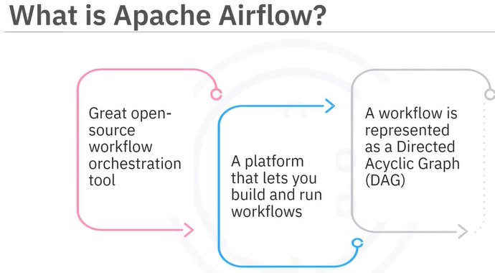

Apache Airflow is a great, open-source workflow orchestration tool that is supported by an active community. It is a platform that lets you build and run workflows, such as batch data pipelines.

With Apache Airflow, a workflow is represented as a directed acyclic graph (DAG). The DAG is made of tasks that are arranged in a specific order of execution.

Note that Apache Airflow is not a data streaming solution.

Apache Airflow is a workflow manager and is not an event or data streaming solution.

Airflow comes with a built-in scheduler, which handles the triggering of all scheduled workflows.

The scheduler is responsible for submitting individual tasks from each scheduled workflow to the executor.

The executor handles the running of these tasks by assigning them to workers, which then run the tasks.

The web server component of the Airflow provides a user-friendly, graphical user interface.

From this UI, you can inspect, trigger, and debug any of your DAGs and their individual tasks.

The DAG directory contains all of your DAG files, ready to be accessed by the scheduler, the executor, and each of its employed workers.

Finally, Airflow hosts a metadata database, which is used by the scheduler, executor, and the web server to store the state of each DAG and its tasks.

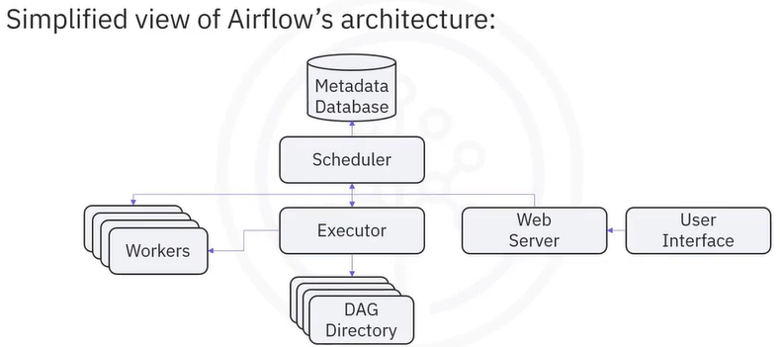

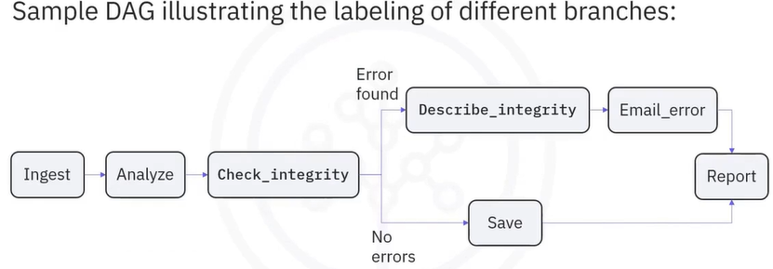

Let's have a look at the life cycle of a task's state. In this diagram, you can see how Apache Airflow might assign states to a task during its lifecycle. No status -- The task has not yet been cued for execution. Scheduled -- The scheduler has determined that the task's dependencies are met and has scheduled it to run. Removed -- For some reason, the task has vanished from the DAG since the run started. Upstream failed -- An upstream task has failed. Queued -- The task has been assigned to the executor, and is waiting for a worker to become available. Running -- The task is being run by a worker. Success -- The task completed successfully, and no errors were encountered. Failed -- The task could not be completed successfully due to an error, and Up for retry -- The task will be rescheduled as per the retrial configuration. Ideally, a task should flow throughout the scheduler from no status, to scheduled, to queued, to running, and finally to success.

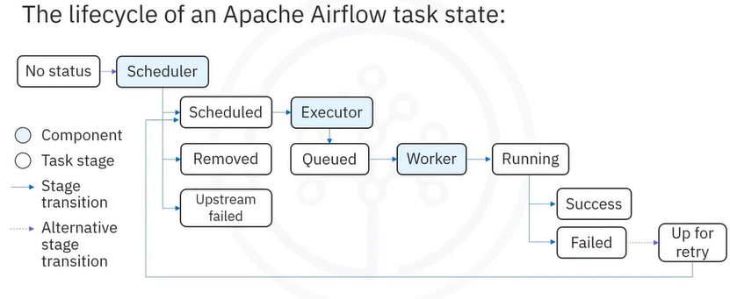

Apache Airflow features:

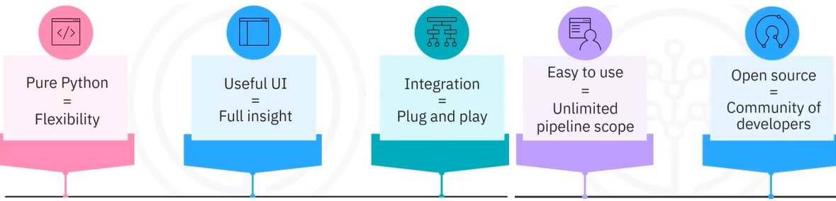

The five main features and benefits of Apache Airflow:

* Pure Python. Create your workflows using standard Python. This allows you to maintain full flexibility when building your data pipelines.
* Useful UI provides the ability to monitor the workflow, schedule the workflow, or manually run it, and manage the workflows via a sophisticated web app, offering you full insight into the status of your tasks.
* Integration. Apache Airflow provides many plug-and-play integrations, such as IBM data band that helps achieve continuous observability and monitoring.
* Easy to use. A workflow is easy to create and deploy for anyone with prior knowledge of Python. The Airflow pipeline can combine many tasks created with many options of operators and sensors without any limits. Airflow does not limit the scope of your pipelines.
* Finally, the open-source feature. Whenever you want to share your improvement, you can do this by opening a pull request.

Apache Airflow pipelines are built on four main principles:

* They are scalable. Airflow has a modular architecture and uses a message queue to orchestrate an arbitrary number of workers. It is ready to scale to infinity.
* Dynamic. Airflow pipelines are defined in Python, and allow dynamic pipeline generation. Thus, your pipelines can contain multiple simultaneous tasks.
* Extensible. You can easily define your own operators and extend libraries to suit your environment.
* Lean (agil). Airflow pipelines are lean and explicit. Parameterization is built into its core using the powerful Jinja templating engine

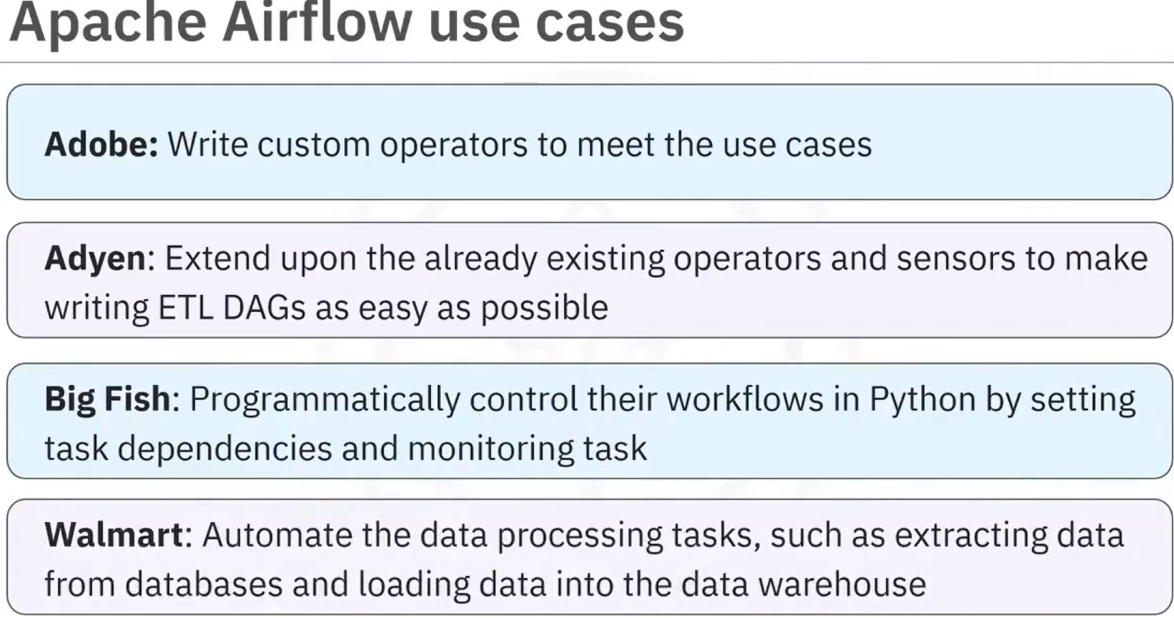

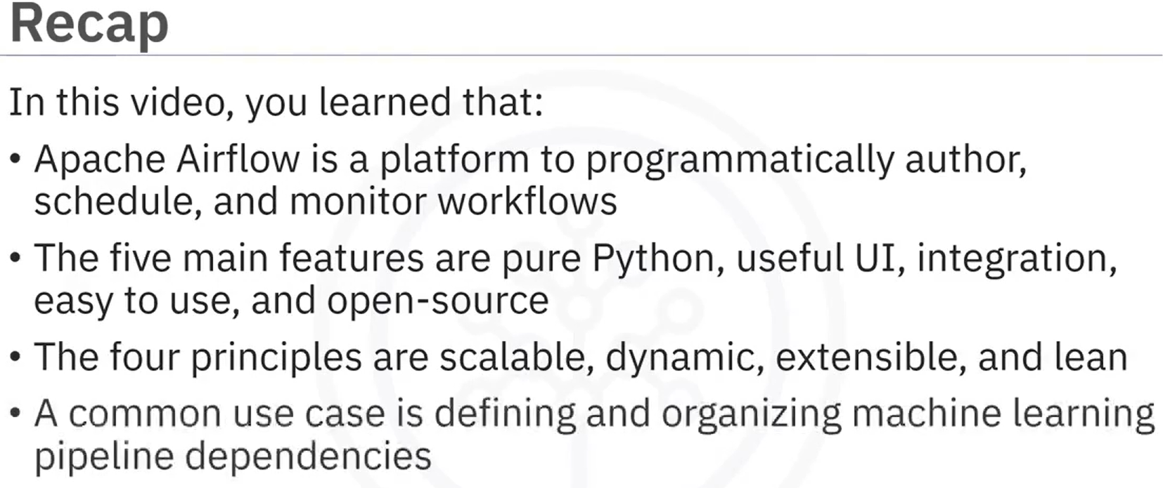

### **Advantages of Representing Data Pipelines as DAGs in Apache Airflow**

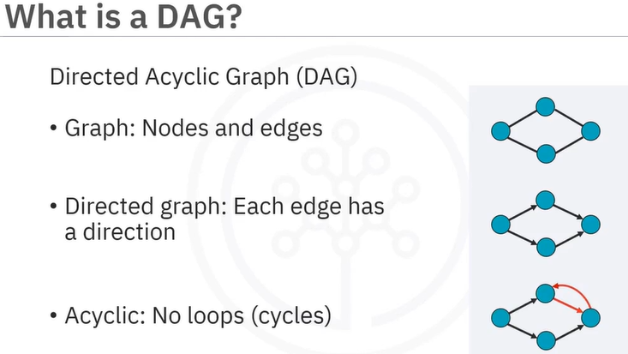 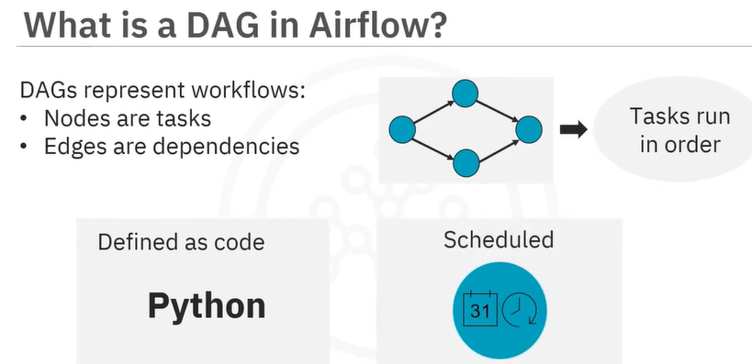

A DAG is defined in a Python script, which represents the DAG structure, thus, the tasks and their dependencies are defined as code. Also, scheduling instructions are specified as code in the DAG script.

Just like the DAG itself, each task performed within your DAG is also written in Python. Each task implements an operator, for example, a Python operator is used to deploy some Python code, a SQL operator to run a SQL query, and a bash operator can be used to run a bash command. Operators are used to define what each task in your DAG does.

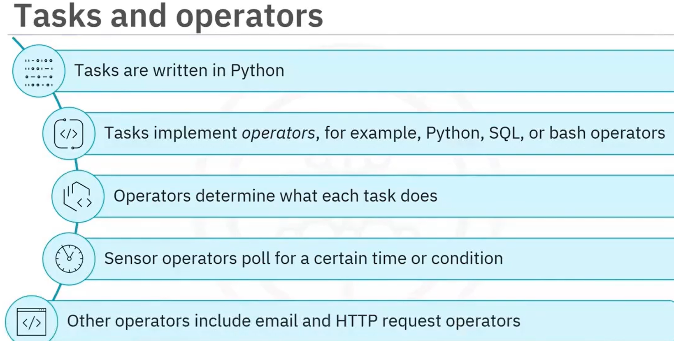

An Apache Airflow DAG is a Python script consisting of the following logical blocks:

Library imports, DAG arguments, DAG definition, task definitions, and task pipeline.

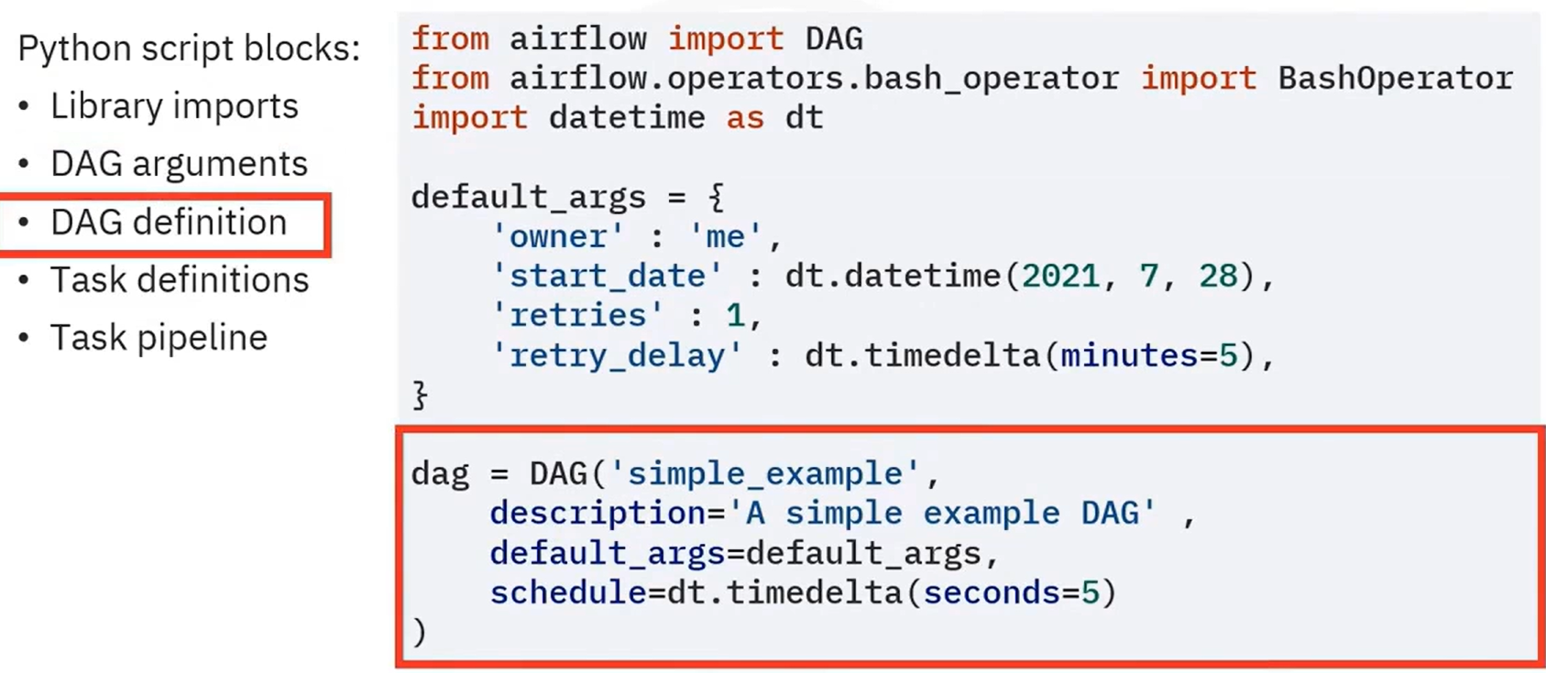

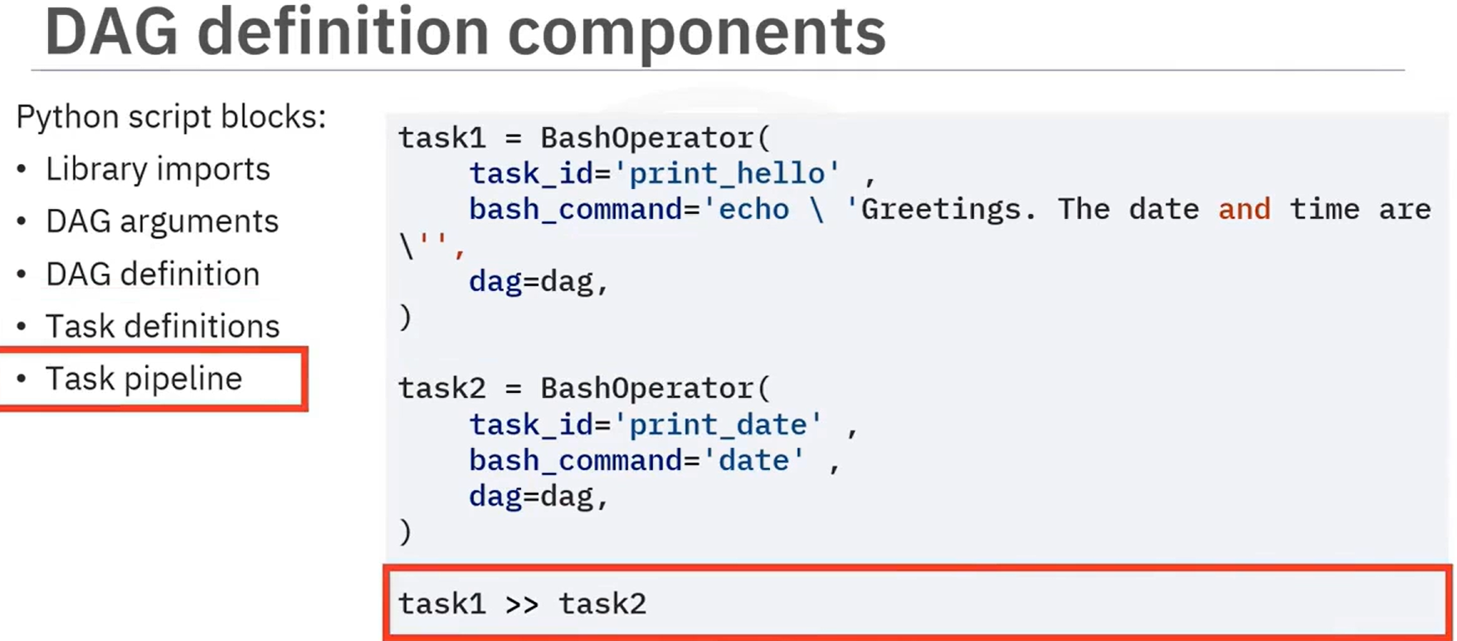

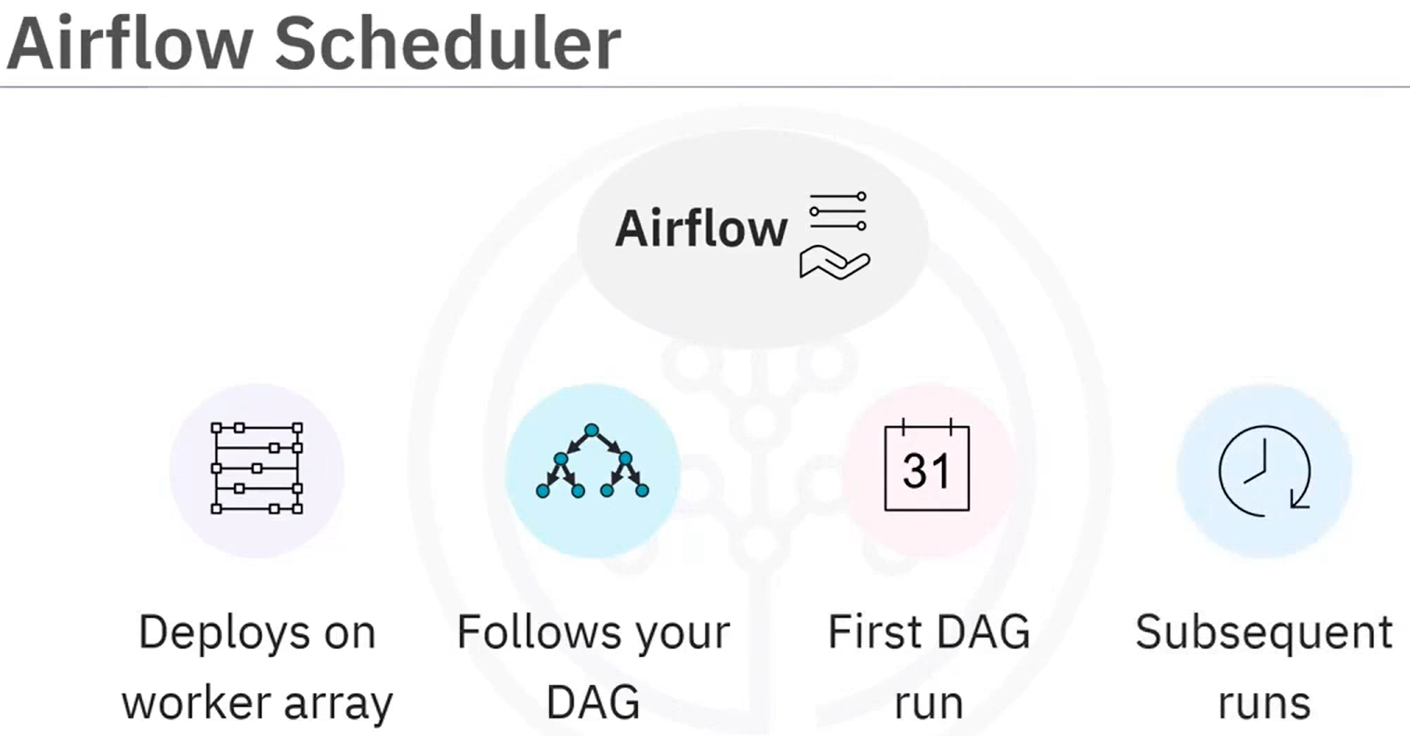 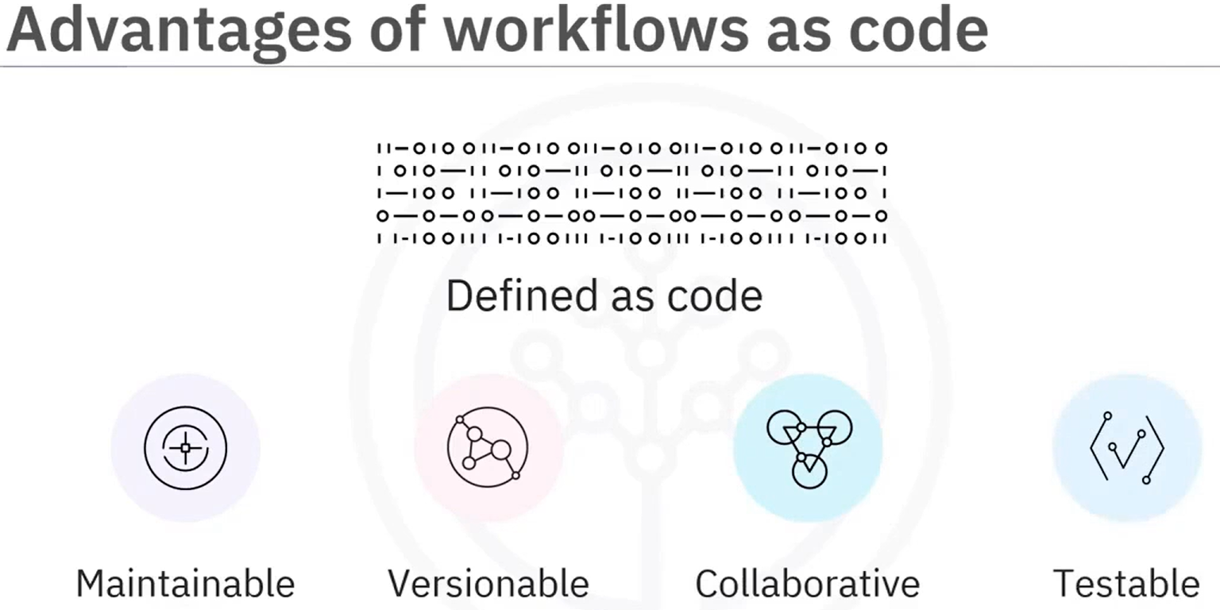

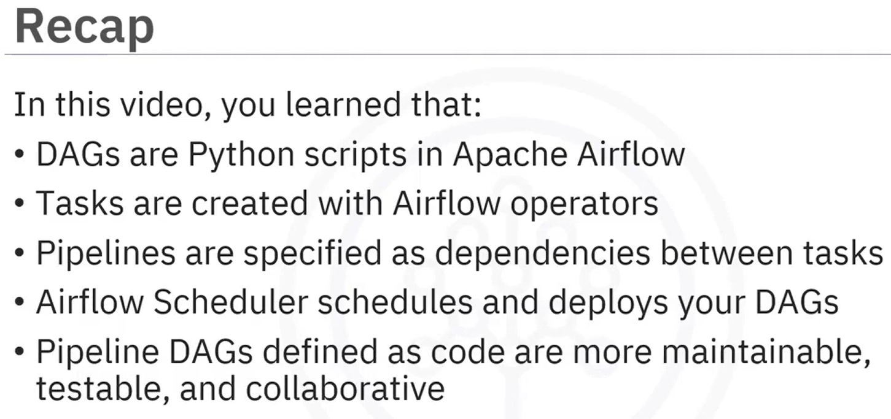

### **Apache Airflow UI**

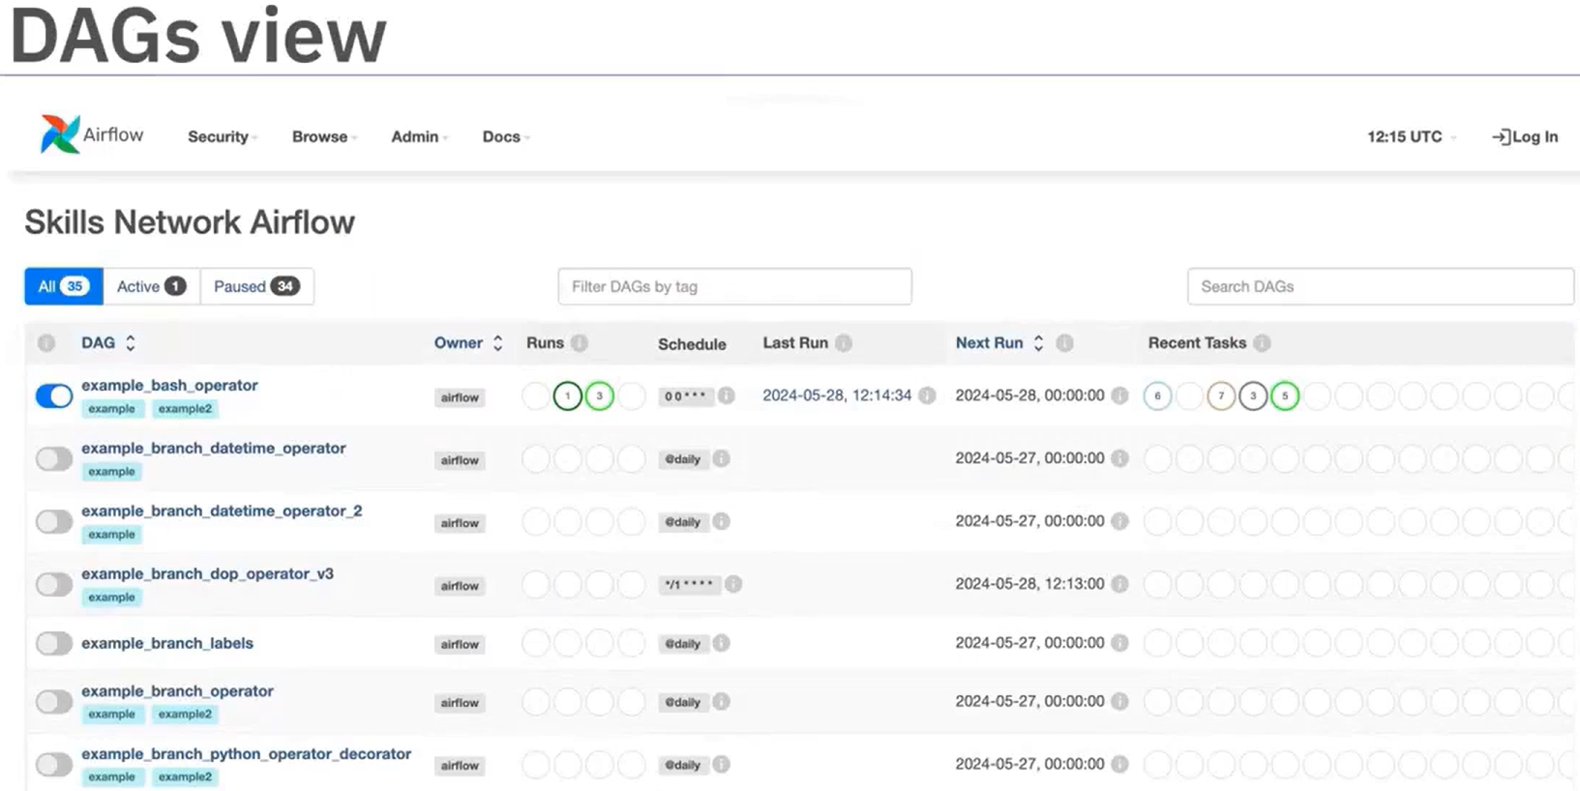

Select the simple-example:  
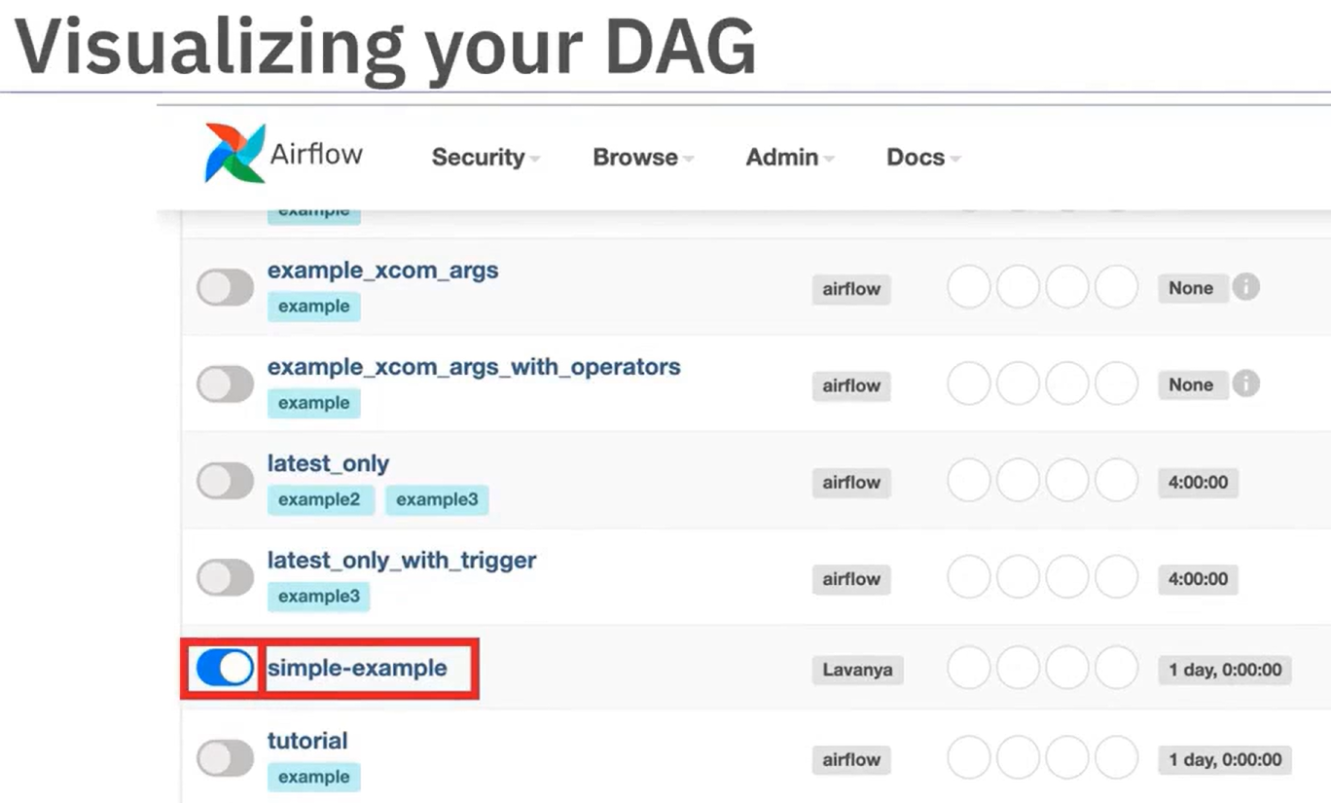

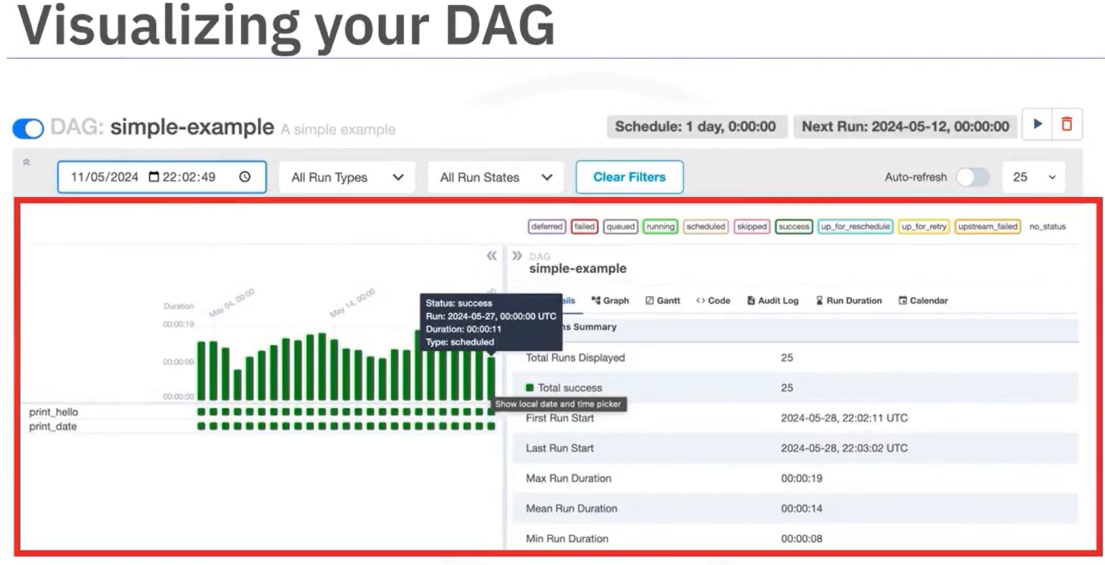

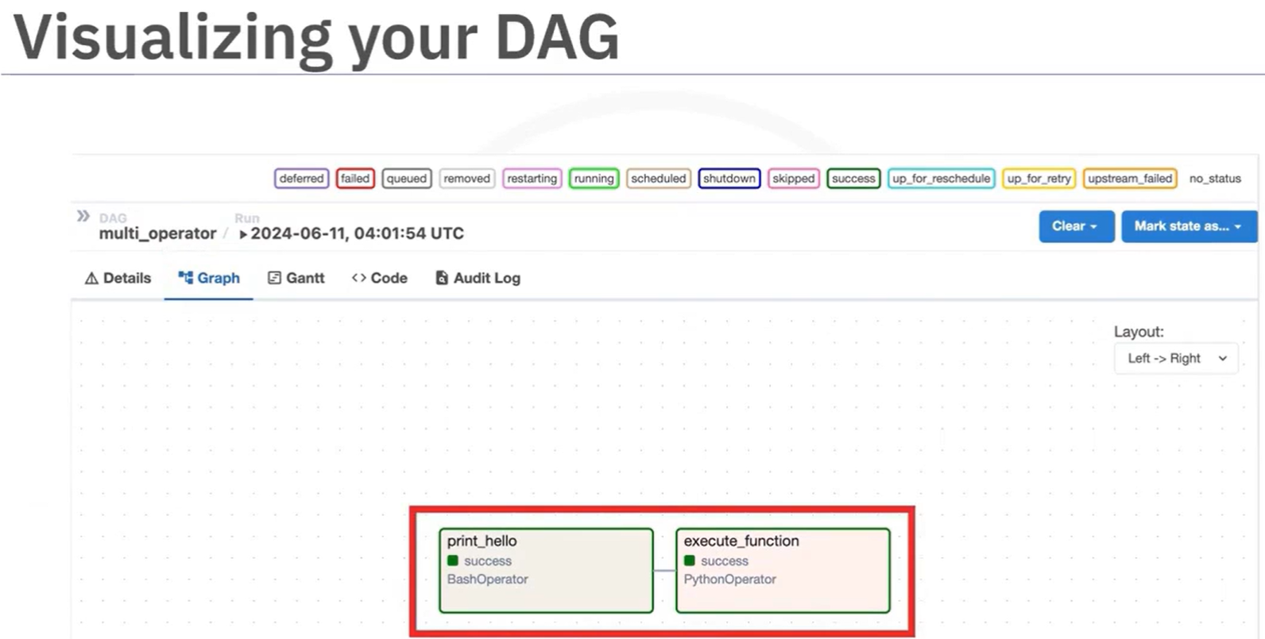

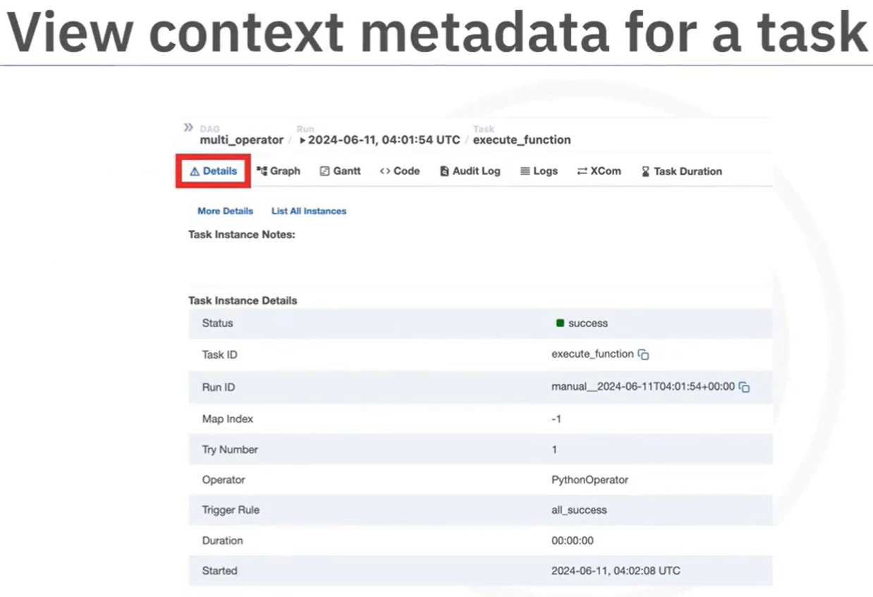

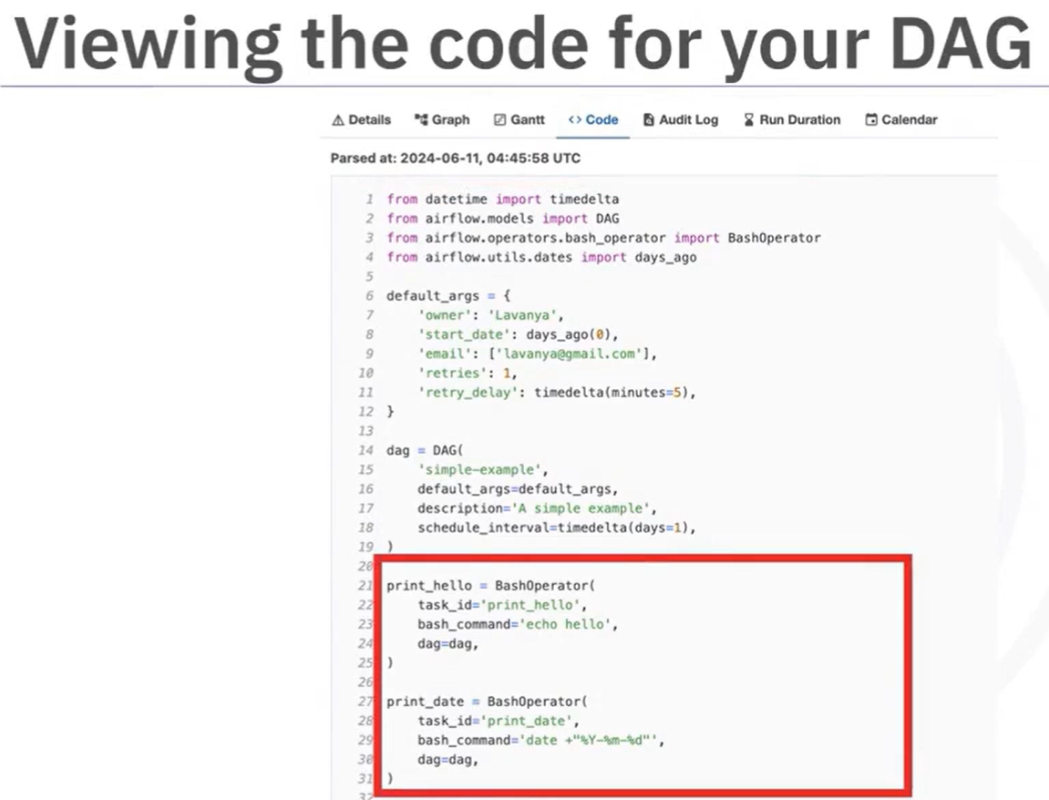

By clicking on "Task duration", you can view a timeline chart of your DAG's task durations to see how they have been performing: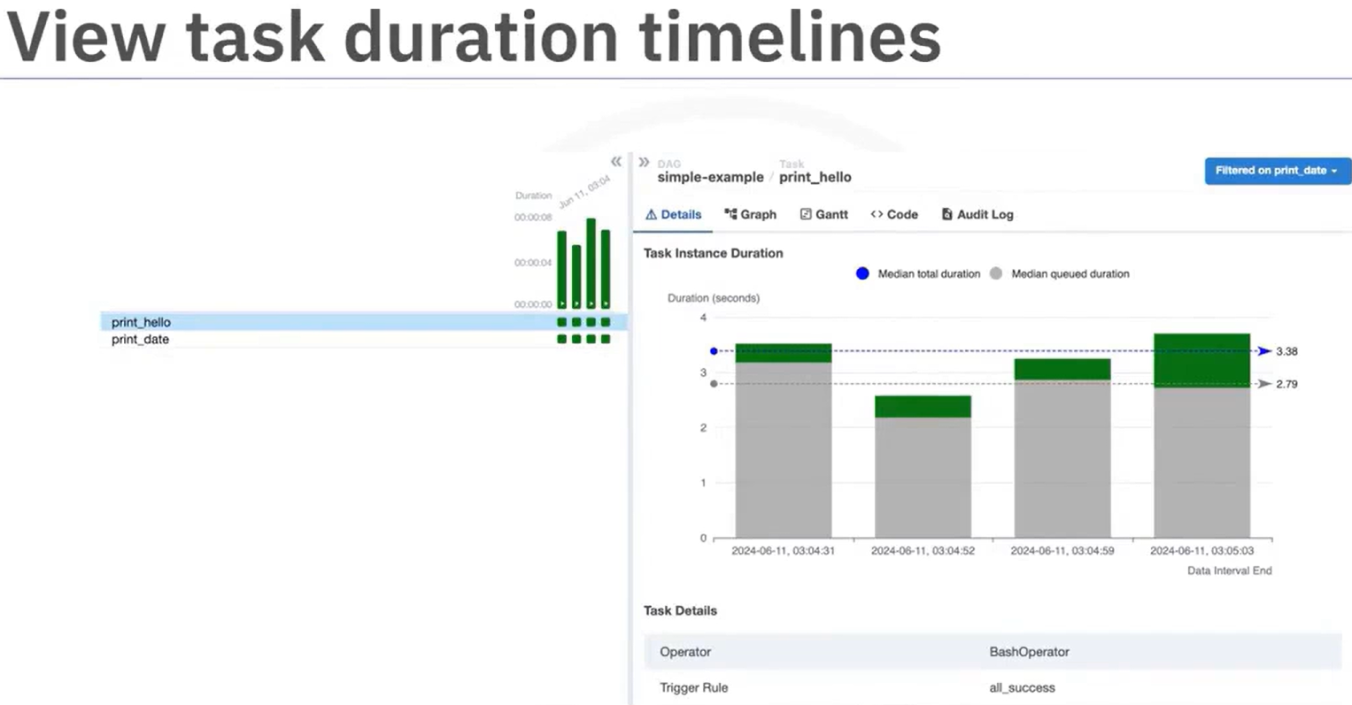

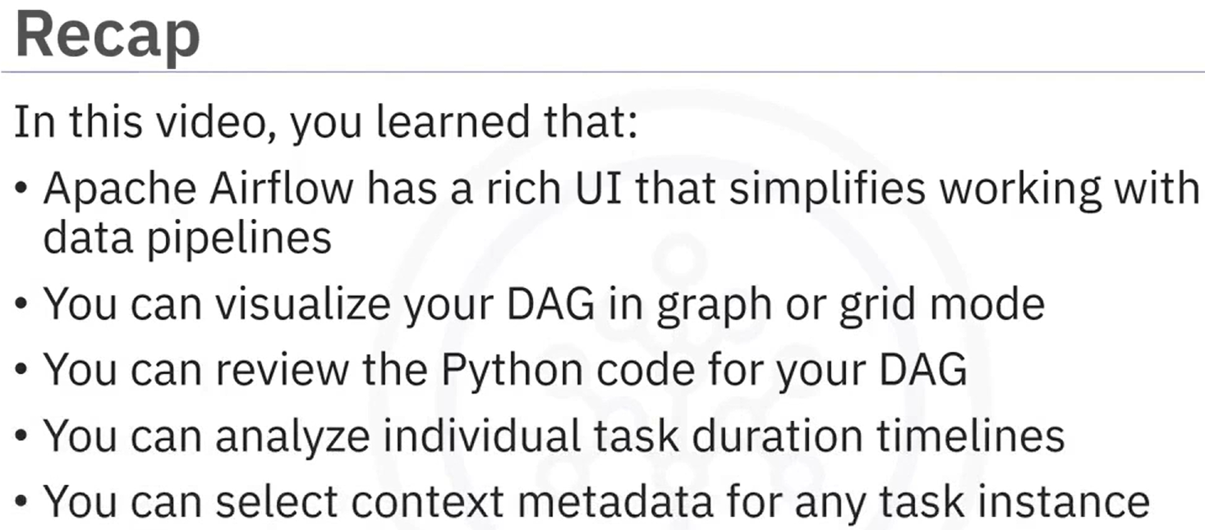

### Reading: DAG Structure and Operators

Apache Airflow is a Python framework that helps create workflows using multiple technologies using both CLI and a user-friendly WebUI. An Apache Airflow Directed Acyclic Graph (DAG) is a Python program where you define the tasks and the pipeline with the order in which the tasks will be executed.

**Airflow operator for task definition**

Airflow offers a wide range of operators, including many that are built into the core or are provided by pre-installed providers. Some popular core operators include:

* BashOperator - executes a bash command
* PythonOperator - calls an arbitrary Python function
* EmailOperator - sends an email

The other core operators available include:

* BaseBranchOperator - A base class for creating operators with branching functionality

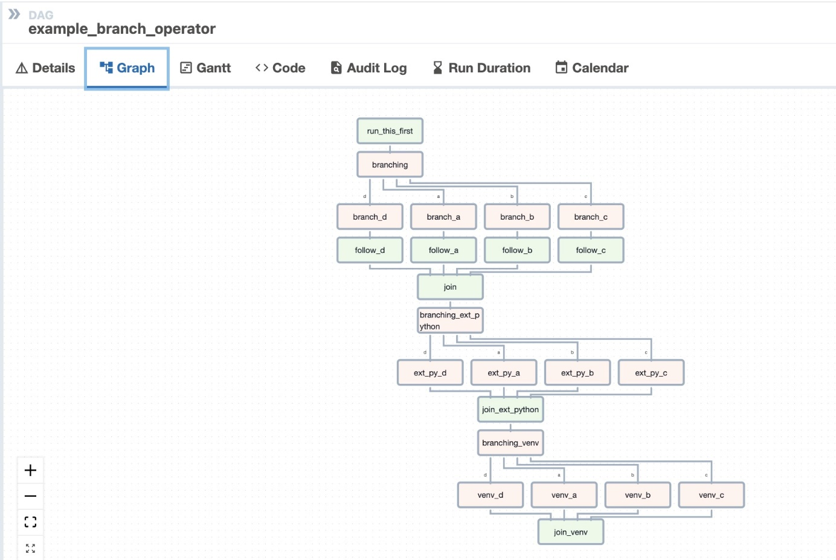

* BranchDateTimeOperator

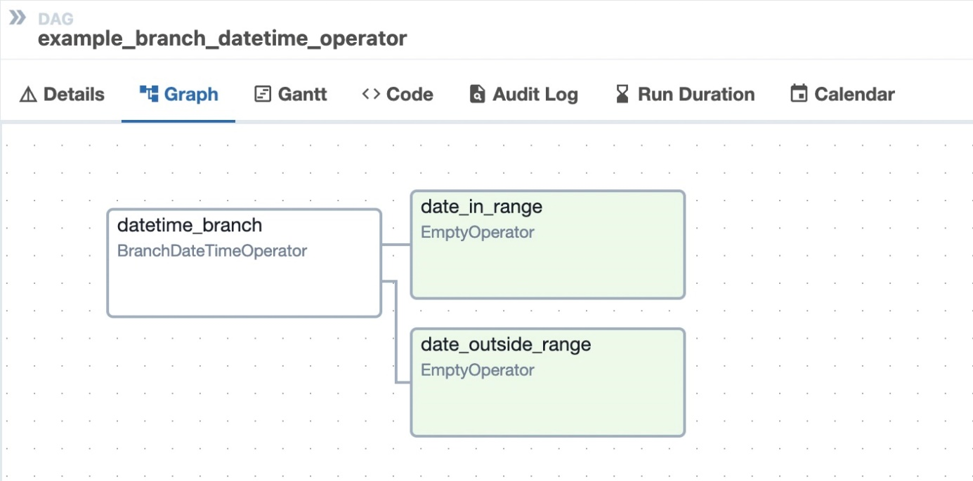

* EmptyOperator - Operator that does nothing
* GenericTransfer - Moves data from on database connection to another.
* LatestOnlyOperator - Skip tasks that are not running during the most recent schedule interval.
* TriggerDagRunOperator - Triggers a DAG run for a specified dag_id.

Besides these, there are also many community provided operators. Some of the popular and useful ones are:

* HttpOperator
* MySqlOperator
* PostgresOperator
* MsSqlOperator
* OracleOperator
* JdbcOperator
* DockerOperator
* HiveOperator
* S3FileTransformOperator
* PrestoToMySqlOperator
* SlackAPIOperator

In addition to operators, you also have sensors and decorators that allow you to combine bash and Python. You can find more information regarding the same in this [link](https://airflow.apache.org/docs/apache-airflow/stable/core-concepts/index.html).

**Anatomy of a DAG**

A DAG consists of these logical blocks.

* Imports
* DAG Arguments
* DAG Definition
* Task Definitions
* Task Pipeline

**imports block example**

1. # import the libraries
2. from datetime import timedelta
3. # The DAG object; we'll need this to instantiate a DAG
4. from airflow.models import DAG
5. # Operators; you need this to write tasks!
6. from airflow.operators.bash_operator import BashOperator
7. from airflow.operators.python import PythonOperator
8. from airflow.operators.email import EmailOperator

**DAG Arguments block example**

1. #defining DAG arguments
2. # You can override them on a per-task basis during operator initialization
3. default_args = {
4. 'owner': 'Your name',
5. 'start_date': days_ago(0),
6. 'email': ['youemail@somemail.com'],
7. 'retries': 1,
8. 'retry_delay': timedelta(minutes=5),
9. }

DAG arguments are like the initial settings for the DAG.

The above settings mention:

* The owner name
* When this DAG should run from: days_ago(0) means today
* The email address where the alerts are sent to
* The number of retries in case of failure
* The time delay between retries

The other options that you can include are:

* 'queue': The name of the queue the task should be a part of
* 'pool': The pool that this task should use
* 'email_on_failure': Whether an email should be sent to the owner on failure
* 'email_on_retry': Whether an email should be sent to the owner on retry
* 'priority_weight': Priority weight of this task against other tasks.
* 'end_date': End date for the task
* 'wait_for_downstream': Boolean value indicating whether it should wait for downtime
* 'sla': Time by which the task should have succeeded. This can be a timedelta object
* 'execution_timeout': Time limit for running the task. This can be a timedelta object
* 'on_failure_callback': Some function, or list of functions to call on failure
* 'on_success_callback': Some function, or list of functions to call on success
* 'on_retry_callback': Another function, or list of functions to call on retry
* 'sla_miss_callback': Yet another function, or list of functions when 'sla' is missed
* 'on_skipped_callback': Some function to call when the task is skipped
* 'trigger_rule': Defines the rule by which the generated task gets triggered

**DAG definition block example**

1. # define the DAG
2. dag = DAG(
3. dag_id='unique_id_for_DAG',
4. default_args=default_args,
5. description='A simple description of what the DAG does',
6. schedule_interval=timedelta(days=1),
7. )

Here you are creating a variable named dag by instantiating the DAG class with the following parameters:

unique_id_for_DAG is the ID of the DAG. This is what you see on the web console. This is what you can use to trigger the DAG using a TriggerDagRunOperator.

You are passing the dictionary default_args, in which all the defaults are defined.

description helps us in understanding what this DAG does.

schedule_interval tells us how frequently this DAG runs. In this case every day. (days=1).

**task definitions block example**

The tasks can be defined using any of the operators that have been imported.

1. # define the tasks
2. # define a task with BashOperator
3. task1 = BashOperator(
4. task_id='unique_task_id',
5. bash_command='<some bashcommand>',
6. dag=dag,
7. )
8. # define a task with PythonOperator
9. task2 = PythonOperator(
10. task_id='bash_task',
11. python_callable=<the python function to be called>,
12. dag=dag,
13. )
14. # define a task with EmailOperator
15. task3 = EmailOperator(
16. task_id='mail_task',
17. to='recipient@example.com',
18. subject='Airflow Email Operator example',
19. html_content='<p>This is a test email sent from Airflow.</p>',
20. dag=dag,
21. )

A task is defined using:

* A task_id which is a string that helps in identifying the task
* The dag this task belongs to
* The actual task to be performed
  + The bash command it represents in case of BashOperator
  + The Python callable function in case of a PythonOperator
  + Details of the sender, subject of the mail and the mail text as HTML in case of EmailOperator

**task pipeline block example**

1. # task pipeline
2. task1 >> task2 >> task3

You can also use upstream and downstream to define the pipeline. For example:

1. task1.set_downstream(task2)
2. task3.set_upstream(task2)

Task pipeline helps us to organize the order of tasks. In the example, the task task1 must run first, followed by task2, followed by the task task3.

### Hands-on Lab: Getting Started with Apache Airflow

You will work with both the Web user interface (UI) and command line interface (CLI) to explore the various ways you can use Airflow for workflow management. In this lab, you will have the opportunity to work with Apache Airflow.

**Objectives**

After completing this lab, you will be able to:

* Start Apache Airflow
* Open the Airflow UI in a browser
* List all the DAGs
* List the tasks in a DAG
* Explore a DAG in the UI

### **Exercise 1: Start Apache Airflow**

1. Click on **Skills Network Toolbox**.
2. From the **BIG DATA** section, click **Apache Airflow**.
3. Click **Start** or **Create** to start the Apache Airflow.

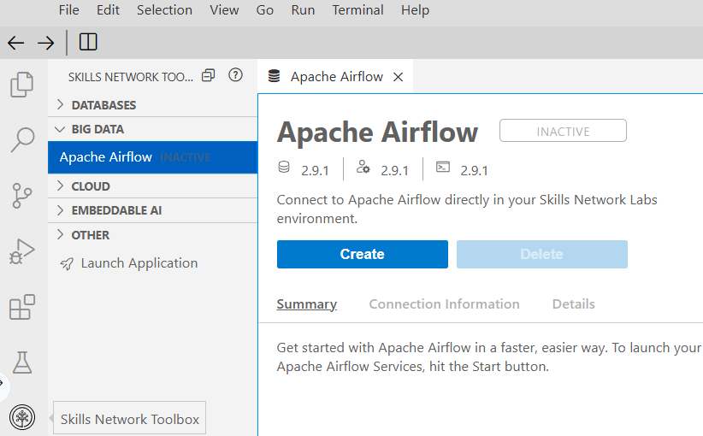

### **Exercise 2: Open the Airflow Web UI**

1. When Airflow starts successfully, you should see an output similar to the one below. Once **Apache Airflow** has started, click on the highlighted icon to open **Apache Airflow Web UI** in the new window.

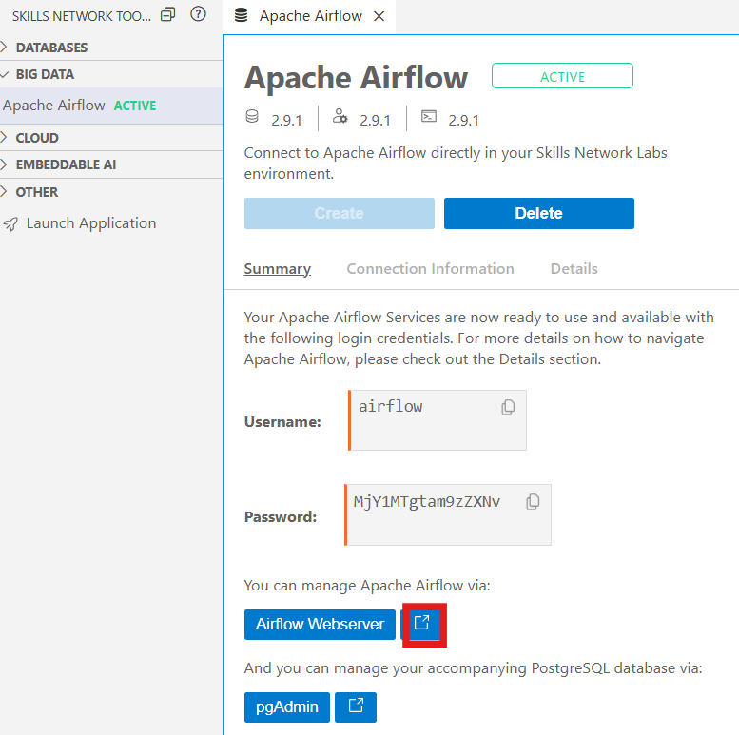MjY1MTgtam9zZXNv

1. You will land on a page that displays various DAGs and associated options.

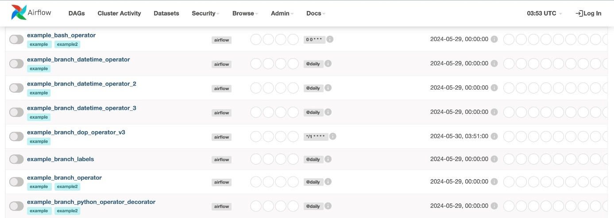

1. You can unpause and pause a DAG using the **Unpause/Pause** toggle button.

*The button is grey when the DAG has been paused.*

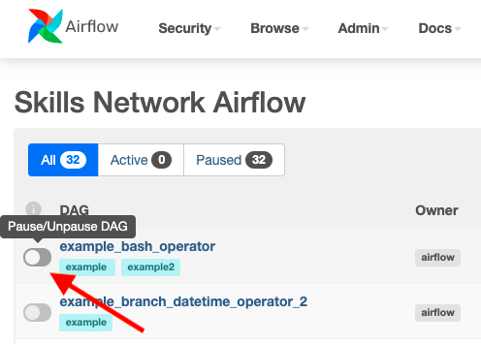

*The button is not greyed out when the DAG is running.*

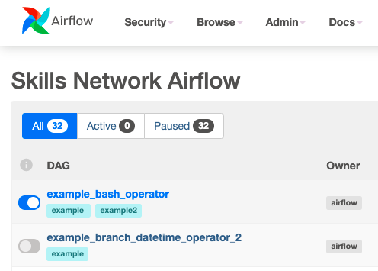

1. Click on a DAG to explore more.

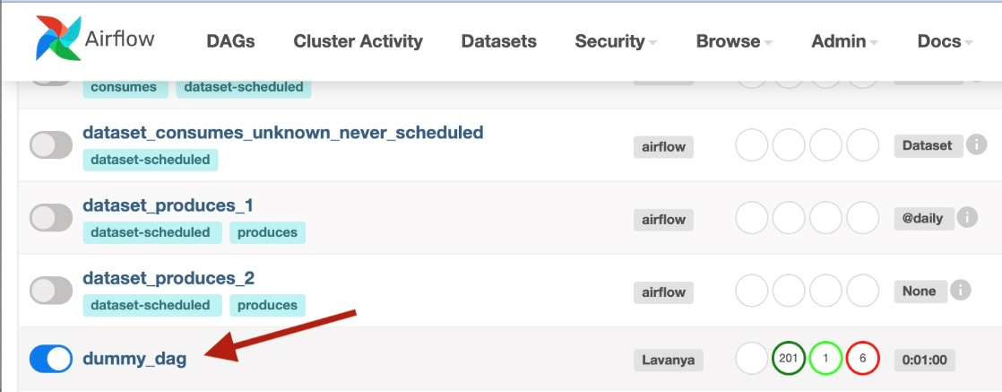

1. You will see the Grid view by default.

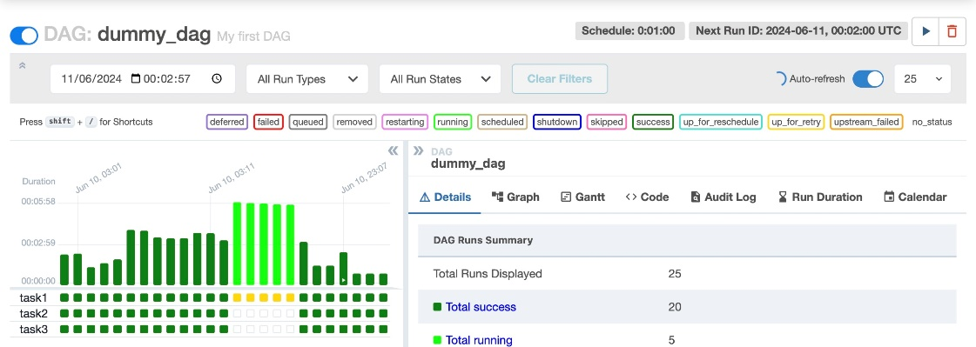

1. Next, click on the **Graph** button.

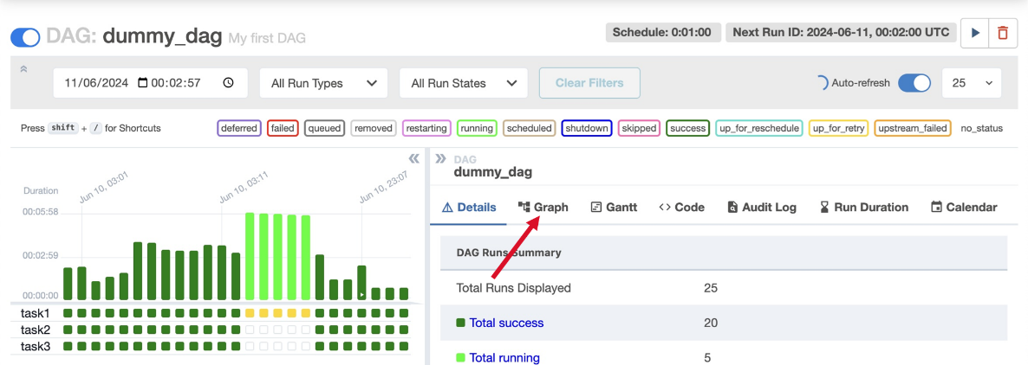

1. Notice the graph view of the DAG will display.

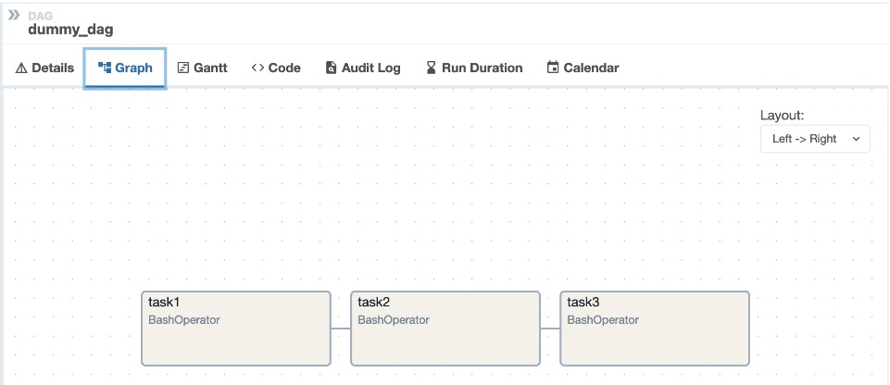

### **Exercise 3: Apache Airflow CLI**

Apache Airflow provides some command line options.

1. Run the command below in the terminal to list all the existing DAGs.

*airflow dags list*

1. Run the command below in the terminal to list all tasks in the DAG named example_bash_operator.

*airflow tasks list example_bash_operator*

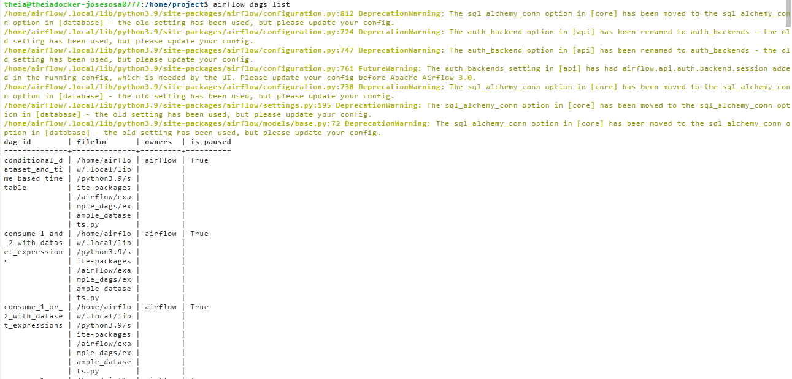

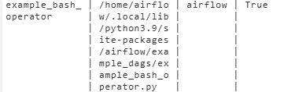

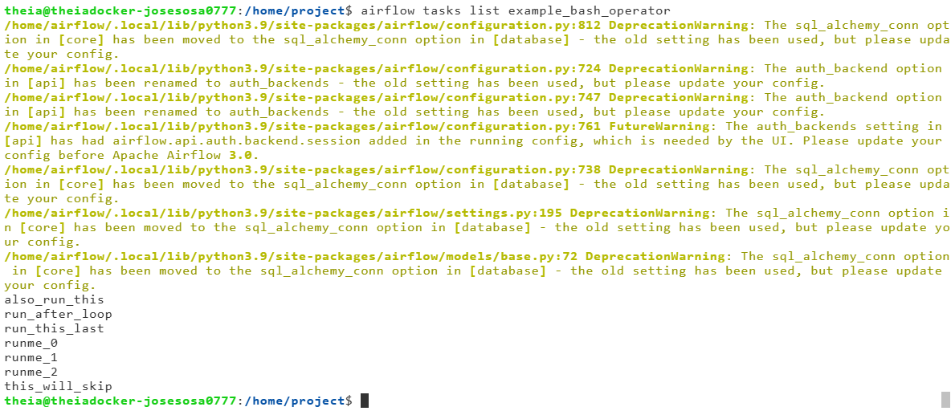

**Practice Exercise**

1. Run a command to list all tasks for the DAG named tutorial

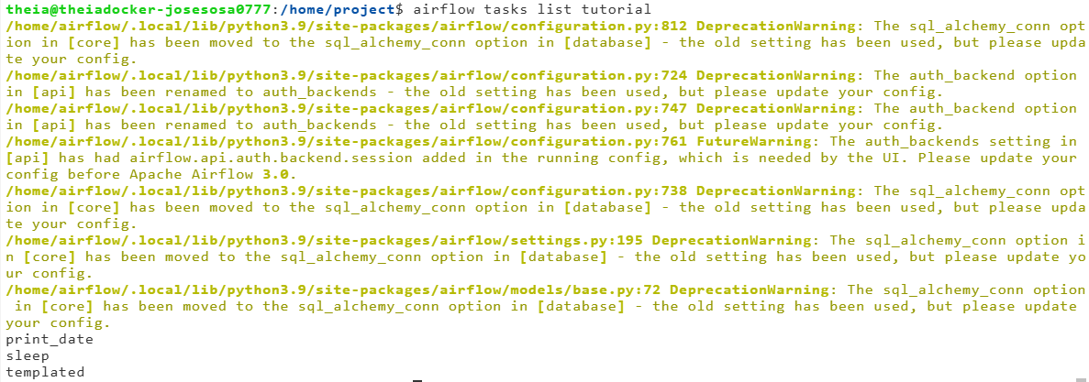

### **Exercise 4: Pause or Unpause a DAG**

1. Run the command below in the terminal to unpause a DAG named tutorial.

*airflow dags unpause tutorial*

1. Run the command to pause the DAG.

*airflow dags pause tutorial*

**Practice Exercise**

1. Run a command to unpause the DAG named example_branch_operator

*airflow dags unpause example_branch_operator*

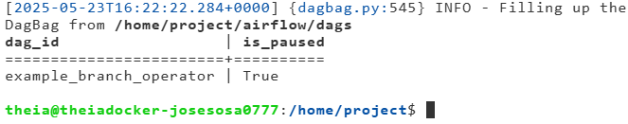

### **Practice exercises**

1. List tasks for the DAG example_branch_labels.
2. Unpause the DAG example_branch_labels.
3. Pause the DAG example_branch_labels.

Solution:

*airflow dags list*

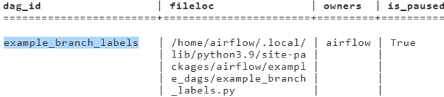

*airflow tasks list example_branch_labels*

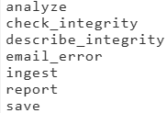

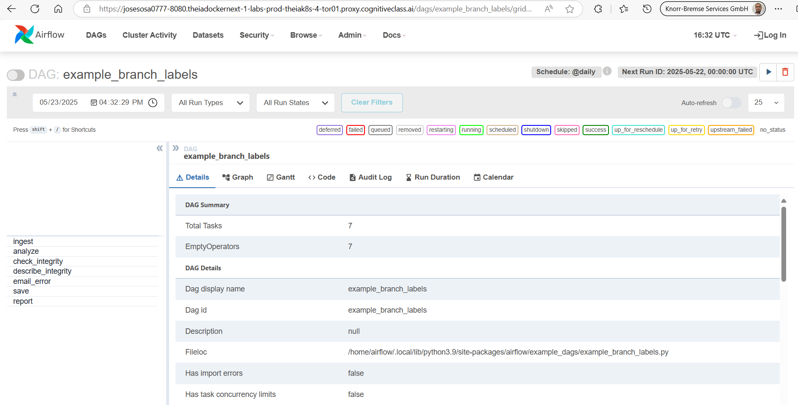

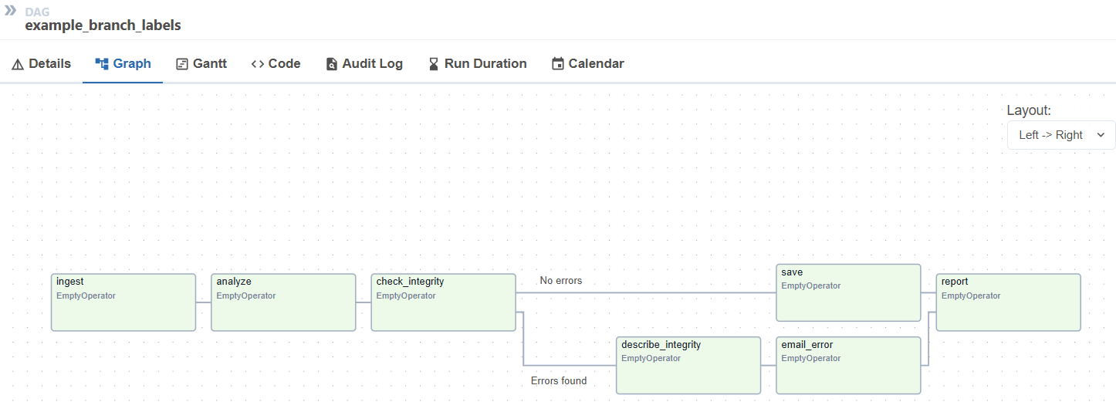

*airflow dags pause example_branch_labels*

**

### **Build a DAG Using Airflow**

An Apache Airflow DAG is a Python script which consists of the following logical blocks.

Python library imports, DAG argument specification, the DAG definition or instantiation, individual task definitions, which are the nodes of the DAG, and finally, the task pipeline, which specifies the dependencies between tasks.

Let's implement a simple Apache Airflow pipeline by writing a DAG definition script.

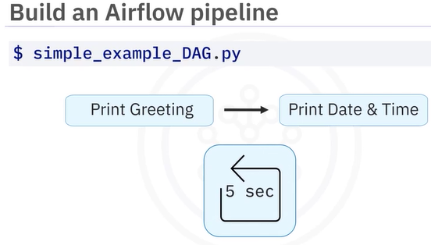

Begin by importing the Python libraries you will need for your DAG here. Start by importing the DAG class from the airflow models library. Then import the bash operator, which you will use to create the two print tasks, and the datetime, and timedelta modules from the datetime package, which you will need for specifying several time-related parameters. The next block is for specifying the default DAG arguments. Notice they are specified as a Python dict, which is just a collection of key-value pairs enclosed by curly braces. These are used to specify such things as the owner of the DAG, which is you, and its start date, in this case January 1, 2024, the number of times it should keep trying if it is failing. Here, only once if it does fail, and the retry_delay, or the time to wait between subsequent tries, which in this case is five minutes.

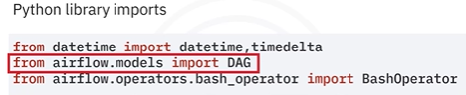

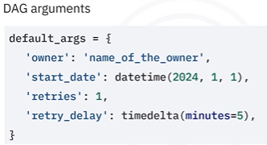

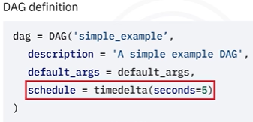

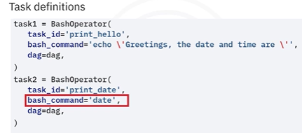

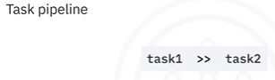

The DAG definition block is used for instantiating your workflow as a DAG object. Here you can specify things like the name of your DAG, such as simple_example, a description for your workflow, for example, a simple example DAG, the default arguments to apply to your DAG, which in this case are specified by the default_args dict you already defined in the previous block, and finally scheduling instructions. In this case, the DAG will run repeatedly on a schedule of every 5 seconds once it is deployed. Next comes the task definition block. Here we define two tasks: task1 and task2, both of which are bash operators. Their respective ids are specified as print_hello and print_date. They each call a bash command, where the first task will echo "Greetings, the date and time are", and the second task will print the current date and time using the bash command date. Finally, each task is assigned to the DAG you instantiated in the DAG definition block above. The final block is where you specify the dependencies for your workflow, like this. Here, the double greater than notation specifies that task2 is downstream from task1. This means that task1, which we named print hello, will run first. Once print hello runs successfully, task2 or print date will run.

### Hands-on Lab: Create a DAG for Apache Airflow with PythonOperator

In this lab, you will explore the Apache Airflow web user interface (UI). You will then create a Direct Acyclic Graph (DAG) using PythonOperator and finally run it through the Airflow web UI.

After completing this lab, you will be able to:

* Explore the Airflow Web UI
* Create a DAG with PythonOperator
* Submit a DAG and run it through the Web UI

Skills Network Cloud IDE (based on Theia and Docker) provides an environment for hands-on labs for course and project-related labs. Theia is an open-source IDE (Integrated Development Environment) that can be run on a desktop or on the cloud. To complete this lab, you will be using the Cloud IDE based on Theia, running in a Docker container.

**Exercise 1: Start Apache Airflow**

1. Click on **Skills Network Toolbox**.
2. From the **BIG DATA** section, click **Apache Airflow**.
3. Click **Create** to start the Apache Airflow. It *will take a few minutes for Airflow to start.*

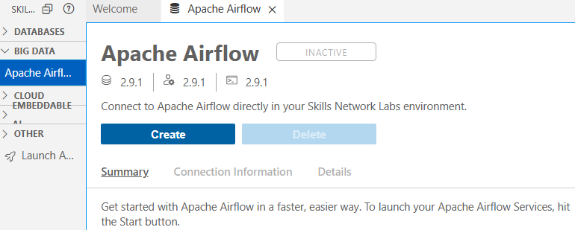

When Airflow starts successfully, you should see an output similar to the one below. Once **Apache Airflow** has started, click on the highlighted icon to open **Apache Airflow Web UI** in the new window.

MjY1MTgtam9zZXNv

### **Exercise 3: Create a DAG with PythonOperator**

Next, you will create a DAG, which will define a pipeline of tasks, such as extract, transform, load, and check with PythonOperator.

1. Create a DAG file, my_first_dag.py, which will run daily. To Create a new file choose File->New File and name it as my_first_dag.py.

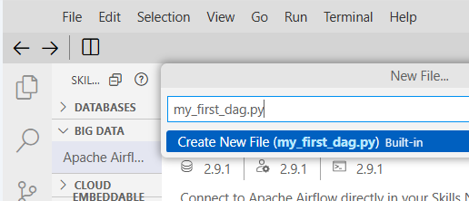 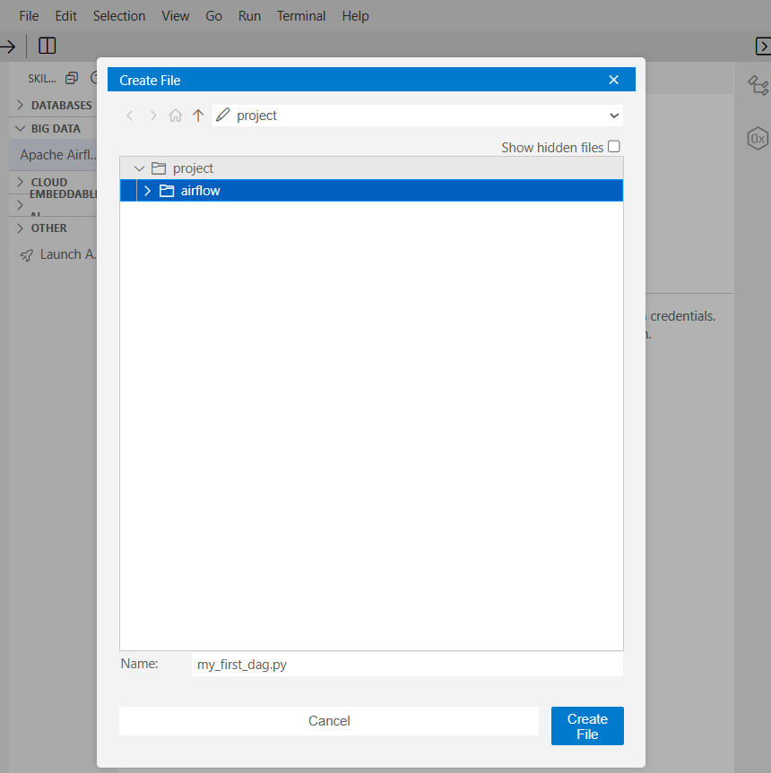

The my_first_dag.py file defines tasks execute_extract, execute_transform, execute_load, and execute_check to call the respective Python functions.

# Import the libraries

from datetime import timedelta

# The DAG object; we'll need this to instantiate a DAG

from airflow.models import DAG

# Operators; you need this to write tasks!

from airflow.operators.python import PythonOperator

# This makes scheduling easy

from airflow.utils.dates import days_ago

# Define the path for the input and output files

input_file = '/etc/passwd'

extracted_file = 'extracted-data.txt'

transformed_file = 'transformed.txt'

output_file = 'data_for_analytics.csv'

def extract():

global input_file

print("Inside Extract")

# Read the contents of the file into a string

with open(input_file, 'r') as infile, \

open(extracted_file, 'w') as outfile:

for line in infile:

fields = line.split(':')

if len(fields) >= 6:

field_1 = fields[0]

field_3 = fields[2]

field_6 = fields[5]

outfile.write(field_1 + ":" + field_3 + ":" + field_6 + "\n")

def transform():

global extracted_file, transformed_file

print("Inside Transform")

with open(extracted_file, 'r') as infile, \

open(transformed_file, 'w') as outfile:

for line in infile:

processed_line = line.replace(':', ',')

outfile.write(processed_line + '\n')

def load():

global transformed_file, output_file

print("Inside Load")

# Save the array to a CSV file

with open(transformed_file, 'r') as infile, \

open(output_file, 'w') as outfile:

for line in infile:

outfile.write(line + '\n')

def check():

global output_file

print("Inside Check")

# Save the array to a CSV file

with open(output_file, 'r') as infile:

for line in infile:

print(line)

# You can override them on a per-task basis during operator initialization

default_args = {

'owner': 'Your name',

'start_date': days_ago(0),

'email': ['your email'],

'retries': 1,

'retry_delay': timedelta(minutes=5),

}

# Define the DAG

dag = DAG(

'my-first-python-etl-dag',

default_args=default_args,

description='My first DAG',

schedule_interval=timedelta(days=1),

)

# Define the task named execute_extract to call the `extract` function

execute_extract = PythonOperator(

task_id='extract',

python_callable=extract,

dag=dag,

)

# Define the task named execute_transform to call the `transform` function

execute_transform = PythonOperator(

task_id='transform',

python_callable=transform,

dag=dag,

)

# Define the task named execute_load to call the `load` function

execute_load = PythonOperator(

task_id='load',

python_callable=load,

dag=dag,

)

# Define the task named execute_load to call the `load` function

execute_check = PythonOperator(

task_id='check',

python_callable=check,

dag=dag,

)

# Task pipeline

execute_extract >> execute_transform >> execute_load >> execute_check

### **Exercise 4: Submit a DAG**

Submitting a DAG is as simple as copying the DAG Python file into the dags folder in the AIRFLOW_HOME directory.

1. Open a terminal and run the command below to set the AIRFLOW_HOME.

export AIRFLOW_HOME=/home/project/airflow

echo $AIRFLOW_HOME

1. Run the command below to submit the DAG that was created in the previous exercise.

cp my_first_dag.py $AIRFLOW_HOME/dags

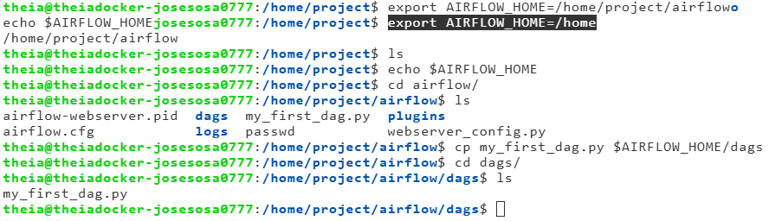

1. Verify that your DAG actually got submitted.
2. Run the command below to list out all the existing DAGs.

airflow dags list

1. Verify that my-first-python-etl-dag is a part of the output.

airflow dags list|grep "my-first-python-etl-dag"

1. You should see your DAG name in the output.
2. Run the command below to list out all the tasks in my-first-python-etl-dag.

airflow tasks list my-first-python-etl-dag

1. You should see all the four tasks in the output.
2. You can run the task from the Web UI. You can check the logs of the tasks by clicking the individual task in the Graph view.

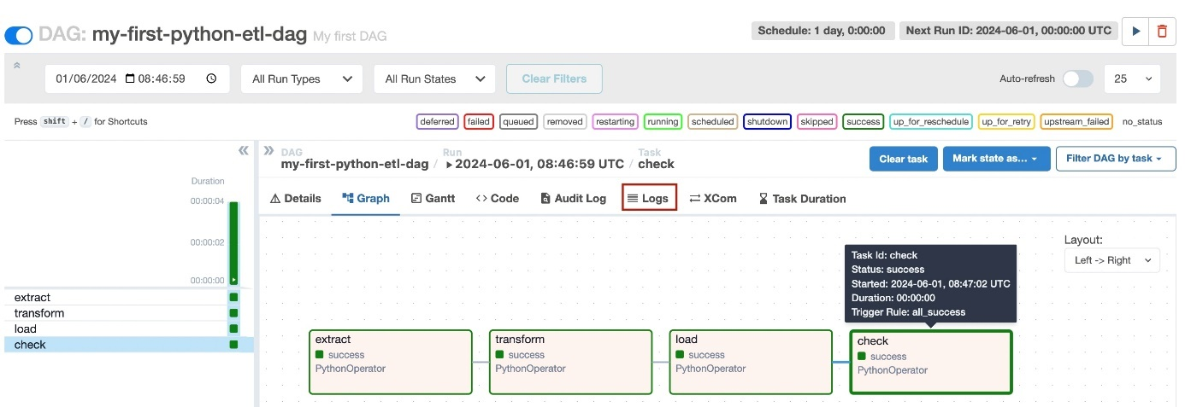

### **Practice exercise**

Write a DAG named ETL_Server_Access_Log_Processing that will extract a file from a remote server and then transform the content and load it into a file.

The file URL is given below:  
<https://cf-courses-data.s3.us.cloud-object-storage.appdomain.cloud/IBM-DB0250EN-SkillsNetwork/labs/Apache%20Airflow/Build%20a%20DAG%20using%20Airflow/web-server-access-log.txt>

The server access log file contains these fields.

a. timestamp - TIMESTAMP  
b. latitude - float  
c. longitude - float  
d. visitorid - char(37)  
e. accessed_from_mobile - boolean  
f. browser_code - int

**Tasks**

1. Add tasks in the DAG file to download the file, read the file, and extract the fields timestamp and visitorid from the web-server-access-log.txt.
2. Capitalize the visitorid for all the records and store it in a local variable.
3. Load the data into a new file capitalized.txt.
4. Create the imports block.
5. Create the DAG Arguments block. You can use the default settings.
6. Create the DAG definition block. The DAG should run daily.
7. Create the tasks extract, transform, and load to call the Python script.
8. Create the task pipeline block.
9. Submit the DAG.
10. Verify if the DAG is submitted.

ETL_Server_Access_Log_Processing.py:

# Import the libraries

from datetime import timedelta

# The DAG object; we'll need this to instantiate a DAG

from airflow.models import DAG

# Operators; you need this to write tasks!

from airflow.operators.python import PythonOperator

from airflow.operators.bash_operator import BashOperator

# This makes scheduling easy

from airflow.utils.dates import days_ago

import requests

# Define the path for the input and output files

input_file = 'web-server-access-log.txt'

extracted_file = 'extracted-data.txt'

transformed_file = 'transformed.txt'

output_file = 'capitalized.txt'

def download_file():

    url = "https://cf-courses-data.s3.us.cloud-object-storage.appdomain.cloud/IBM-DB0250EN-SkillsNetwork/labs/Apache%20Airflow/Build%20a%20DAG%20using%20Airflow/web-server-access-log.txt"

    # Send a GET request to the URL

    with requests.get(url, stream=True) as response:

        # Raise an exception for HTTP errors

        response.raise_for_status()

        # Open a local file in binary write mode

        with open(input_file, 'wb') as file:

            # Write the content to the local file in chunks

            for chunk in response.iter_content(chunk_size=8192):

                file.write(chunk)

    print(f"File downloaded successfully: {input_file}")

def extract():

    global input_file

    print("Inside Extract")

    # Read the contents of the file into a string

    with open(input_file, 'r') as infile, \

            open(extracted_file, 'w') as outfile:

        for line in infile:

            fields = line.split('#')

            if len(fields) >= 4:

                field_1 = fields[0]

                field_4 = fields[3]

                outfile.write(field_1 + "#" + field_4 + "\n")

def transform():

    global extracted_file, transformed_file

    print("Inside Transform")

    with open(extracted_file, 'r') as infile, \

            open(transformed_file, 'w') as outfile:

        for line in infile:

            processed_line = line.upper()

            outfile.write(processed_line + '\n')

def load():

    global transformed_file, output_file

    print("Inside Load")

    # Save the array to a CSV file

    with open(transformed_file, 'r') as infile, \

            open(output_file, 'w') as outfile:

        for line in infile:

            outfile.write(line + '\n')

def check():

    global output_file

    print("Inside Check")

    # Save the array to a CSV file

    with open(output_file, 'r') as infile:

        for line in infile:

            print(line)

# You can override them on a per-task basis during operator initialization

default_args = {

    'owner': 'Your name',

    'start_date': days_ago(0),

    'email': ['your email'],

    'retries': 1,

    'retry_delay': timedelta(minutes=5),

}

# Define the DAG

dag = DAG(

    'etl-server-logs-dag',

    default_args=default_args,

    description='My etl-server-logs DAG',

    schedule_interval=timedelta(days=1),

)

# Define the task named download to call the `download_file` function

download = PythonOperator(

    task_id='download',

    python_callable=download_file,

    dag=dag,

)

# Define the task named execute_extract to call the `extract` function

execute_extract = PythonOperator(

    task_id='extract',

    python_callable=extract,

    dag=dag,

)

# Define the task named execute_transform to call the `transform` function

execute_transform = PythonOperator(

    task_id='transform',

    python_callable=transform,

    dag=dag,

)

# Define the task named execute_load to call the `load` function

execute_load = PythonOperator(

    task_id='load',

    python_callable=load,

    dag=dag,

)

# Define the task named execute_load to call the `load` function

execute_check = PythonOperator(

    task_id='check',

    python_callable=check,

    dag=dag,

)

# Task pipeline

download >> execute_extract >> execute_transform >> execute_load >> execute_check

Execute:

airflow dags list | grep etl-server-logs-dag

airflow dags list-import-errors

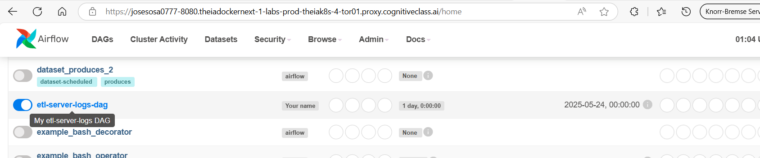

Select the dag and run it  
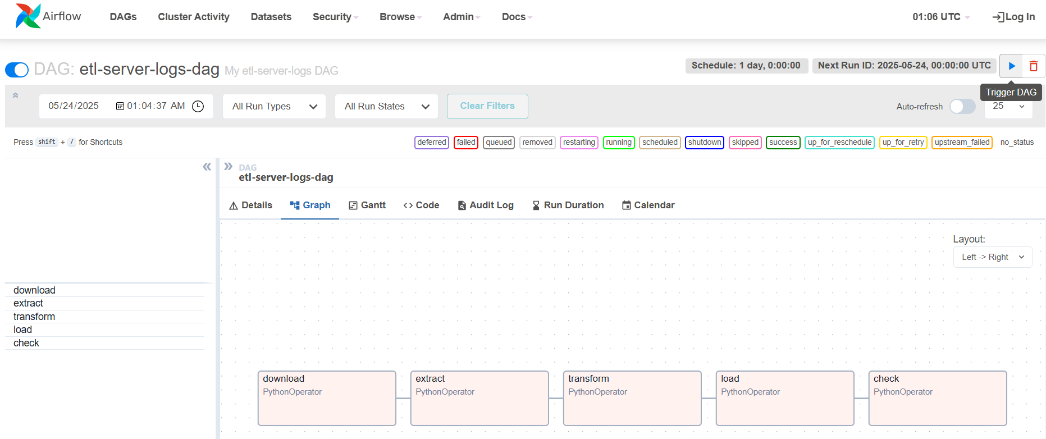

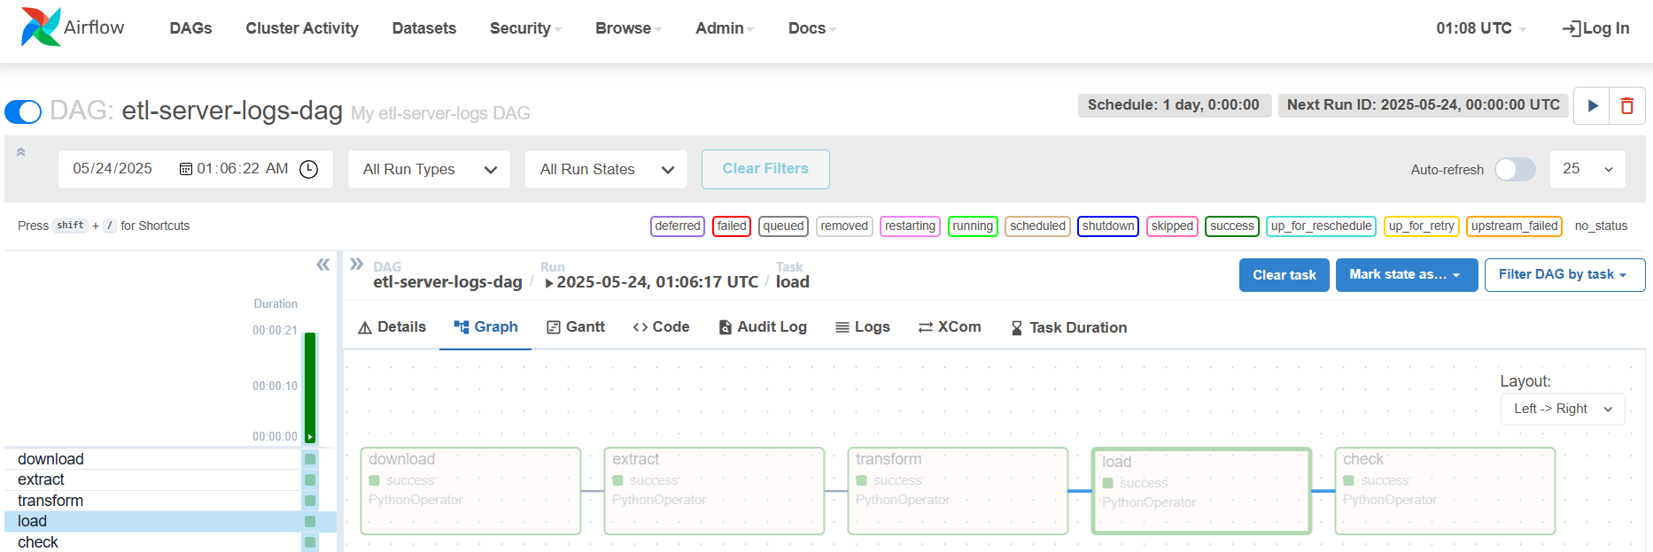

### Hands-on Lab: Create a DAG for Apache Airflow with BashOperator

In this lab, you will create workflows using BashOperator in Airflow DAGs and simulate an ETL process using bash commands that are scheduled to run once a day.

### **Exercise 3: Create a DAG**

Let's create a DAG that runs daily, and extracts user information from */etc/passwd* file, transforms it, and loads it into a file.

This DAG will have two tasks extract that extracts fields from /etc/passwd file and transform_and_load that transforms and loads data into a file.

my_third_dag.py:

# import the libraries

from datetime import timedelta

# The DAG object; we'll need this to instantiate a DAG

from airflow.models import DAG

# Operators; you need this to write tasks!

from airflow.operators.bash_operator import BashOperator

# This makes scheduling easy

from airflow.utils.dates import days_ago

#defining DAG arguments

# You can override them on a per-task basis during operator initialization

default_args = {

'owner': 'your_name_here',

'start_date': days_ago(0),

'email': ['your_email_here'],

'retries': 1,

'retry_delay': timedelta(minutes=5),

}

# defining the DAG

# define the DAG

dag = DAG(

'my-third-dag',

default_args=default_args,

description='My first DAG',

schedule_interval=timedelta(days=1),

)

# define the tasks

# define the first task

extract = BashOperator(

task_id='extract',

bash_command='cut -d":" -f1,3,6 /etc/passwd > /home/project/airflow/dags/extracted-data.txt',

dag=dag,

)

# define the second task

transform_and_load = BashOperator(

task_id='transform',

bash_command='tr ":" "," < /home/project/airflow/dags/extracted-data.txt > /home/project/airflow/dags/transformed-data.csv',

dag=dag,

)

# task pipeline

extract >> transform_and_load

airflow tasks list my-third-dag

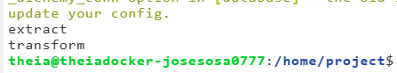

### **Practice exercise**

Write a DAG named ETL_Server_Access_Log_Processing.py.

* 1. Create the imports block.
  2. Create the DAG Arguments block. You can use the default settings
  3. Create the DAG definition block. The DAG should run daily.
  4. Create the download task. The download task must download the server access log file, which is available at the URL:

<https://cf-courses-data.s3.us.cloud-object-storage.appdomain.cloud/IBM-DB0250EN-SkillsNetwork/labs/Apache%20Airflow/Build%20a%20DAG%20using%20Airflow/web-server-access-log.txt>

* 1. Create the extract task.

The server access log file contains these fields.

* timestamp – TIMESTAMP
* latitude – float
* longitude – float
* visitorid - char(37accessed_from_mobile - boolean  
  f. browser_code - int

The extract task must extract the fields timestamp and visitorid.

* 1. Create the transform task. The transform task must capitalize the visitorid.
  2. Create the load task. The load task must compress the extracted and transformed data.
  3. Create the task pipeline block. The pipeline block should schedule the task in the order listed below:
* download
* extract
* transform
* load
  1. Submit the DAG.

# import the libraries

from datetime import timedelta

# The DAG object; we'll need this to instantiate a DAG

from airflow.models import DAG

# Operators; you need this to write tasks!

from airflow.operators.bash_operator import BashOperator

# This makes scheduling easy

from airflow.utils.dates import days_ago

#defining DAG arguments

# You can override them on a per-task basis during operator initialization

default_args = {

'owner': 'your_name',

'start_date': days_ago(0),

'email': ['your email'],

'retries': 1,

'retry_delay': timedelta(minutes=5),

}

# defining the DAG

# define the DAG

dag = DAG(

'ETL_Server_Access_Log_Processing',

default_args=default_args,

description='My first DAG',

schedule_interval=timedelta(days=1),

)

# define the tasks

# define the task 'download'

download = BashOperator(

task_id='download',

bash_command='curl "https://cf-courses-data.s3.us.cloud-object-storage.appdomain.cloud/IBM-DB0250EN-SkillsNetwork/labs/Apache%20Airflow/Build%20a%20DAG%20using%20Airflow/web-server-access-log.txt" -o web-server-access-log.txt',

dag=dag,

)

# define the task 'extract'

extract = BashOperator(

task_id='extract',

bash_command='cut -f1,4 -d"#" web-server-access-log.txt > /home/project/airflow/dags/extracted.txt',

dag=dag,

)

# define the task 'transform'

transform = BashOperator(

task_id='transform',

bash_command='tr "[a-z]" "[A-Z]" < /home/project/airflow/dags/extracted.txt > /home/project/airflow/dags/capitalized.txt',

dag=dag,

)

# define the task 'load'

load = BashOperator(

task_id='load',

bash_command='zip log.zip capitalized.txt' ,

dag=dag,

)

# task pipeline

download >> extract >> transform >> load

### **Airflow Logging and Monitoring**

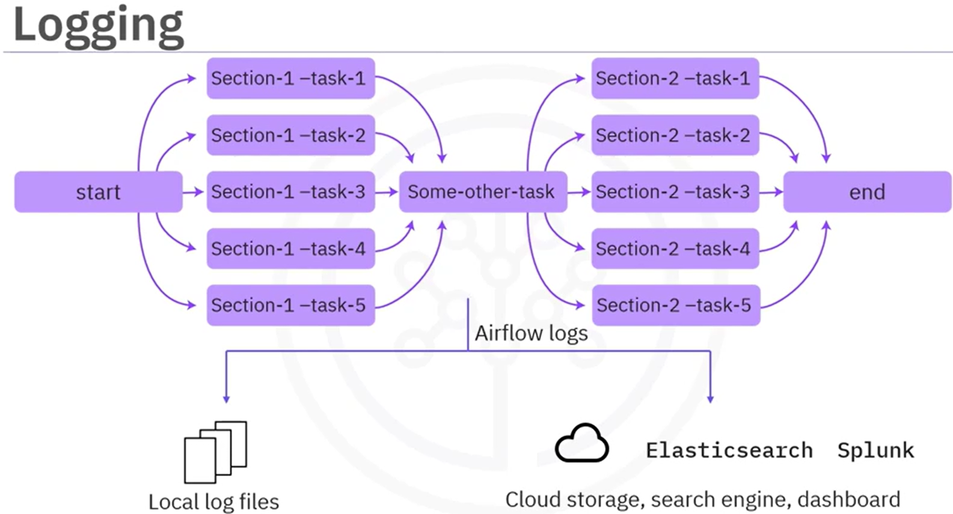

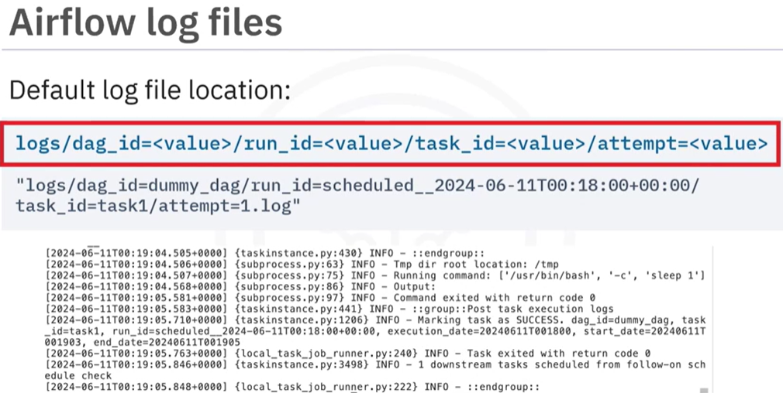

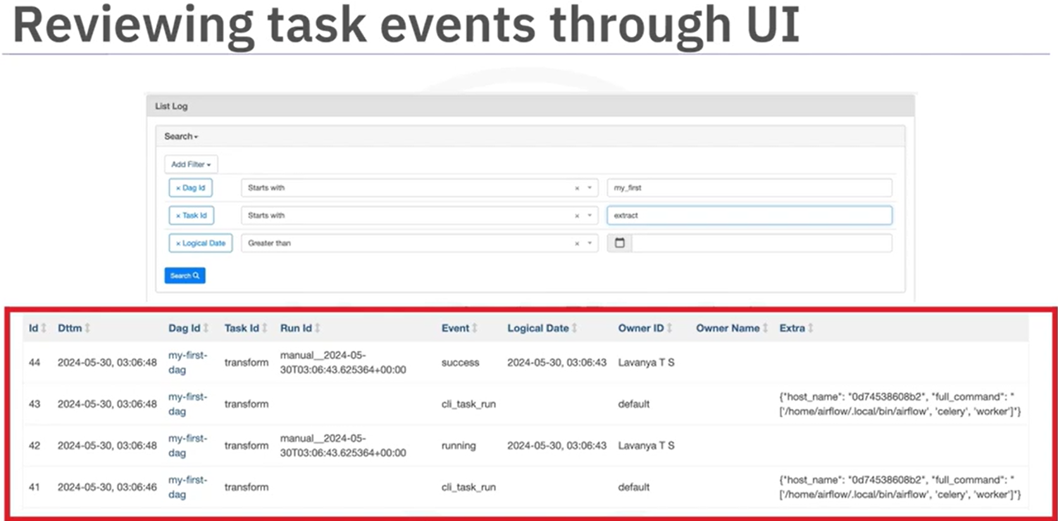

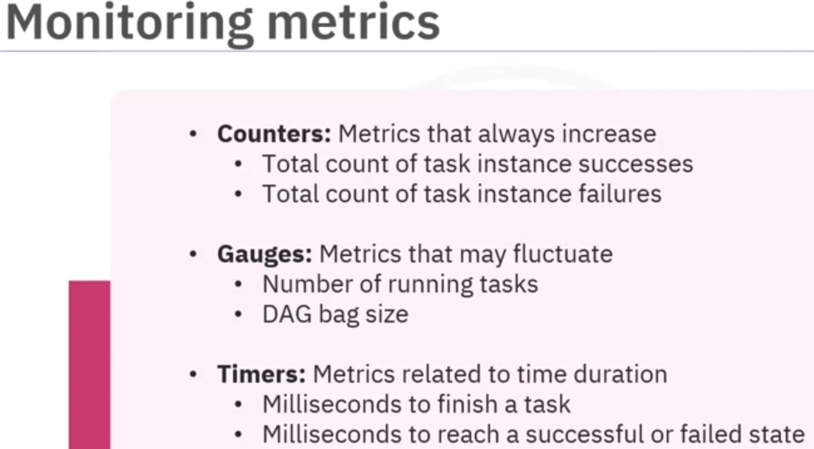

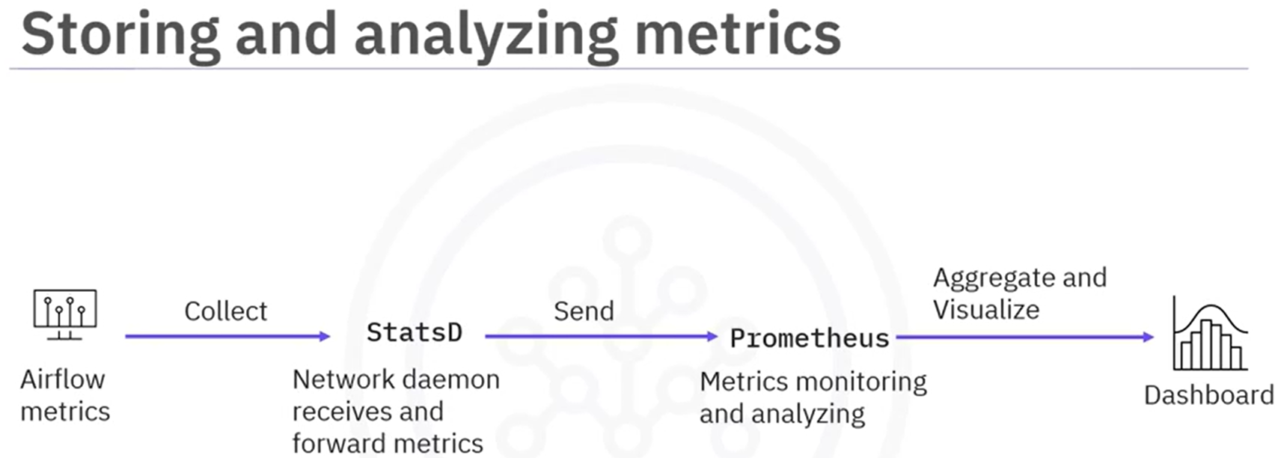

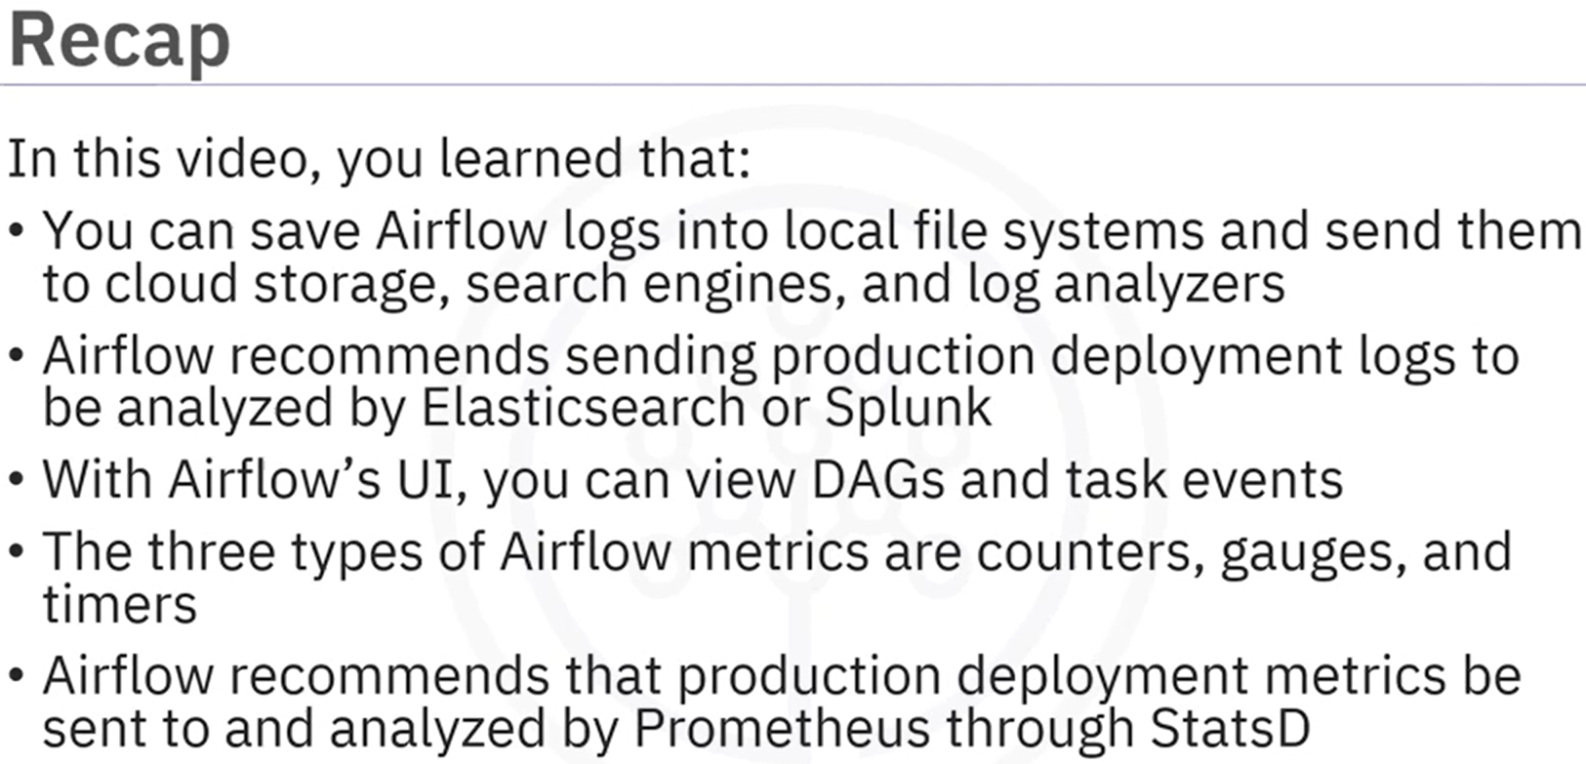

### Hands-on Lab: Monitoring a DAG

In this lab, you will work with the Airflow Web UI and CLi to explore the DAGs further. You will be exposed to using the interactive tools to search for DAGs, introduces to various views of the DAGS and how you can use this to explore the DAG workflow, the individual tasks in the workflow and view the outcome of the tasks.

After completing this lab you will be able to:

* Search for a DAG
* Pause/Unpause a DAG
* Get the Details of a DAG
* Explore grid view of a DAG
* Explore graph view of a DAG
* Explore Calendar view of a DAG
* Explore Task Duration view of a DAG
* Explore Details view of a DAG
* View the source code of a DAG
* Delete a DAG
  1. Start Apache Airflow and Open the Airflow Web UI
  2. For the purpose of monitoring, let's create a dummy DAG with three tasks
* Task1 does nothing but sleep for 1 second.
* Task2 sleeps for 2 seconds.
* Task3 sleeps for 3 seconds.

This DAG is scheduled to run every 1 minute.

Using Menu->File->New File create a new file named dummy_dag.py with:

# import the libraries

from datetime import timedelta

# The DAG object; we'll need this to instantiate a DAG

from airflow import DAG

# Operators; we need this to write tasks!

from airflow.operators.bash_operator import BashOperator

# This makes scheduling easy

from airflow.utils.dates import days_ago

#defining DAG arguments

# You can override them on a per-task basis during operator initialization

default_args = {

'owner': 'Your name',

'start_date': days_ago(0),

'email': ['your email'],

'retries': 1,

'retry_delay': timedelta(minutes=5),

}

# defining the DAG

dag = DAG(

'dummy_dag',

default_args=default_args,

description='My first DAG',

schedule_interval=timedelta(minutes=1),

)

# define the tasks

# define the first task

task1 = BashOperator(

task_id='task1',

bash_command='sleep 1',

dag=dag,

)

# define the second task

task2 = BashOperator(

task_id='task2',

bash_command='sleep 2',

dag=dag,

)

# define the third task

task3 = BashOperator(

task_id='task3',

bash_command='sleep 3',

dag=dag,

)

# task pipeline

task1 >> task2 >> task3

Set the AIRFLOW_HOME directory.

*export AIRFLOW_HOME=/home/project/airflow*

Submitting a DAG is as simple as copying the DAG python file into dags folder in the AIRFLOW_HOME directory. Open a terminal and run the command below to submit the DAG.

*cp dummy_dag.py $AIRFLOW_HOME/dags*

Verify that our DAG actually got submitted. Run the command below to list out all the existing DAGs.

*airflow dags list*

*airflow dags list | grep dummy_dag*

*airflow tasks list dummy_dag*

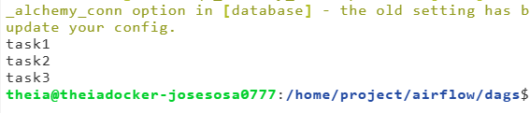

* 1. In the Web-UI, identify the Search DAGs text box as shown in the image below and type dummy_dag in the textbox and press enter.

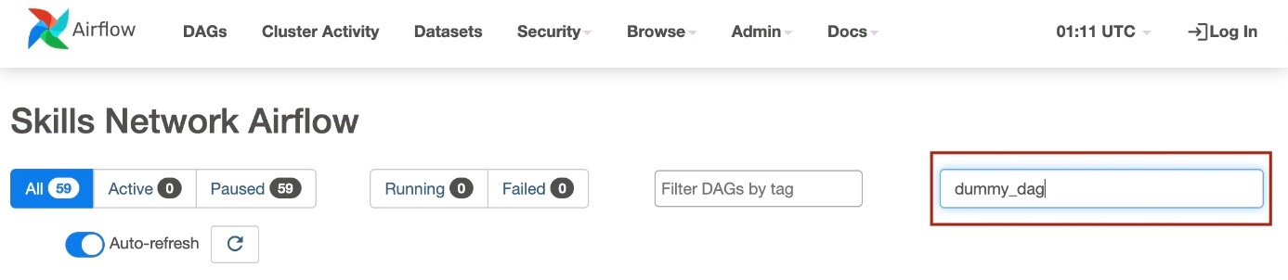

Note: It may take a couple of minutes for the dag to appear here. If you do not see your DAG, please give it a minute and try again.

You should see the dummy_dag listed as seen in the image below:

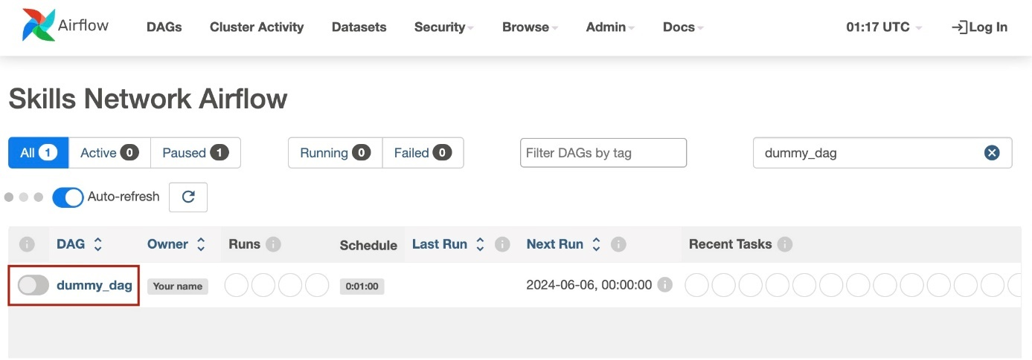

* 1. Unpause the DAG using the Pause/Unpause button.

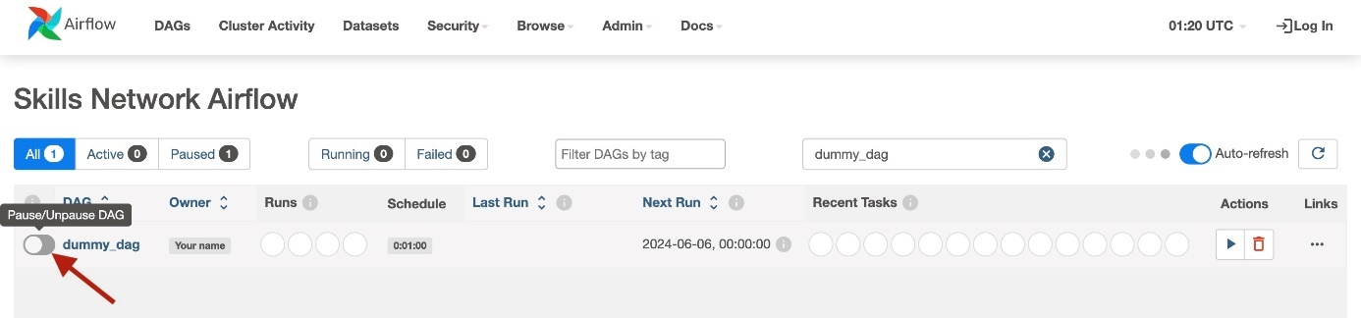

You can see the following details in this view.

* Owner of the DAG
* How many times this DAG has run
* Schedule of the DAG
* Last run time of the DAG
* Recent task status

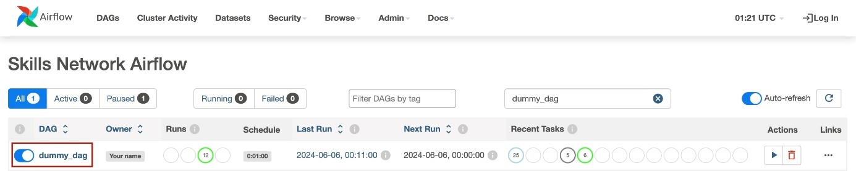

* 1. Calender view

The calender view gives you an overview of all the dates when this DAG was run along with its status as a color code.

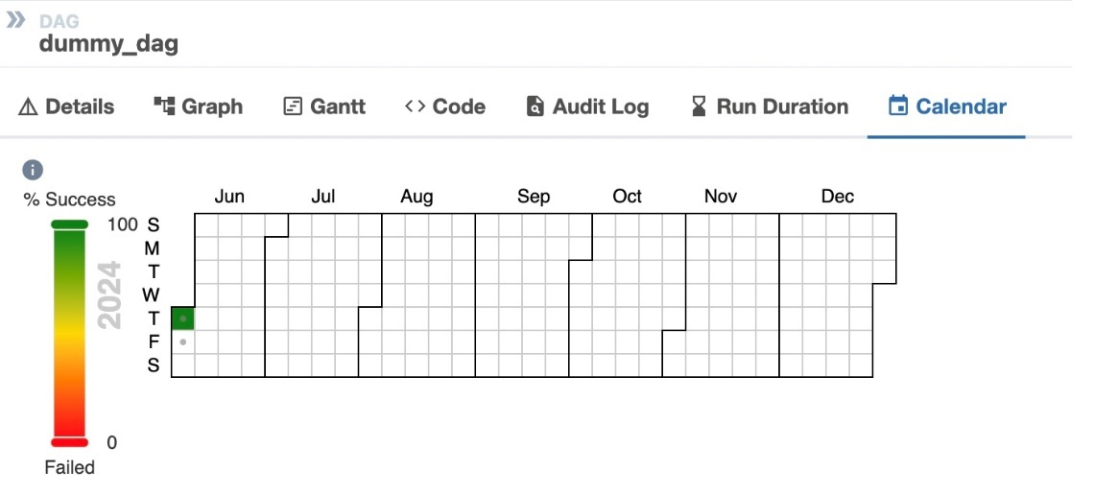

* 1. Delete a tag

To delete a DAG click on the delete button.

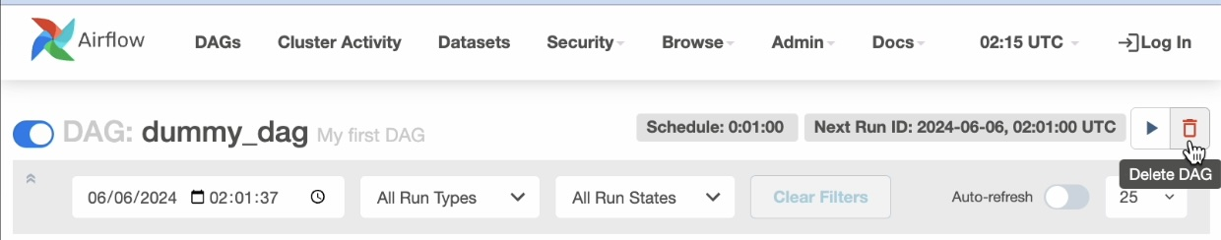

### **Summary and highlights**

* Apache Airflow is scalable, dynamic, extensible, and lean
* The five main features of Apache Airflow are pure Python, useful UI, integration, easy to use, and open-source
* A common use case is that Apache Airflow defines and organizes machine learning pipeline dependencies
* Tasks are created with Airflow operators
* Pipelines are specified as dependencies between tasks
* Pipeline DAGs defined as code are more maintainable, testable, and collaborative
* Apache Airflow has a rich UI that simplifies working with data pipelines
* You can visualize your DAG in graph or grid mode
* Key components of a DAG definition file include DAG arguments, DAG and task definitions, and the task pipeline
* Set a schedule to specify how often to re-run your DAG
* You can save Airflow logs into local file systems and send them to cloud storage, search engines, and log analyzers
* Airflow recommends sending production deployment logs to be analyzed by Elasticsearch or Splunk
* You can view DAGs and task events with Airflow’s UI
* The three types of Airflow metrics are counters, gauges, and timers
* Airflow recommends that production deployment metrics be sent to and analyzed by Prometheus via StatsD

### **Practice Quiz: Building Data Pipelines using Airflow**

**Question 1. What is the primary purpose of Apache Airflow?**

Data orchestration

Data streaming solution

Workflow manager

Transformation utility

**Question 2. What does acyclic in Directed Acyclic Graph (DAG) mean?**

Parallel edges.

Repeated nodes

Two nodes

No loops

**Question 3. Which of the following Apache Airflow UI views will you use to see the tasks and dependencies for your DAG?**

Graph view

DAGs view

Last run view

Grid view

**Question 4. Apache Airflow DAGs are Python scripts that consist of specific Operators. Which of the following operators can be used specifically to call Python functions?**

ImportOperator

HttpOperator

PythonOperator

BashOperator

**Question 5. Which of the options allows you to view the logs of a specific task on the Web UI?**

Audit logs view

Task details view

Graph view for a specific task

Hovering over the Grid view

### Graded Quiz: Building Data Pipelines using Airflow

**Question 1. Which of these statements is TRUE about Apache Airflow?**

Tasks in Apache Airflow can only be schedule and cannot be manually triggered.

Apache Airflow is a workflow management tool.

Apache Airflow is a data pipeline orchestration tool.

You can only use one kind of operator in one DAG.

**Correct**

Correct! Apache Airflow is a great open-source workflow orchestration tool that is supported by an active community.

**Question 2. Which component in the Apache Airflow architecture takes care of executing the tasks?**

The scheduler

The web server

The worker

The meta database

**Question 3. In the DAG definition Python script, which of the following logical blocks might contain the ‘from airflow import DAG’ command?**

Task pipeline

DAG definition

DAG arguments

Library imports

**Question 4. You have both operators and sensors that you can use with DAG for tasks. Which is of these operators can you use to run the script `datatranfer.sh`?**

Python

Bash

Http

TriggerDagRunOperator

**Question 5. Which of the following advantages of Apache Airflow expressing workflows as code enables Git to track them?**

Collaborative

Maintainable

Testable

Versionable

**Question 6. Where can you access the 'Task Instance Context Menu' from?**

Gantt

Code view

Any of the DAG views that display details

Any of the DAG views that display task instances

**Question 7. The final block in your Airflow pipeline script is where you specify the dependencies for your workflow. How do you specify the order of task 1 and task 2?**

>

>>

>=

//

**Question 8. Which block specifies the DAG start date?**

DAG definition

Task definitions

Task pipeline

DAG arguments

**Question 9. Which of the following Airflow metrics could fluctuate?**

Timers

Gauges

Counters

Air flows

**Question 10. Which of the following Apache Airflow basic components serves the interactive UI?**

Executor

DAG directory

Scheduler

Web server

## Module 4. Distributed Event Streaming Platform Components

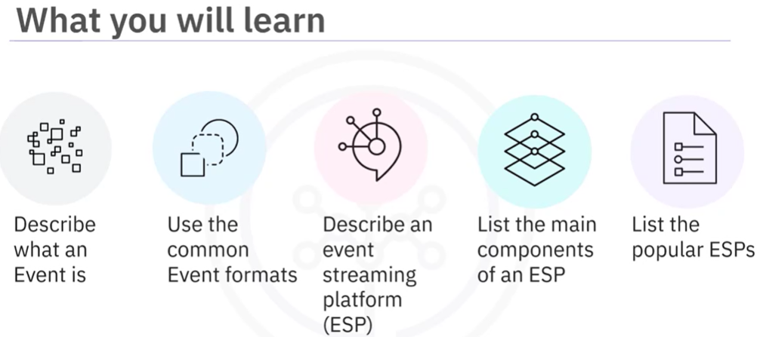

An event normally means something worth noticing is happening.

In the context of event streaming, an event is a type of data which describes the entity's observable state updates over time.

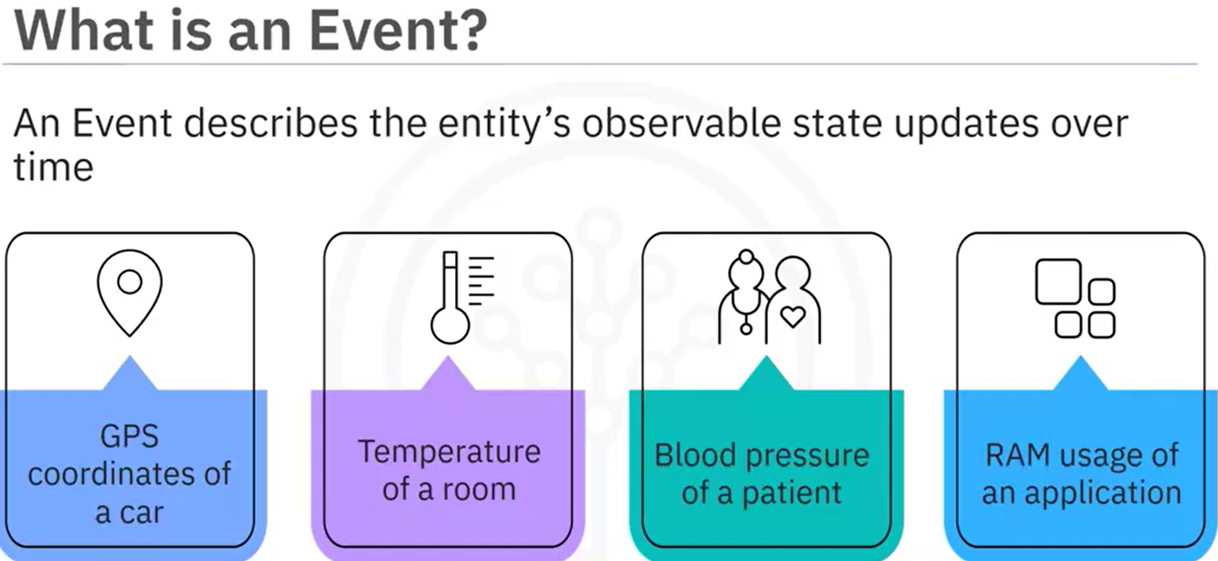 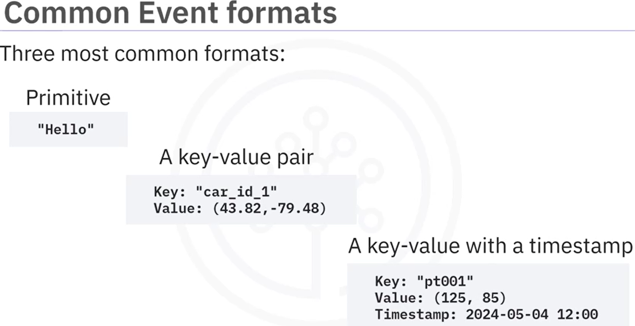

The continuous event transportation between an event source and an event destination is called event streaming.

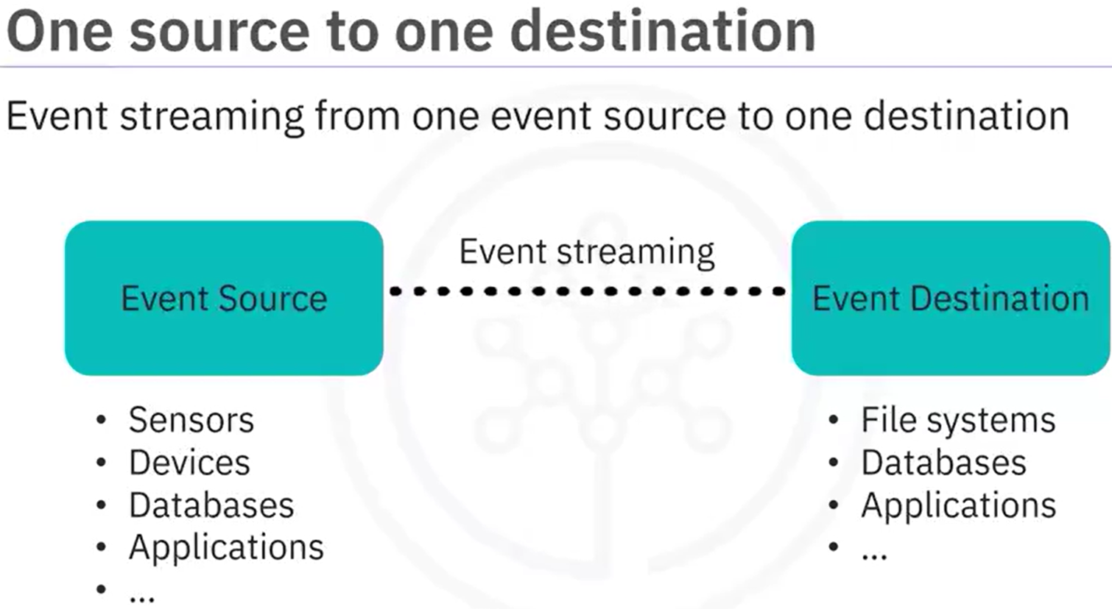

After all you have learned about ETL so far, you may think that to implement such an ETL process between one event source to one event destination should be straightforward. However, what if we have multiple different event sources and destinations?

In a real-world scenario, event streaming can be really complicated with multiple distributed event sources and destinations, as data transfer pipelines may be based on different communication protocols, such as FTP, file transfer protocol, HTTP, Hypertext Transfer Protocol, JDBC, Java database connectivity, SCP, secure copy, and so on.

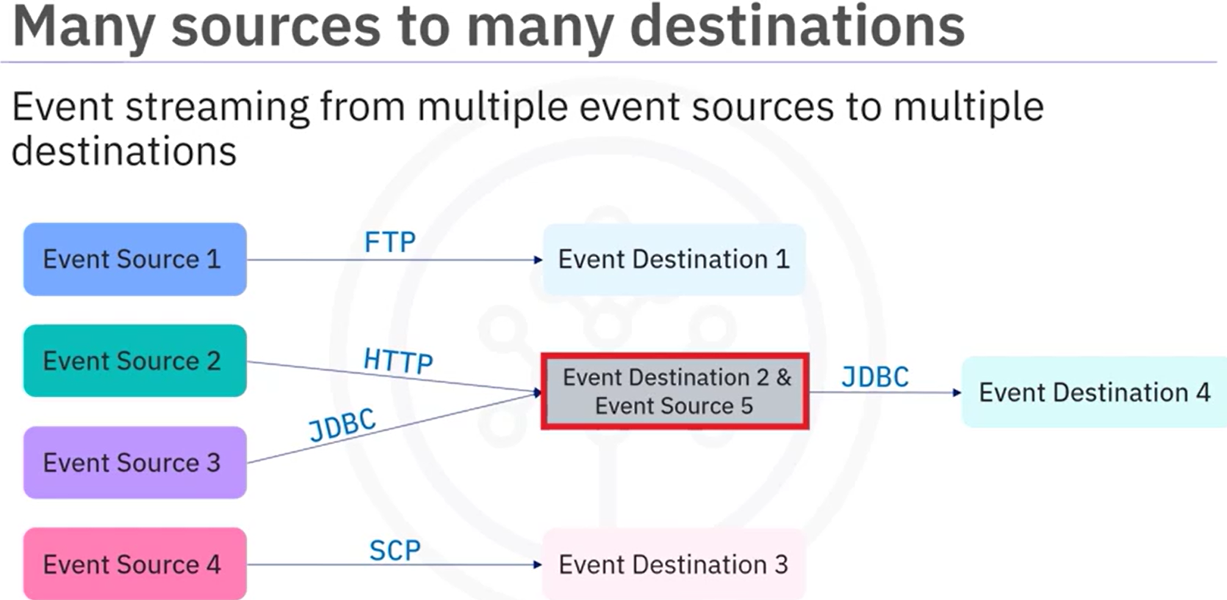

To overcome such a challenge of handling different event sources and destinations, we will need to employ the event streaming platform. An ESP acts as a middle layer among various event sources and destinations and provides a unified interface for handling event-based ETL. As such, all event sources only need to send events to an ESP instead of sending them to the individual event destination. On the other side, event destinations only need to subscribe to an ESP and just consume the event sent from the ESP instead of the individual event source.

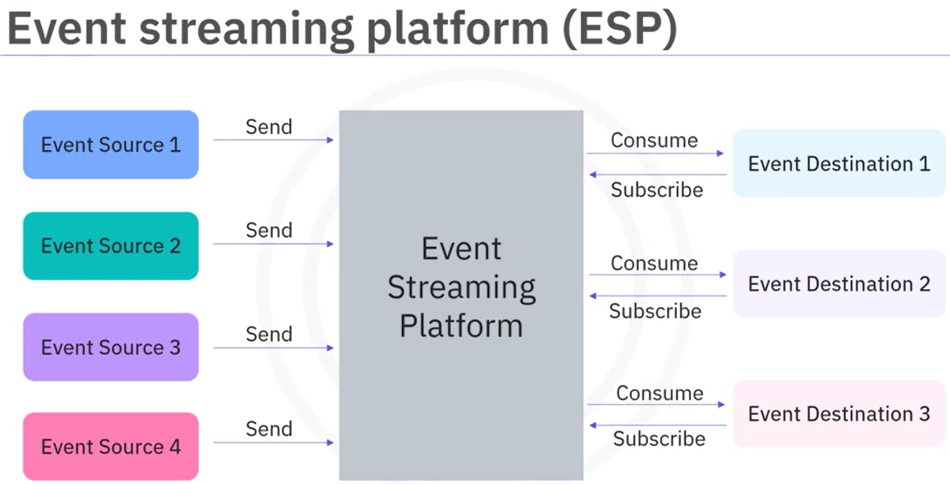

Different ESPs may have different architectures and components. Here we show you some common components included in most ESP systems:

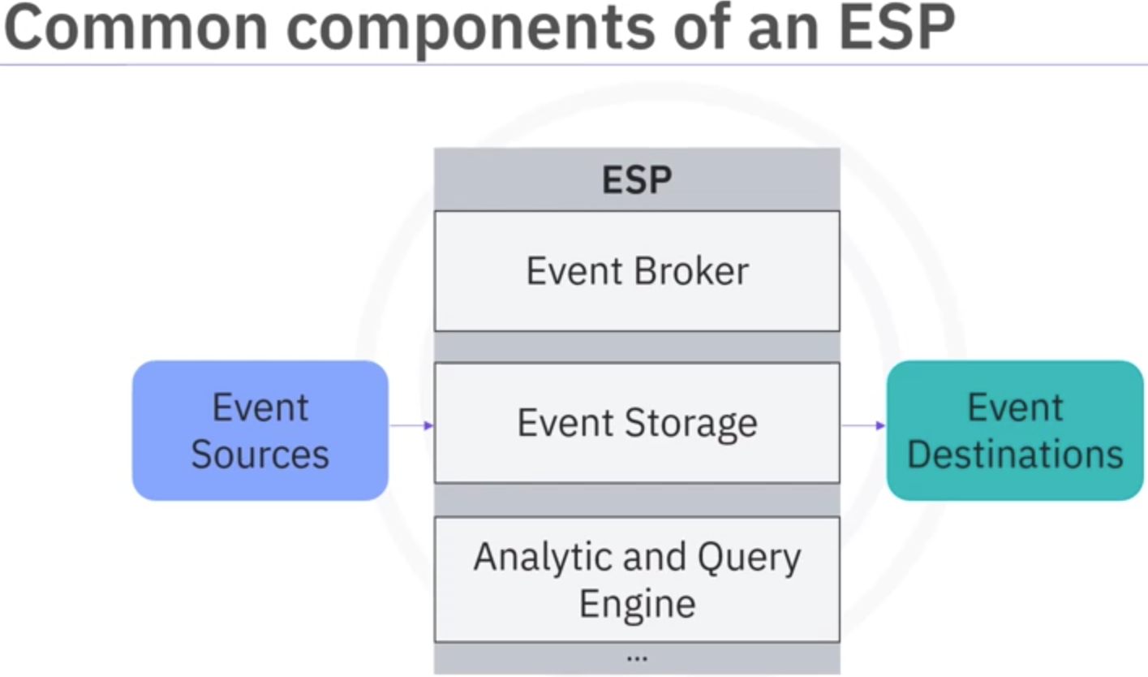

The first and foremost component is the event broker, which is designed to receive and consume events, it is the core component of an ESP.

The second common component of an ESP is event storage, which is used for storing events being received from event sources.

The third common component is the analytic and query engine, which is used for querying and analyzing the stored events

**The event broker** normally contains three subcomponents**, ingester, processor,** and **consumption.**

The ingester is designed to efficiently receive events from various event sources.

The processor performs operations on data such as serializing and deserializing, compressing and decompressing, encryption and decryption, and so on.

The consumption component retrieves events from event storage and efficiently distributes them to subscribed event destinations

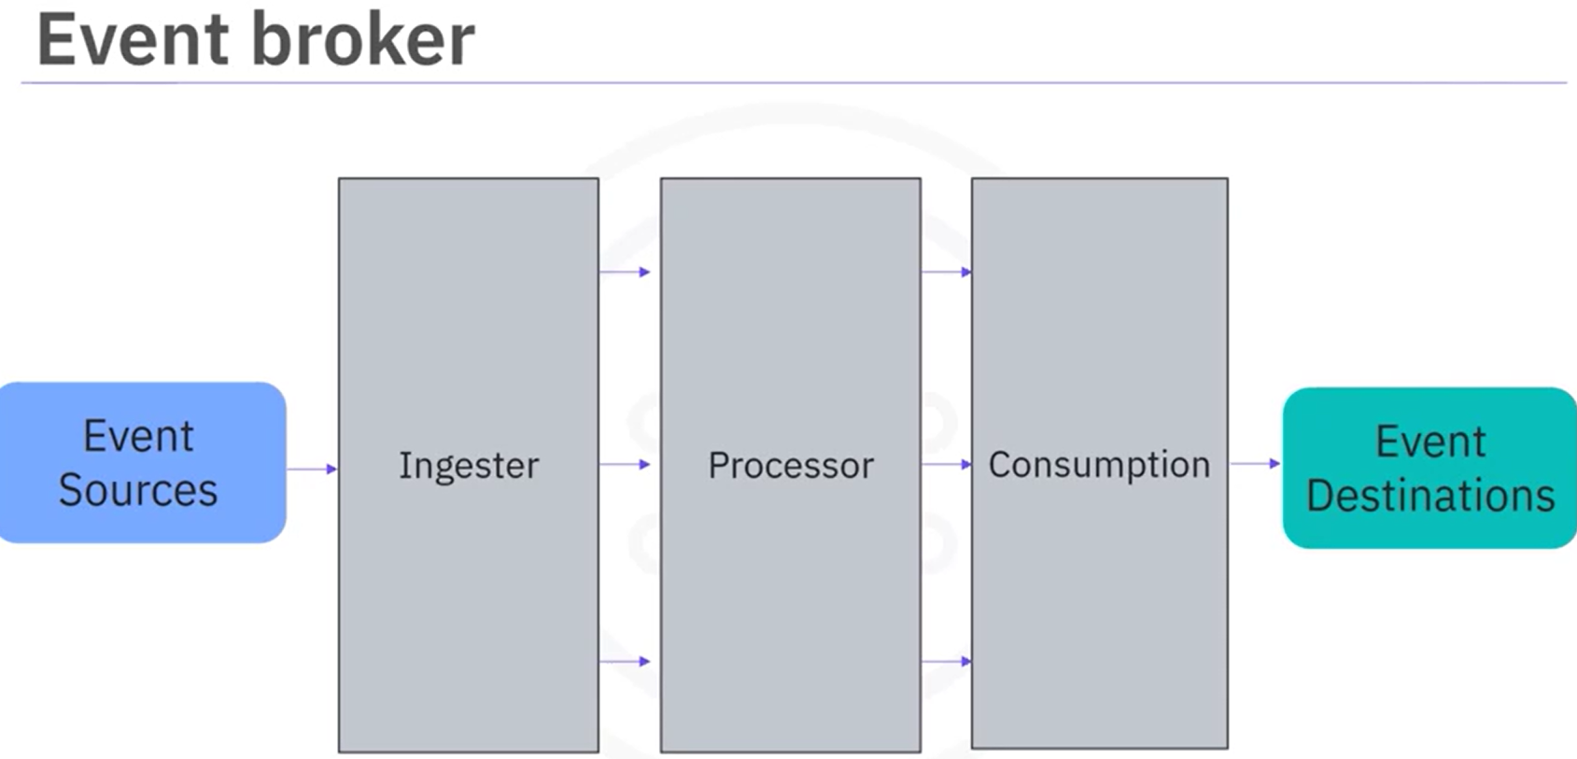

There are many ESP solutions, including Apache Kafka, Amazon Kinesis, Apache Flink, IBM Event Stream, Azure Event Hub, and so on. Each has its unique features and application scenarios. Among these ESPs, Apache Kafka is probably the most popular one.

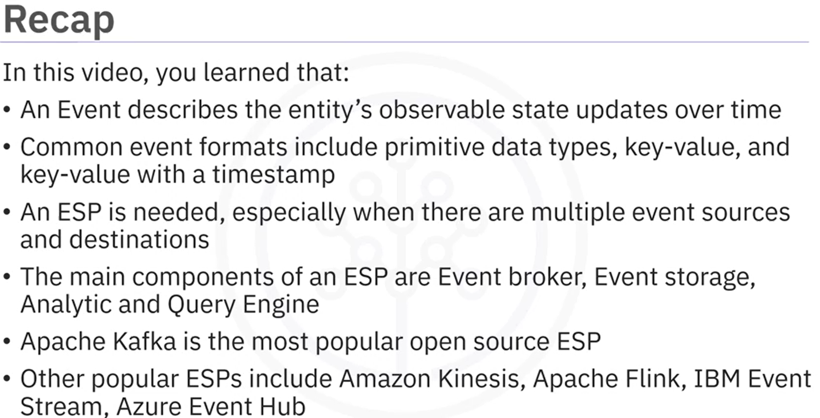

### **Apache Kafka Overview**

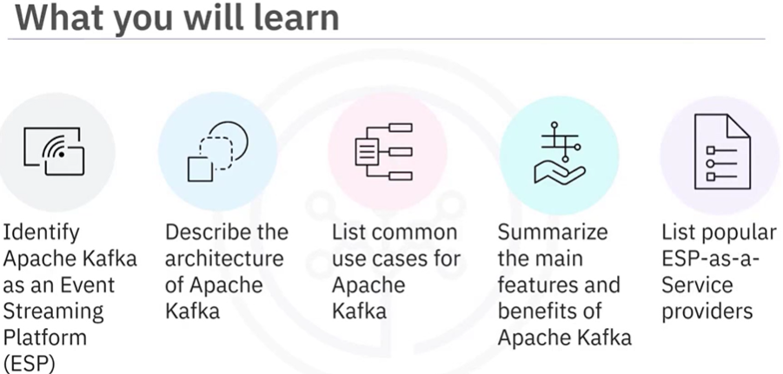

Kafka was originally used to track user activities such as keyboard strokes, mouse clicks, page views, searches, gestures, screen time, and so on. But now Kafka is also suitable for all kinds of metric streaming such as sensor readings, GPS, and hardware and software monitoring.

For enterprise applications and infrastructure with a huge number of logs, Kafka can be used to collect and integrate them into a centralized repository. For banks, insurance, or fintech companies, Kafka is widely used for payments and transactions.

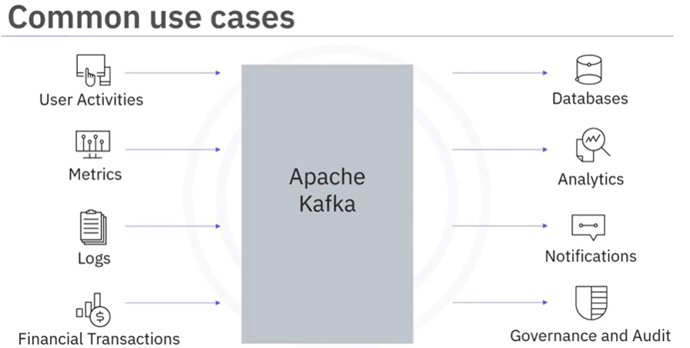

Kafka is a distributed, real time event streaming platform that adheres to client server architecture. Kafka runs as a cluster of broker servers, acting as the event broker to receive events from the producers, store the streams of records, and distribute events. It also has servers that run Kafka Connect to import and export data as event streams. Please note that all the brokers before version 2.8 relied on another distributed system called Zookeeper for management and to ensure all brokers work in an efficient and collaborative way. However, Kafka Raft, pronounced as KRaft, is now used to eliminate Kafka's reliance on Zookeeper for metadata management.

Using Kafka controllers, producers send or publish data to the topic, and the consumers subscribe to the topic to receive data. Kafka uses a transmission control protocol, TCP based network communication protocol, to exchange data between clients and servers. For the client side, Kafka provides different types of clients such as Kafka command line interface, CLI. A collection of shell scripts to communicate with the Kafka server, several high level programming APIs such as Java, Scala, Python, Go, C, and C++, rest APIs, and some specific third party clients made by the Kafka community.

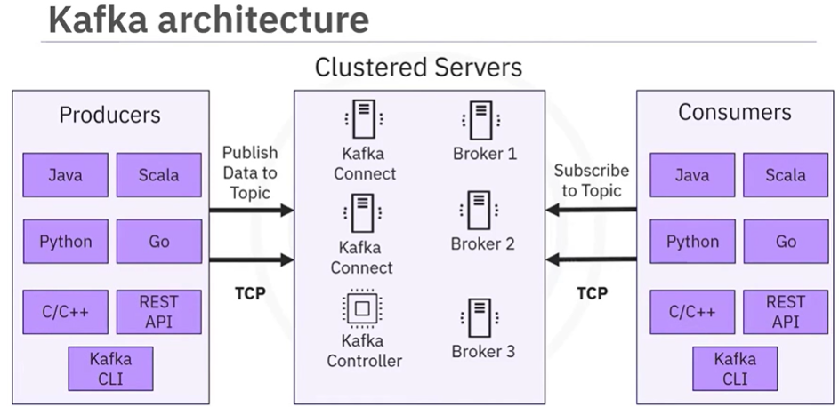

A Kafka cluster normally has multiple event brokers which can handle event streaming in parallel.

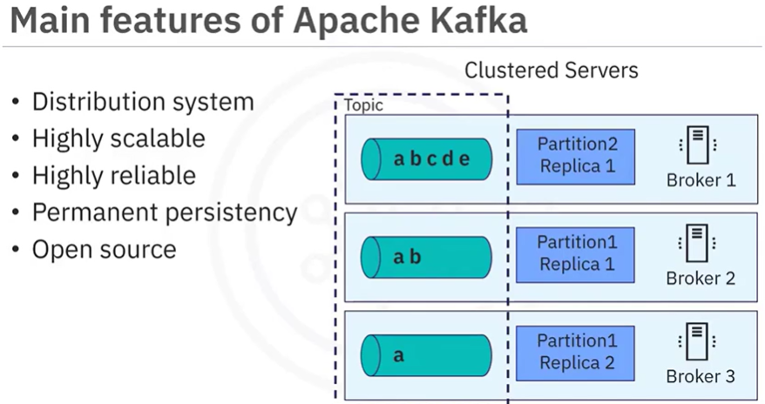

Even though Kafka is open source and well documented, it is still challenging to configure and deploy Kafka without professional assistance. Fortunately, several commercial service providers offer an on-demand ESP as a service to meet your streaming requirements.

Some well-known ESP providers include Confluent Cloud, which provides customers with fully managed Kafka services either on premises or on cloud. IBM event streams, which is also based on Kafka and provides many add-on services such as enterprise-grade security, disaster recovery, and 24/7 cluster monitoring. Amazon managed streaming for Apache Kafka, which is also a fully managed service to facilitate the build and deployment of Kafka.

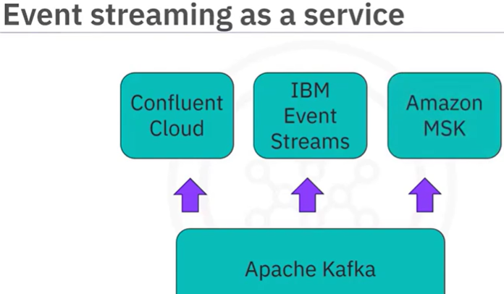 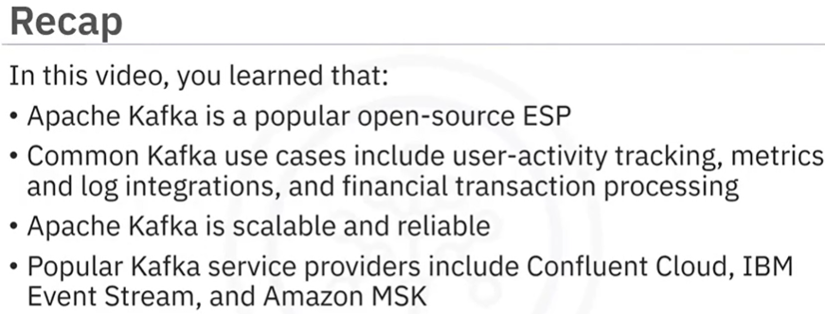

### **Building Event Streaming Pipelines using Kafka**

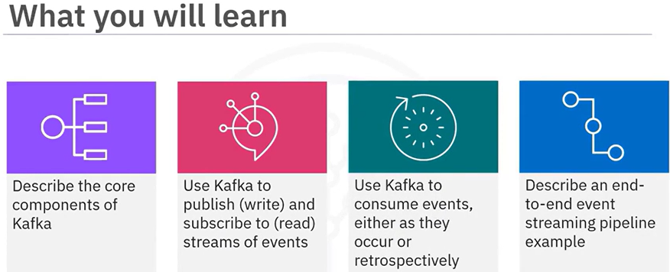

A Kafka cluster contains one or many brokers. You may think of a Kafka broker as a dedicated server to receive, store, process, and distribute events. Brokers are synchronized and use KRaft controller nodes that use the consensus protocol to manage the Kafka metadata log that contains information about each change to the cluster metadata.

Brokers manage to save published events into topics and distribute the events to subscribed consumers.

Example:

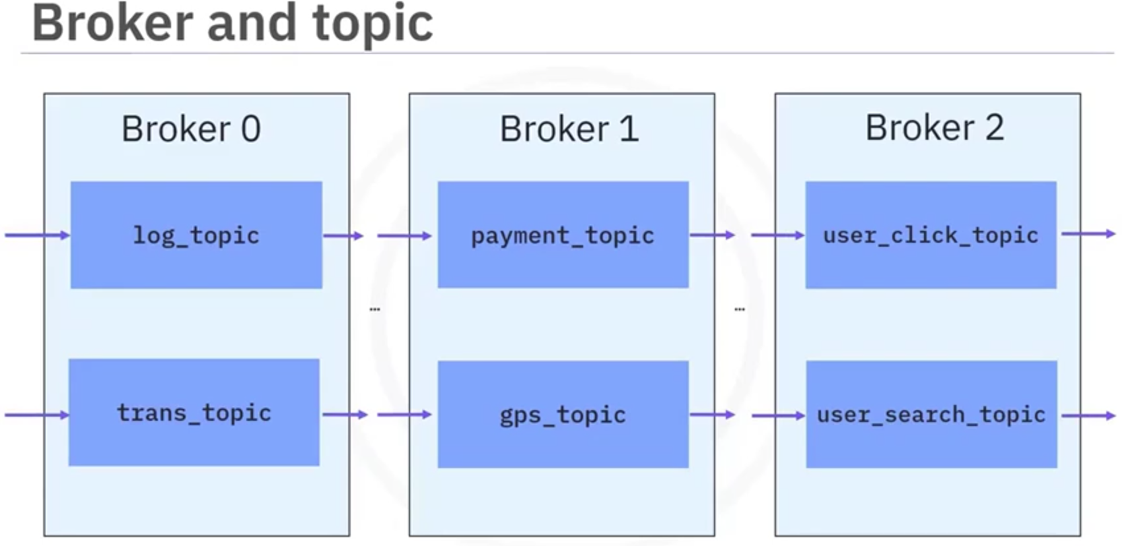

Even if some brokers are down, kafka clients are still able to work with the target topics replicated in other working brokers. For example, a log_topic has been separated into two partitions (0,1) and a user topic has been separated into two partitions (0,1) and each topic partitioned is duplicated into two replications and stored in different brokers.

The Kafka CLI, or command-line interface client, provides a collection of powerful script files for users to build an event streaming pipeline.

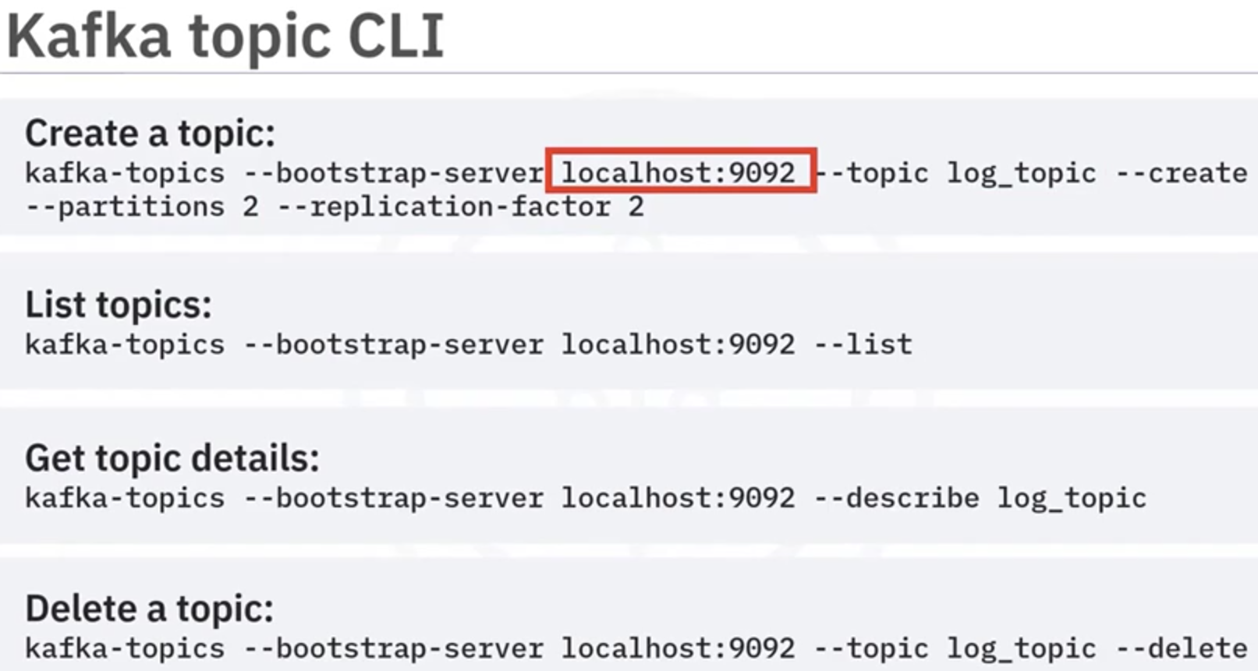

Publishing events using Kafka producers:

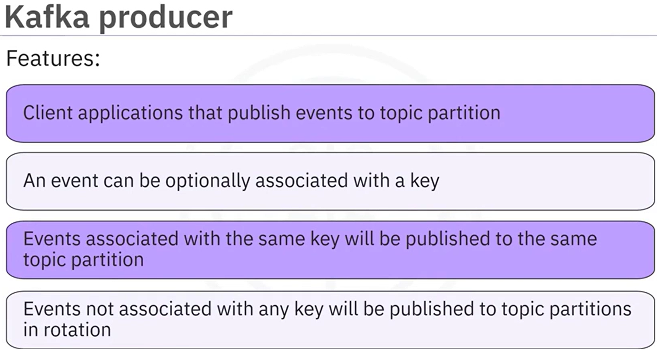

Let's see how you can publish events to topic partitions using the following example. Suppose you have an Event Source 1 which generates various log entries and an Event Source 2 which generates user activity tracking records. Then you can create a Kafka producer to publish log records to log topic partitions and a user producer to publish user activity events to user topic partitions, respectively. When you publish events in producers, you can choose to associate events with a key, for example, an application name or a user ID.

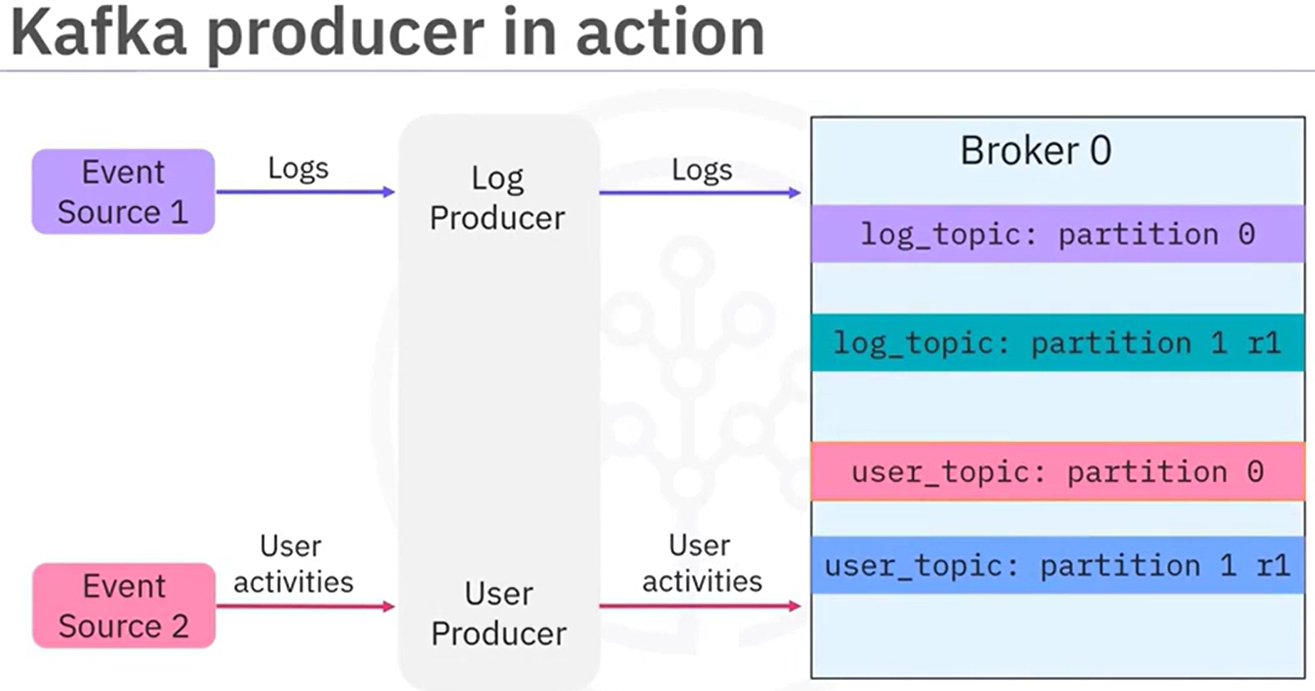

Similar to the Kafka topic CLI, Kafka provides the Kafka producer CLI for users to manage producers.

Here you start a producer and point it to the log_topic. Then you can type some messages in the console to start publishing events. For example, log1, log2, and log3:

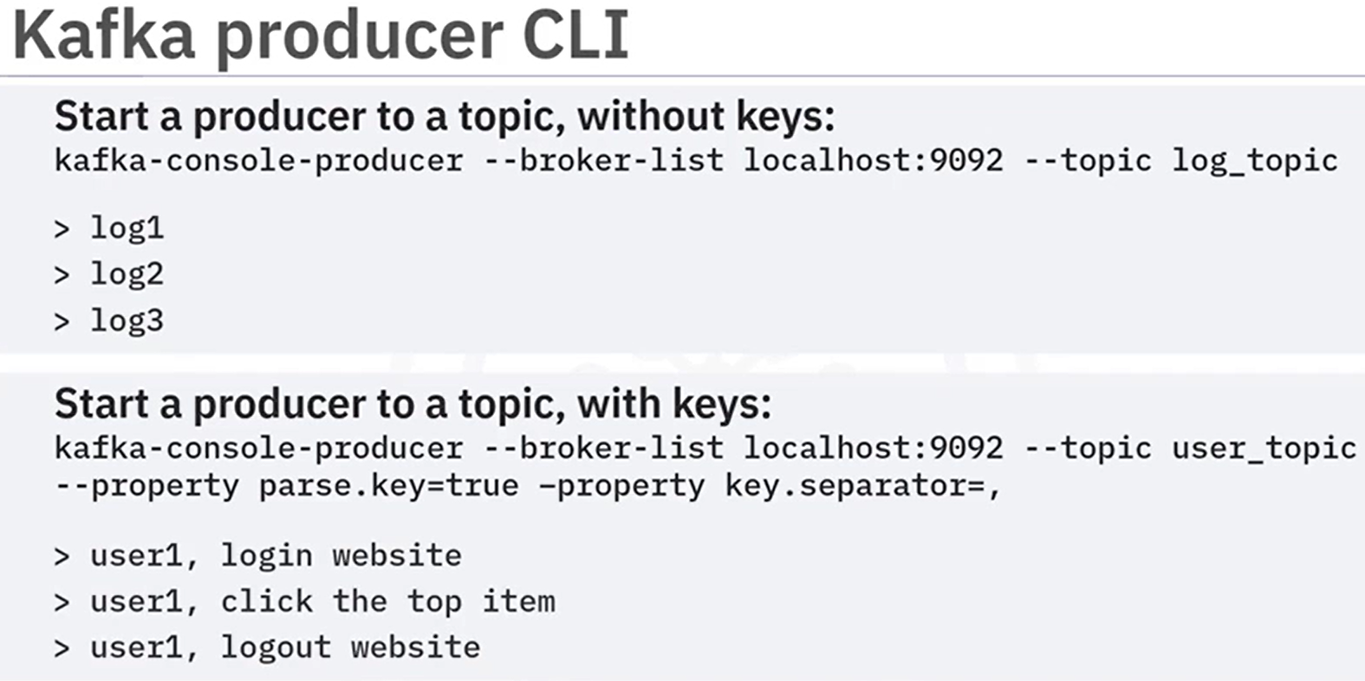

You can provide keys to events to make sure the events with the same key will go to the same partition. Here you are starting a producer to user_topic with the parse.key option to be true and you also specify the key.separator to be comma. Then you can write messages as follows, key: user1, value: login website, key: user1, value: click the top item and key: user1, value: logout website. Accordingly, all events about user1 will be saved in the same partition to facilitate the reading for consumers



Once events are published and properly stored in topic partitions, you can create consumers to read them. Consumers are client applications that can subscribe to topics and read the stored events.

Consumers read data from topic partitions in the same order as they are published. Consumers also store an offset for each topic partition as the last read position. With the offset, consumers are guaranteed to read events as they occur. A playback is also possible by resetting the offset to zero. This way, the consumer can read all events in the topic partition from the beginning. In Kafka, producers and consumers are fully decoupled. As such, producers don't need to synchronize with consumers, and after events are stored in topics, consumers can have independent schedules to consume them.

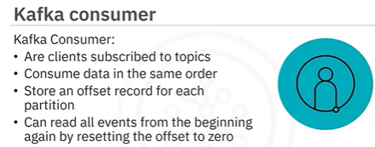

To read published log and user events from topic partitions, you will need to create log and user consumers and make them subscribe to corresponding topics. Then Kafka will push the events to those subscribed consumers. Then the consumers will further send to event destinations.

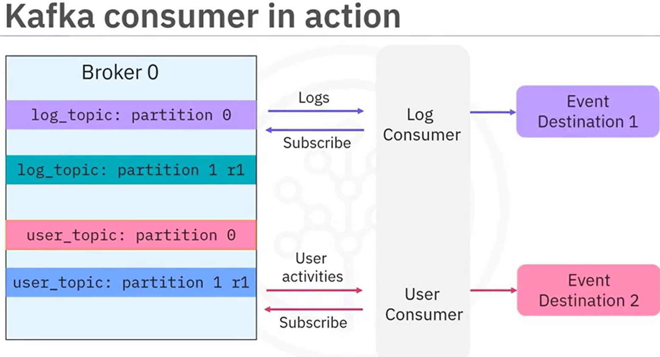

To start a consumer is also easy using the Kafka consumer script.

Example: To read events from the log_topic you just need to run the Kafka console consumer script and specify a Kafka cluster and the topic to subscribe to. Here you can subscribe to and read events from the topic log_topic.

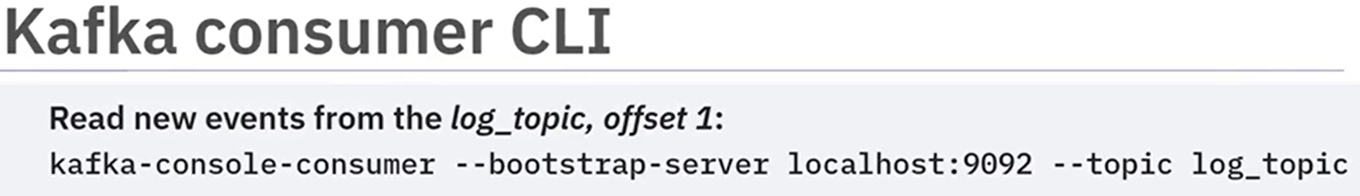

Then, the started consumer will read only the new events starting from the last partition offset.

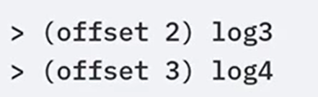

After those events are consumed, the partition offset for the consumer will also be updated and committed back to Kafka.

Very often a user wants to read all events from the beginning as a playback of all historical events. To do so, you just need to add the **from-beginning** option. Now you can read all events starting from offset 0.

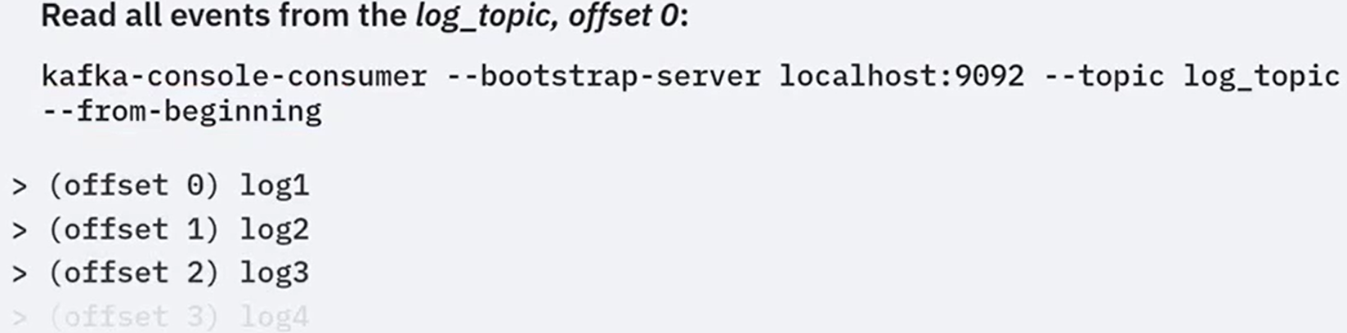

**Let's have a look at a more concrete example to help you understand how to build an event streaming pipeline end to end.**

Suppose you want to collect and analyze weather and Twitter event streams so that you can correlate how people talk about extreme weather on Twitter. Here you can use two event sources:

- IBM weather API to obtain real time and forecasted weather data in JSON format.

- Twitter API to obtain real-time tweets and mentions also in JSON format.

To receive weather and Twitter JSON data in Kafka, you need to create a weather topic and a Twitter topic in a Kafka cluster with some partitions and replications.

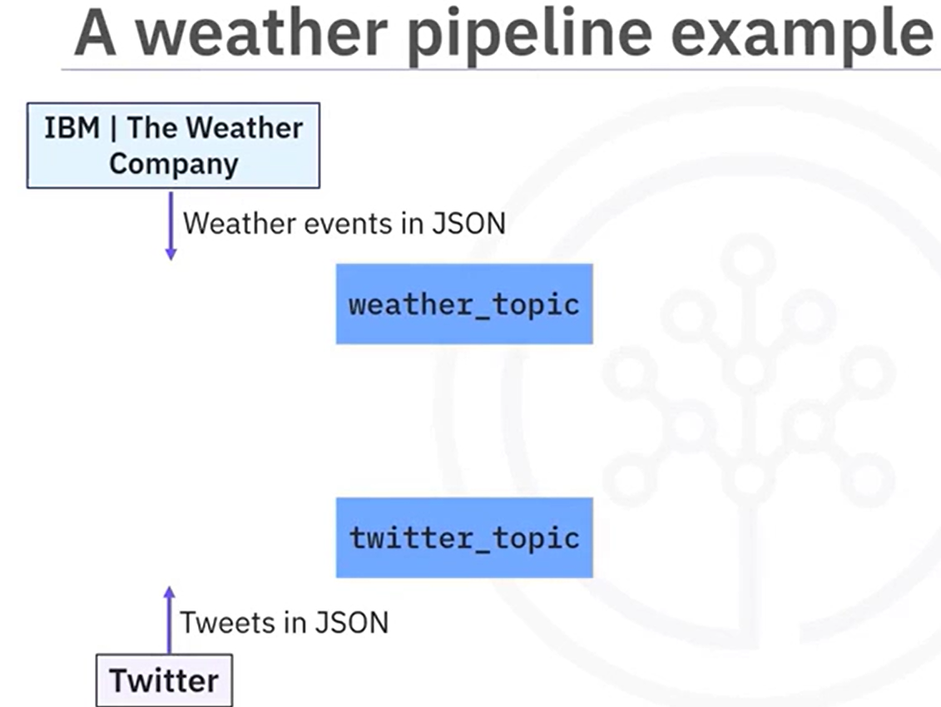

To publish weather and Twitter JSON data to the two topics, you need to create a weather producer and a Twitter producer. The event's JSON data will be serialized into bytes and saved in Kafka topics.

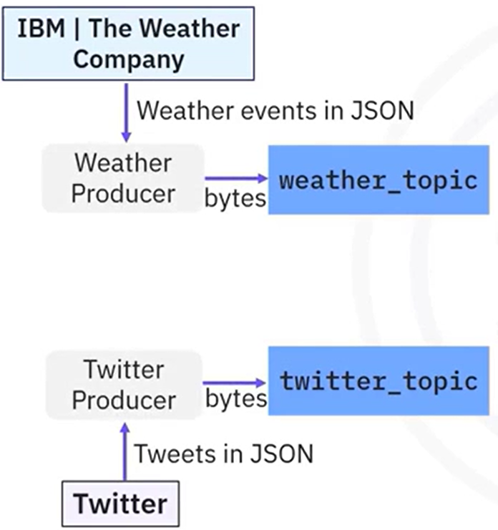

To read events from the two topics, you need to create a weather consumer and a Twitter consumer. The bytes stored in Kafka topics will be deserialized into event JSON data.

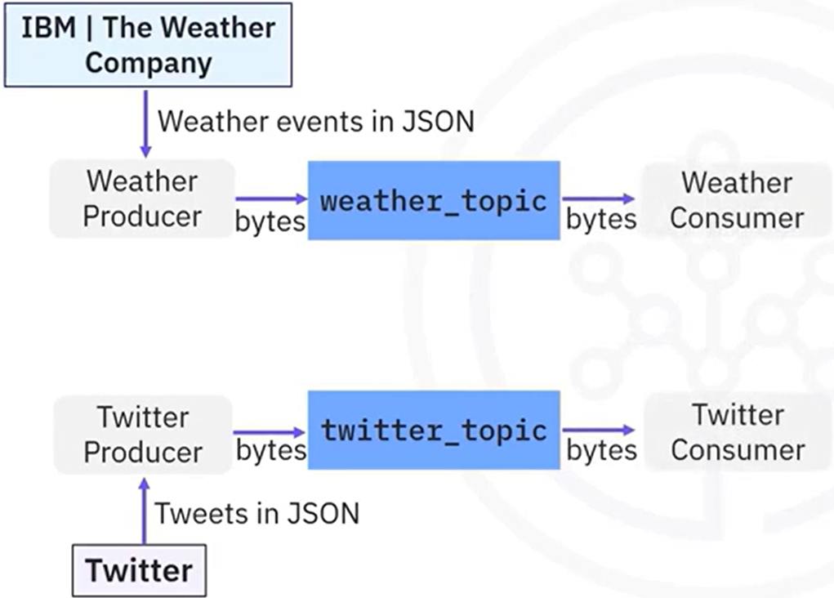

If you now want to transport the weather and Twitter event JSON data from the consumers to a relational database, you will use a DB writer to parse those JSON files and create database records, and then you can write those records into a database using SQL insert statements.

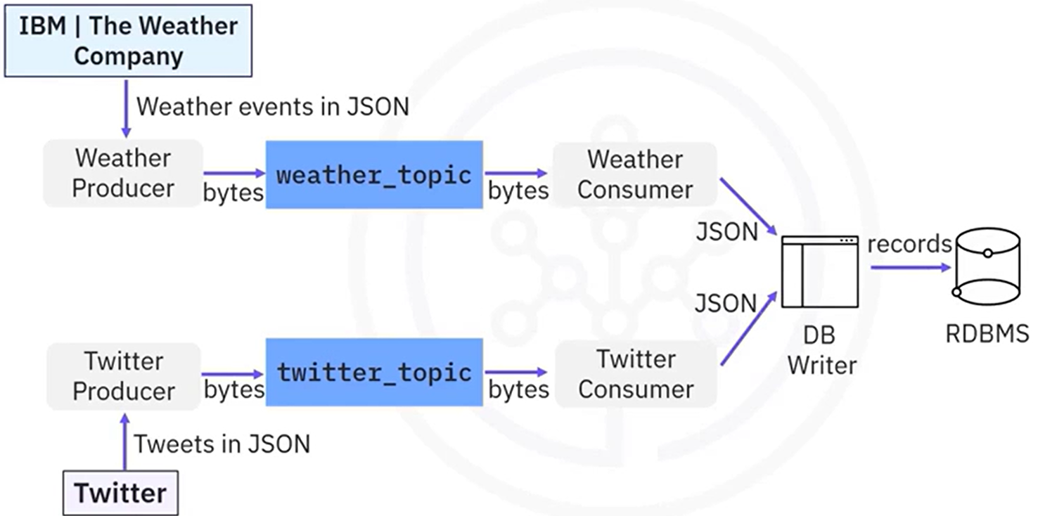

Finally, you can query the database records from the relational database and visualize and analyze them in a dashboard to complete the end-to-end pipeline:

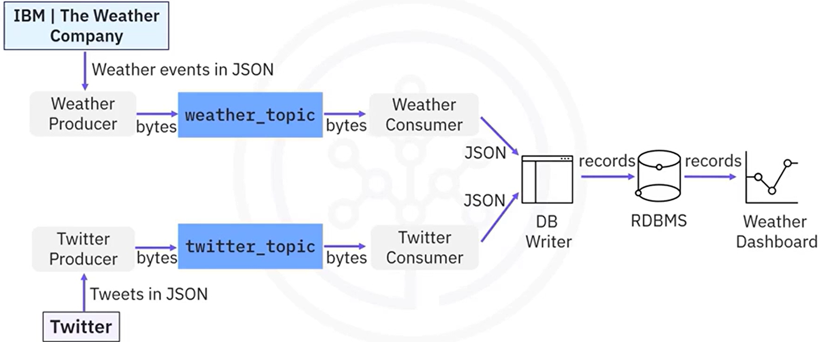

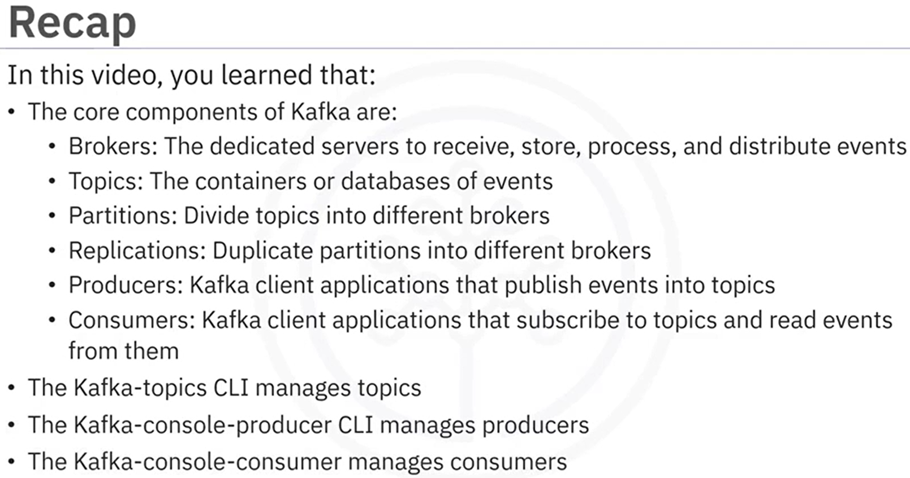

### **Kafka Streaming Process**

En la transmisión de eventos, además de transportar datos, los ingenieros de datos también necesitan procesarlos mediante, por ejemplo, filtrado, agregación y mejora. Cualquier aplicación desarrollada para procesar flujos se denomina aplicación de procesamiento de flujos. Para las aplicaciones de procesamiento de flujo basadas en Kafka, una forma sencilla es implementar un procesador de datos ad hoc para leer eventos de un tema procesarlos, y publicarlos en otro tema.

Let's look at an example. You first request raw weather JSON data from a weather API, and you start a weather producer to publish the raw data into a raw_weather_topic. Then you start a consumer to read the raw weather data from the weather topic. Next, you create an ad hoc data processor to filter the raw weather data to only include extreme weather events, such as very high temperatures. Such a processor could be a simple script file or an application which works with Kafka clients to read and write data from Kafka. Afterwards, the processor sends the processed data to another producer and it gets published to a processed_weather_topic. Finally, the processed weather data will be consumed by a dedicated consumer and sent to a dashboard for visualization.

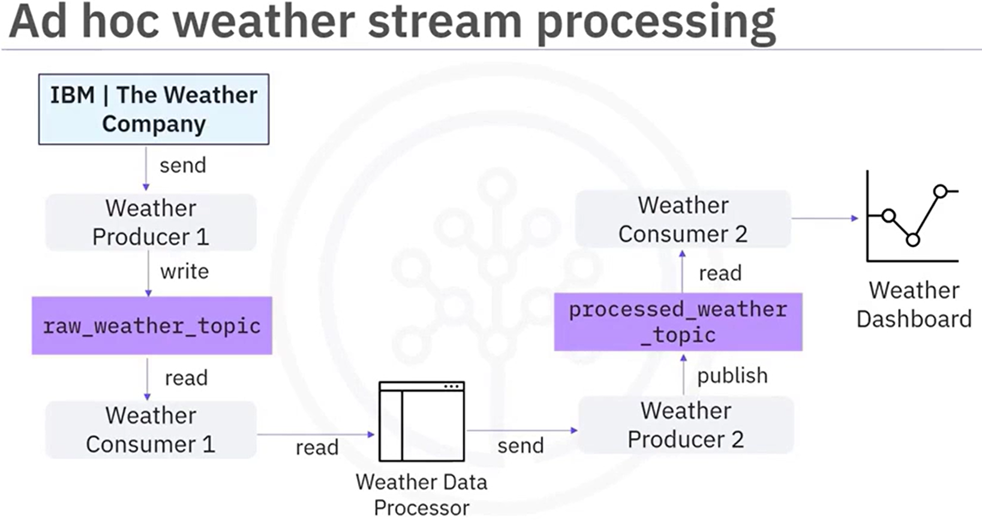

Such ad hoc processors may become complicated if you have many different topics to be processed. A solution that may solve these challenges is Kafka. It provides the Streams API to facilitate stream processing.

Kafka Streams API is a simple client library aiming to facilitate data processing in event streaming pipelines. It processes and analyzes data stored in Kafka topics. Thus, both the input and output of the Streams API are Kafka topics. Additionally, Kafka Streams API ensures that each record will only be processed once. Finally, it processes only one record at a time.

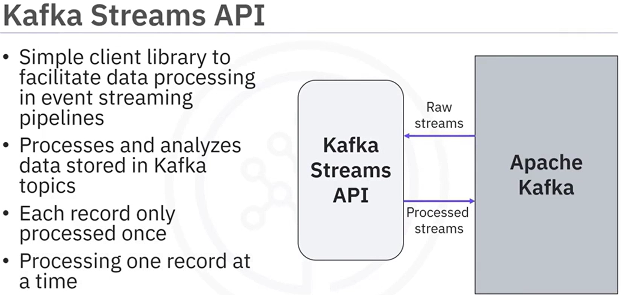

In this topology, each node is a stream processor, which receives streams from its upstream processor; performs data transformations, such as mapping, filtering, formatting, and aggregation:

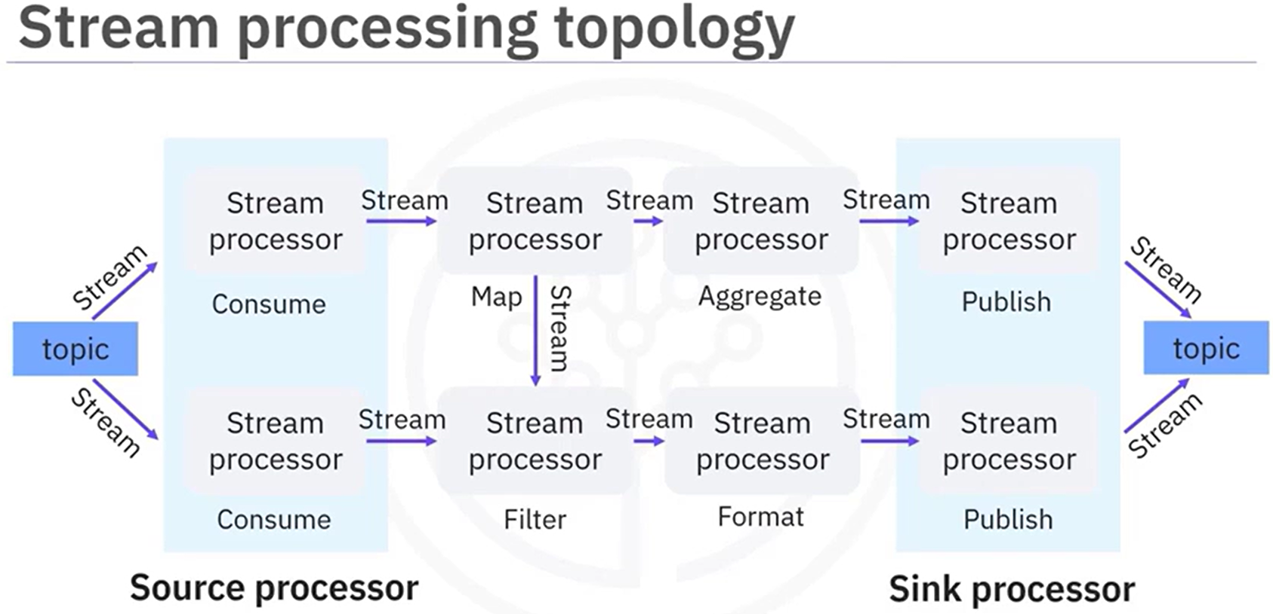

Simpler design than an ad hoc data processor.

Let's redesign the previous weather stream processing application with Kafka Streams API. Suppose you have a raw_weather_topic and a processed_weather_topic in Kafka. Now, instead of spending a huge amount of effort developing an ad hoc processor, you could just plug in the Kafka Streams API here. In the Kafka Streams topology, we have three stream processors, the source processor that consumes raw weather streams from the raw_weather_topic and forwards the weather stream to the stream processor to filter the stream based on high temperature. Then the filtered stream will be forwarded to the sink processor, which then publishes the output to the processed_weather_topic.

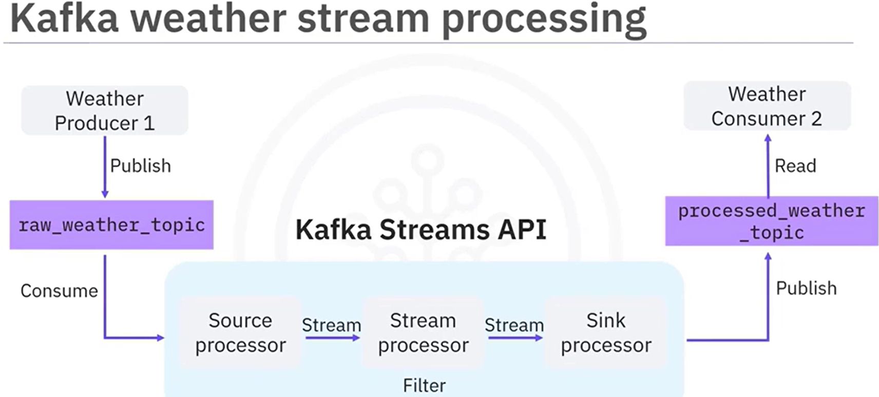

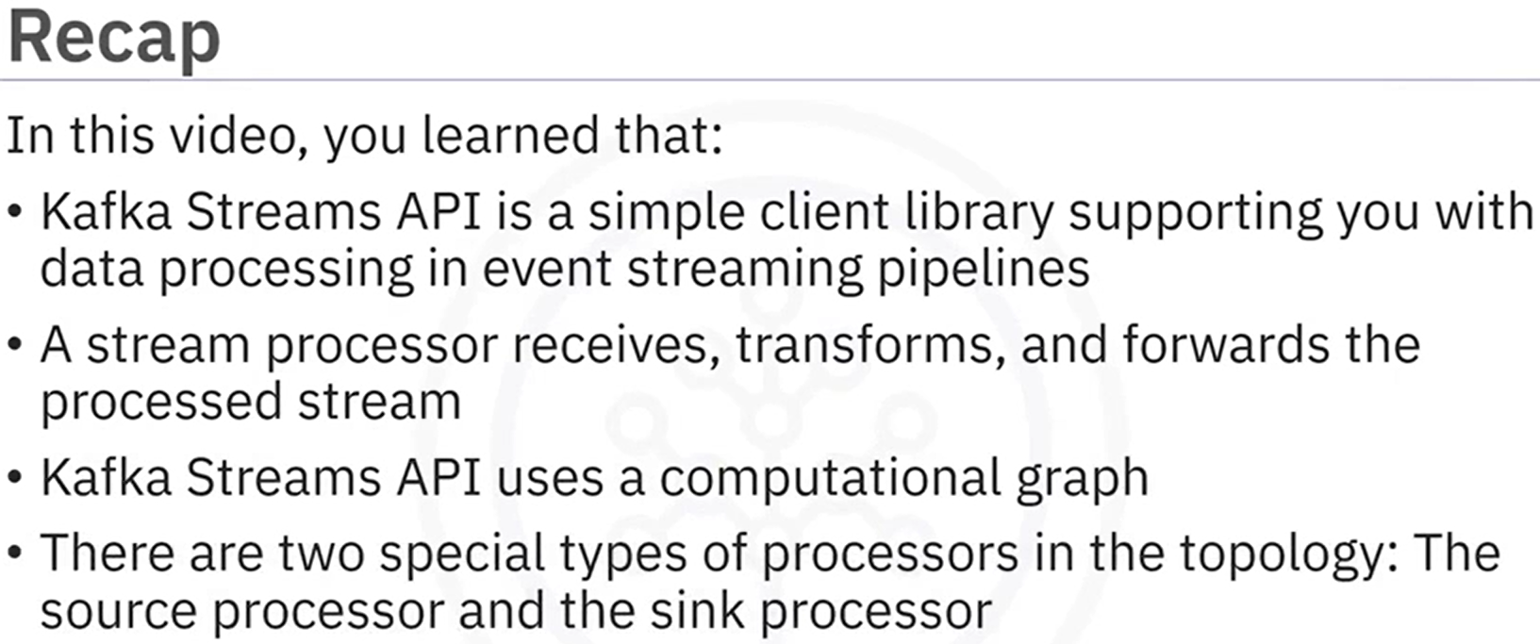

| **Tipo** | **¿Qué hace?** |
| --- | --- |
| **Source Processor** | **Lee datos** desde un **topic de Kafka** y los **ingresa** al flujo de procesamiento. |
| **Sink Processor** | **Escribe datos** procesados hacia un **topic de Kafka** u otro destino. |

### Hands-on Lab: Working with Streaming Data using Kafka

In this lab you will download and install Kafka and start streaming data using Kafka.

**Introduction**

In this lab, you will work with streaming data using Kafka. You will start by configuring the Kafka server to use the Kraft mode followed by starting the Kafka message broker service, creating a topic and then starting the producer and consumer.

**Objectives**

After completing this lab, you will be able to:

* Download Kafka binaries
* Configure the Kafka server to use the KRaft mode
* Start the Kafka message broker service
* Create a topic
* Start a producer
* Start a consumer

#### **Exercise 1: Download and extract Kafka**

1. Open a new terminal

**Next, run the following commands on the terminal.**

1. Download Kafka by running the command below:

*wget* [*https://downloads.apache.org/kafka/3.8.0/kafka_2.13-3.8.0.tgz*](https://downloads.apache.org/kafka/3.8.0/kafka_2.13-3.8.0.tgz)

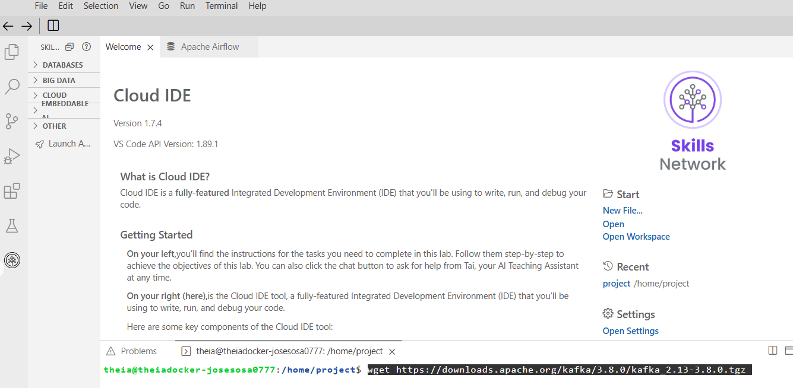

1. Extract Kafka from the zip file by running the command below.

*tar -xzf kafka_2.13-3.8.0.tgz*

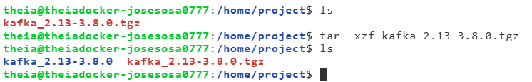

This command will create a new directory kafka_2.13-3.8.0 in the current directory.

#### **Exercise 2: Configure KRaft and start server**

1. Navigate to the kafka_2.13-3.8.0 directory.

*cd kafka_2.13-3.8.0*

1. Generate a cluster UUID that will uniquely identify the Kafka cluster.

*KAFKA_CLUSTER_ID="$(bin/kafka-storage.sh random-uuid)"*

This cluster id will be used by the KRaft controller.

1. KRaft requires the log directories to be configured. Run the following command to configure the log directories passing the cluster ID.

*bin/kafka-storage.sh format -t $KAFKA_CLUSTER_ID -c config/kraft/server.properties*

1. Now that KRaft is configured, you can start the Kafka server by running the following command.

*bin/kafka-server-start.sh config/kraft/server.properties*

You can be sure that the Kafka server has started when the output displays messages like "Kafka Server started".

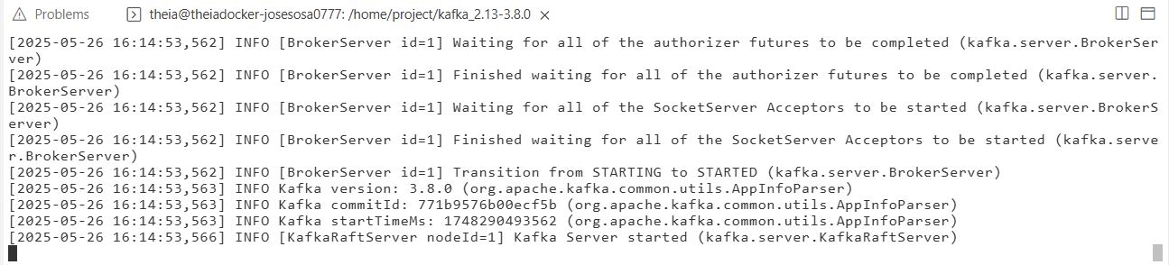

#### **Exercise 3: Create a topic and start producer**

You need to create a topic before you can start to post messages.

1. Start a new terminal and change to the kafka_2.13-3.8.0 directory.

*cd kafka_2.13-3.8.0*

1. To create a topic named news, run the command below.

*bin/kafka-topics.sh --create --topic news --bootstrap-server localhost:9092*

You will see the message: Created topic news.

1. You need a producer to send messages to Kafka. Run the command below to start a producer.

*bin/kafka-console-producer.sh --bootstrap-server localhost:9092 --topic news*

1. After the producer starts, and you get the '>' prompt, type any text message and press enter. Or you can copy the text below and paste. The below text sends three messages to Kafka.

* Good morning
* Good day
* Enjoy the Kafka lab

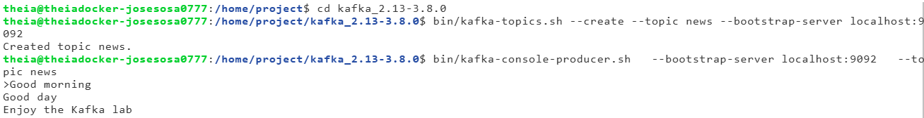

#### **Exercise 4: Start Consumer**

You need a consumer to read messages from Kafka.

1. Start a new terminal and change to the kafka_2.13-3.8.0 directory.

*cd kafka_2.13-3.8.0*

1. Run the command below to listen to the messages in the topic news.

*bin/kafka-console-consumer.sh --bootstrap-server localhost:9092 --topic news --from-beginning*

1. You should see all the messages you sent from the producer appear here.

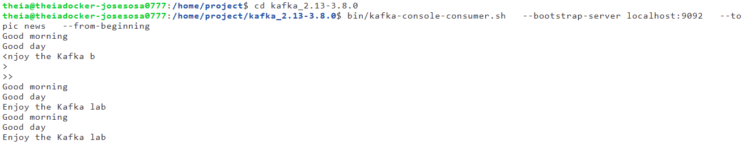

1. You can go back to the producer terminal and type some more messages, one message per line, and you will see them appear here.

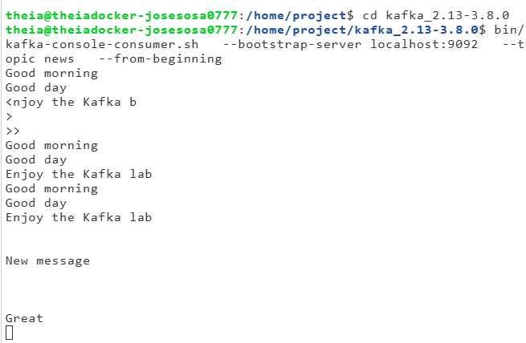

#### **Exercise 5: Explore Kafka directories**

Kafka uses the **/tmp//tmp/kraft-combined-logs** directory to store the messages.

1. Start a new terminal and navigate to the kafka_2.13-3.8.0 directory.

cd kafka_2.13-3.8.0

1. Explore the root directory of the server.

ls

1. Notice there is a tmp directory. The kraft-combine-logs inside the tmp directory contains all the logs. To check the logs generated for the topic news run the following command:

ls /tmp/kraft-combined-logs/news-0

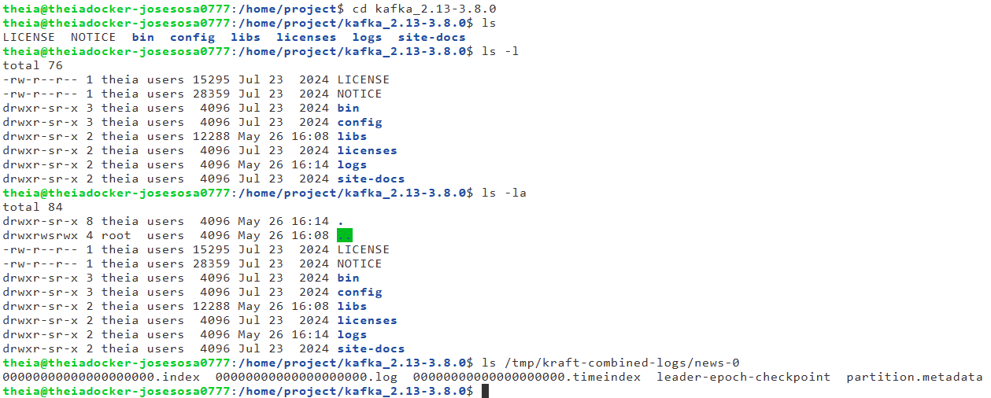

***Note****: All messages are stored in the news-0 directory under the****/tmp/kraft-combined-logs****directory.*

#### **Exercise 6: Clean up**

**To stop the producer**

In the terminal where you are running producer, press CTRL+C.

**To stop the consumer**

In the terminal where you are running consumer, press CTRL+C.

**To stop the Kafka server**

In the terminal where you are running Kafka server, press CTRL+C.

### **Practice exercises**

Initialize starting the kafka server, then:

1. Create a new topic named weather.

Click here for a **hint**.

1. Start a new terminal and change to the kafka_2.13-3.8.0 directory.

*cd kafka_2.13-3.8.0*

1. To create a topic named weather, run the command below.

*bin/kafka-topics.sh --create --topic weather --bootstrap-server localhost:9092*

You will see the message: Created topic weather.

1. You need a producer to send messages to Kafka. Run the command below to start a producer.

*bin/kafka-console-producer.sh --bootstrap-server localhost:9092 --topic weather*

1. Post messages to the topic weather.
2. In new terminal run the command below to listen to the messages in the topic news.

*bin/kafka-console-consumer.sh --bootstrap-server localhost:9092 --topic weather --from-beginning*

1. You should see all the messages you sent from the producer appear here.

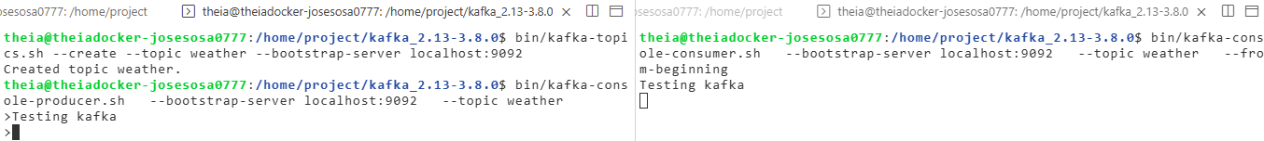

### [Optional] Hands-on Lab: Kafka Message Keys and Offset

In this lab, you will learn how to keep the message streams added to the partitions in the topics in a Kafka broker sorted in their original publication order and state using offset and groups.

#### **Exercise 1: Download and extract Kafka**

Open a new terminal

**Next, d**ownload Kafka by running the command below:

*wget* [*https://downloads.apache.org/kafka/3.8.0/kafka_2.13-3.8.0.tgz*](https://downloads.apache.org/kafka/3.8.0/kafka_2.13-3.8.0.tgz)

Extract Kafka from the zip file by running the command below.

*tar -xzf kafka_2.13-3.8.0.tgz*

This command will create a new directory kafka_2.13-3.8.0 in the current directory.

**

#### **Exercise 2: Configure KRaft and start server**

1. Navigate to the kafka_2.13-3.8.0 directory.

*cd kafka_2.13-3.8.0*

1. Generate a cluster UUID that will uniquely identify the Kafka cluster.

*KAFKA_CLUSTER_ID="$(bin/kafka-storage.sh random-uuid)"*

This cluster id will be used by the KRaft controller.

1. KRaft requires the log directories to be configured. Run the following command to configure the log directories passing the cluster ID.

*bin/kafka-storage.sh format -t $KAFKA_CLUSTER_ID -c config/kraft/server.properties*

1. Now that KRaft is configured, you can start the Kafka server by running the following command.

*bin/kafka-server-start.sh config/kraft/server.properties*

You can be sure that the Kafka server has started when the output displays messages like "Kafka Server started".



#### **Exercise 3: Create a topic and producer for processing bank ATM transactions**

Next, you will create a **bankbranch** topic to process messages from bank branch ATM machines.

Suppose the messages come from the ATM in the form of a simple JSON object, including an ATM ID and a transaction ID like the following example:

{"atmid": 1, "transid": 100}

**To process the ATM messages, you will first need to create a new topic called bankbranch.**

1. Open a new terminal and change to the kafka_2.13-3.8.0 directory.

*cd kafka_2.13-3.8.0*

1. Create a new topic using the --topic argument with the name bankbranch. To simplify the topic configuration and better explain how message key and consumer offset work, you specify the --partitions 2 argument to create two partitions for this topic. To compare the differences, you may try other partitions settings for this topic.

*bin/kafka-topics.sh --create --topic bankbranch --partitions 2 --bootstrap-server localhost:9092*

1. List all topics to check if bankbranch has been created successfully.

*bin/kafka-topics.sh --bootstrap-server localhost:9092 --list*

1. You can also use the --describe command to check the details of the topic bankbranch.

*bin/kafka-topics.sh --bootstrap-server localhost:9092 --describe --topic bankbranch*

You can view the bankbranch as two partitions, Partition 0 and Partition 1. If no message keys are specified, messages will be published to these two partitions in an alternating sequence like this:

Partition 0 -> Partition 1 -> Partition 0 -> Partition 1 …



**Next, you can create a producer to publish ATM transaction messages.**

1. Run the following command in the same terminal window with the topic details to create a producer for the topic bankbranch.

*bin/kafka-console-producer.sh --bootstrap-server localhost:9092 --topic bankbranch*

1. To produce the messages, look for the > icon and add the following ATM messages after the icon:

*{"atmid": 1, "transid": 100}*

*{"atmid": 1, "transid": 101}*

*{"atmid": 2, "transid": 200}*

*{"atmid": 1, "transid": 102}*

*{"atmid": 2, "transid": 201}*

**Then, create a consumer in a new terminal window to consume these five new messages.**

1. Open a new terminal and change to the kafka_2.13-3.8.0 directory.

*cd kafka_2.13-3.8.0*

1. Then start a new consumer to subscribe to the bankbranch topic:

*bin/kafka-console-consumer.sh --bootstrap-server localhost:9092 --topic bankbranch --from-beginning*

You should be able to view the five new messages that you published. However, the messages may not be consumed in the same order as they were published. Typically, you will need to keep the consumed messages sorted in their original published order, especially for critical use cases, such as financial transactions.

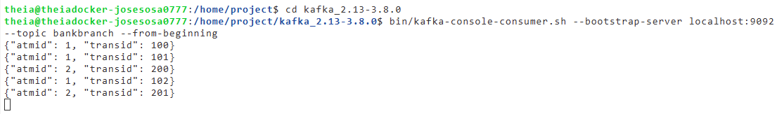

#### **Exercise 4: Produce and consume with message keys**

In this step, you will use message keys to ensure that messages with the same key are consumed in the same order as they were published. In the back end, messages with the same key are published into the same partition and will always be consumed by the same consumer. As such, the original publication order is kept on the consumer side.

At this point, you should have the following three terminals open in Cloud IDE:

* Kafka Server terminal
* Producer terminal
* Consumer terminal

In the next steps, you will frequently switch between these terminals.

* First, go to the consumer terminal and stop the consumer using **Ctrl + C** (Windows) or **COMMAND + .** (Mac).
* Then, switch to the Producer terminal and stop the previous producer.

You will now start a new producer and consumer using message keys. You can start a new producer with the following message key options:

* **--property parse.key=true** to make the producer parse message keys
* **--property key.separator=:** define the key separator to be the : character, so our message with key now looks like the following key-value pair example:
  + **1:{"atmid": 1, "transid": 102}**Here, the message key is 1, which also corresponds to the ATM ID, and the value is the transaction JSON object, **{"atmid": 1, "transid": 102}**.

1. Start a new producer with the message key enabled.

*bin/kafka-console-producer.sh --bootstrap-server localhost:9092 --topic bankbranch --property parse.key=true --property key.separator=:*

1. Once you see the > symbol, you can start to produce the following messages, where you define each key to match the ATM ID for each message:

*1:{"atmid": 1, "transid": 103}*

*1:{"atmid": 1, "transid": 104}*

*2:{"atmid": 2, "transid": 202}*

*2:{"atmid": 2, "transid": 203}*

*1:{"atmid": 1, "transid": 105}*

1. Next, switch to the consumer terminal again and start a new consumer with **--property print.key=true** and **--property key.separator=:** arguments to print the keys.

*bin/kafka-console-consumer.sh --bootstrap-server localhost:9092 --topic bankbranch --from-beginning --property print.key=true --property key.separator=:*

Now, you should see that messages with the same key are being consumed in the same order (for example: trans102 -> trans103 -> trans104) as they were published.

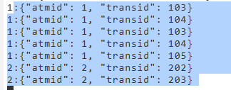

Each topic partition maintains its message queue, and new messages are enqueued (appended to the end of the queue) as they are published to the partition. Once consumed, the earliest messages are dequeued and no longer available for consumption.

Recall that with two partitions and no message keys specified, the transaction messages were published to the two partitions in rotation:

Partition 0: **[{"atmid": 1, "transid": 100}, {"atmid": 2, "transid": 200}, {"atmid": 2, "transid": 201}]**

Partition 1: **[{"atmid": 1, "transid": 101}, {"atmid": 1, "transid": 102}]**

As you can see, the transaction messages from atm1 and atm2 got scattered across both partitions. It would be difficult to unravel this and consume messages from one ATM in the same order as they were published.

However, with the message key specified as the atmid value, the messages from the two ATMs will look like the following:

Partition 0: **[{"atmid": 1, "transid": 103}, {"atmid": 1, "transid": 104}, {"atmid": 1, "transid": 105}]**

Partition 1: **[{"atmid": 2, "transid": 202}, {"atmid": 2, "transid": 203}]**

Messages with the same key will always be published to the same partition so that their published order will be preserved within the message queue of each partition.

As such, you can keep the states or orders of the transactions for each ATM.

#### **Exercise 5: Consumer offset**

Topic partitions keep published messages in a sequence, such as a list. Message offset indicates a message's position in the sequence. For example, the offset of an empty Partition 0 of bankbranch is 0, and if you publish the first message to the partition, its offset will be 1.

Using offsets in the consumer, you can specify the starting position for message consumption, such as from the beginning to retrieve all messages or from some later point to retrieve only the latest messages.

**Consumer group**

In addition, you normally group related consumers together as a consumer group.

For example, you may want to create a consumer for each ATM in the bank and manage all ATM-related consumers together in a group.

So let's see how to create a consumer group, which is actually very easy with the --group argument.

1. In the consumer terminal, stop the previous consumer if it is still running.
2. Run the following command to create a new consumer within a consumer group called atm-app:

*bin/kafka-console-consumer.sh --bootstrap-server localhost:9092 --topic bankbranch --group atm-app*

After the consumer within the atm-app consumer group is started, you should not expect any messages to be consumed. This is because the offsets for both partitions have already reached the end. In other words, previous consumers have already consumed all messages and therefore queued them.

You can verify that by checking consumer group details.

1. Stop the consumer.
2. Show the details of the consumer group atm-app:

*bin/kafka-consumer-groups.sh --bootstrap-server localhost:9092 --describe --group atm-app*

Now you should see the offset information for the topic bankbranch:  


Recall that you have published 10 messages in total, and you can see the CURRENT-OFFSET column of partition 1 and partition 0 add up to 10 messages.

The LOG-END-OFFSET column indicates the last offset or the end of the sequence. Thus, both partitions have reached the end of their queues and no more messages are available for consumption.

Meanwhile, you can check the LAG column which represents the number of unconsumed messages for each partition.

Currently, it is 0 for all partitions, as expected.

**Next, let's produce more messages and see how the offsets change.**

1. Switch to the previous producer terminal and publish two more messages:

*1:{"atmid": 1, "transid": 106}*

*2:{"atmid": 2, "transid": 204}*

1. Switch back to the consumer terminal and check the consumer group details again.

*bin/kafka-consumer-groups.sh --bootstrap-server localhost:9092 --describe --group atm-app*

You should see that both offsets have been increased by 1, and the LAG columns for both partitions have become 1. It means you have one new message for each partition to be consumed.

1. Start the consumer again and see whether the two new messages will be consumed.

*bin/kafka-console-consumer.sh --bootstrap-server localhost:9092 --topic bankbranch --group atm-app*

Both partitions have reached the end once again.

**Reset offset**

**Next, let's look at how you can set the partitions to consume the messages again from the beginning through resetting offset.**

You can reset the index with the **--reset-offsets** argument.

First, let's try resetting the offset to the earliest position (beginning) using **--reset-offsets --to-earliest**

1. Stop the previous consumer if it is still running, and run the following command to reset the offset.

*bin/kafka-consumer-groups.sh --bootstrap-server localhost:9092 --topic bankbranch --group atm-app --reset-offsets --to-earliest --execute*

Now, the offsets have been set to 0 (the beginning).

1. Start the consumer again:

*bin/kafka-console-consumer.sh --bootstrap-server localhost:9092 --topic bankbranch --group atm-app*

You should see that all 12 messages are consumed and that all offsets have reached the partition ends again.

You can reset the offset to any position. For example, let's reset the offset so that you only consume the last two messages.

1. Stop the previous consumer.
2. Shift the offset to the left by two using **--reset-offsets --shift-by -2**:

*bin/kafka-consumer-groups.sh --bootstrap-server localhost:9092 --topic bankbranch --group atm-app --reset-offsets --shift-by -2 --execute*

1. If you run the consumer again, you should see that you consumed four messages, 2 for each partition:

*bin/kafka-console-consumer.sh --bootstrap-server localhost:9092 --topic bankbranch --group atm-app*

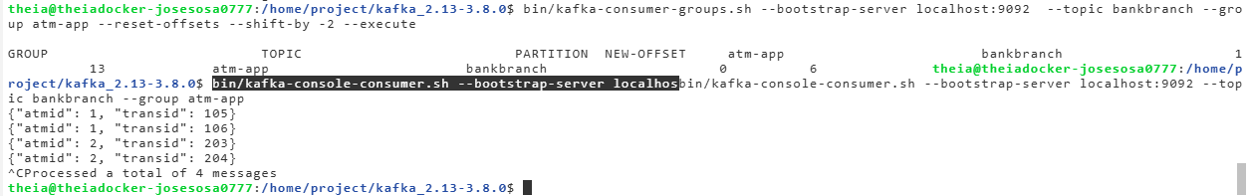

1. Stop your producer, consumer and the Kafka server.

### **Kafka Python Client**

**Objectives**

After completing this reading, you will be able to:

* List the common Apache Kafka clients
* Use kafka-python to interact with Kafka server in Python

**Apache Kafka Clients**

Kafka has a distributed client-server architecture. For the server side, Kafka is a cluster with many associated servers called broker, acting as the event broker to receive, store, and distribute events. It also has some servers that run "Kafka Connect" to import and export data as event streams. All the brokers until versions prior to 2.8 relied on another distributed system called ZooKeeper for management and to ensure all brokers work in an efficient and collaborative way.

However, Kafka Raft, or KRaft, is now used to eliminate Kafka's reliance on ZooKeeper for metadata management. It is a consensus protocol that streamlines Kafka's architecture by consolidating metadata responsibilities within Kafka itself using Kafka Controllers. Producers send or publish data to the Topic  and the consumers subscribe to the topic to receive data. Kafka uses a TCP-based network communication protocol to exchange data between clients and servers.

For the client side, Kafka provides different types of clients, such as:

* Kafka CLI, which is a collection of shell scripts to communicate with a Kafka server
* Many high-level programming APIs such as Python, Java, and Scala
* REST APIs
* Specific third-party clients made by the Kafka community

You can choose different clients based on your requirements.

**Kafka Python**

Let's focus on the **Kafka Python client** called kafka-python.

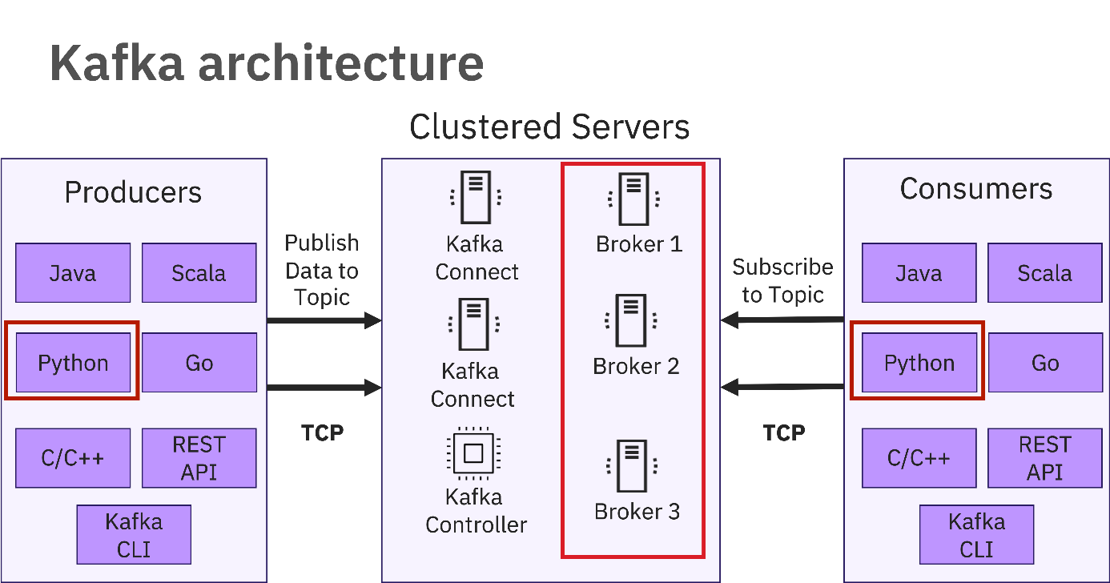

***Note****: Code snippets provided in this reading are just for your reference but not the complete working code.*

**The "kafka-python" package**

kafka-python is a Python client for the Apache Kafka distributed stream processing system, which aims to provide similar functionalities as the main Kafka Java client. With kafka-python, you can easily interact with your Kafka server such as managing topics, publish, and consume messages in Python programming language.

You must install kafka-python using pip3 installer to use it with a Python client.

*pip3 install kafka-python*

Next, let's review use cases for the main functions provided by the kafka-python package.

**"KafkaAdminClient" class**

The main purpose of KafkaAdminClient class is to enable fundamental administrative management operations on kafka server such as creating/deleting topic, retrieving, and updating topic configurations and so on.

Let's check some code examples:

1. To use KafkaAdminClient, you first need to define and create a KafkaAdminClient object.

*admin_client = KafkaAdminClient(bootstrap_servers="localhost:9092", client_id='test')*

* 1. bootstrap_servers="localhost:9092" argument specifies the host/IP and port that the consumer should contact to bootstrap initial cluster metadata
  2. client_id specifies an id of current admin client

1. The most common use of the admin_client is managing topics, such as creating and deleting topics. To create topics, you must first define an empty topic list:

*topic_list = []*

1. Then, you use the NewTopic class to create a topic with name, partition, and replication factors. For example, name equals bankbranch, partition nums equals 2, and replication factor equals 1.

*new_topic = NewTopic(name="bankbranch", num_partitions= 2, replication_factor=1)*

*topic_list.append(new_topic)*

1. You can use create_topics(...) method to create topics.

*admin_client.create_topics(new_topics=topic_list)*

***Note****: The create topic operation used above is equivalent to using kafka-topics.sh --topic in Kafka CLI client.*

**Describe a topic**

1. After the topics are created, you can check its configuration details using the describe_configs() method.

*configs = admin_client.describe_configs(*

*config_resources=[ConfigResource(ConfigResourceType.TOPIC, "bankbranch")])*

***Note****: The describe topic operation used above is equivalent to using kafka-topics.sh --describe in Kafka CLI client.*

**KafkaProducer**

Having created the new bankbranch topic, you can start producing messages.

For kafka-python, you will use KafkaProducer class to produce messages. Since many real-world message values are in the JSON format, let's look at how to publish JSON messages as an example.

1. First, let's define and create a KafkaProducer.

*producer = KafkaProducer(value_serializer=lambda v: json.dumps(v).encode('utf-8'))*

Since Kafka produces and consumes messages in raw bytes, you need to encode our JSON messages and serialize them into bytes. For the value_serializer argument, you will define a lambda function to take a Python dict/list object and serialize it into bytes.

1. Then, with the KafkaProducer created, you can use it to produce two ATM transaction messages in JSON format as follows:

*producer.send("bankbranch", {'atmid':1, 'transid':100})*

*producer.send("bankbranch", {'atmid':2, 'transid':101})*

The first argument specifies the topic bankbranch to be sent and the second argument represents the message value in a Python dict format and will be serialized into bytes.

***Note****: The above producing message operation is equivalent to using kafka-console-producer.sh --topic in Kafka CLI client.*

**KafkaConsumer**

In the previous step, you published two JSON messages. Now, you can use the KafkaConsumer class to consume the messages.

1. Define and create a KafkaConsumer subscribing to the topic bankbranch:

*consumer = KafkaConsumer('bankbranch')*

1. Once the consumer is created, it will receive all available messages from the topic bankbranch. Then, you can iterate and print them with the following code snippet:

*for msg in consumer:*

*print(msg.value.decode("utf-8"))*

***Note****: The above consuming message operation is equivalent to using kafka-console-consumer.sh --topic in Kafka CLI client.*

### [Optional] Hands-on Lab: Kafka Python Client

#### **Exercise 1: Download and extract Kafka**

1. Open a new terminal by clicking the menu bar and selecting **Terminal**->**New Terminal**.

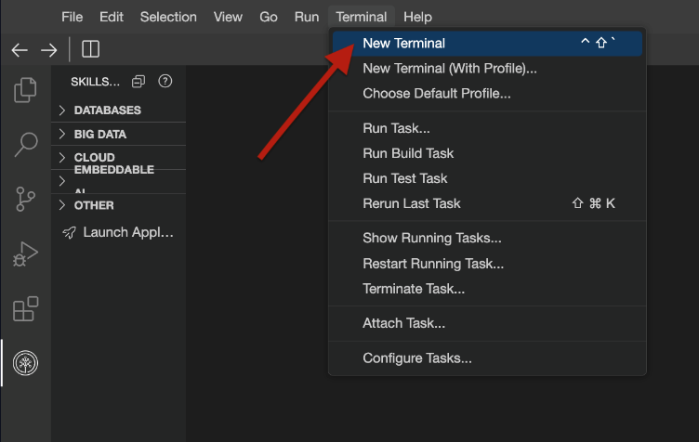

This will open a new terminal at the bottom of the screen.

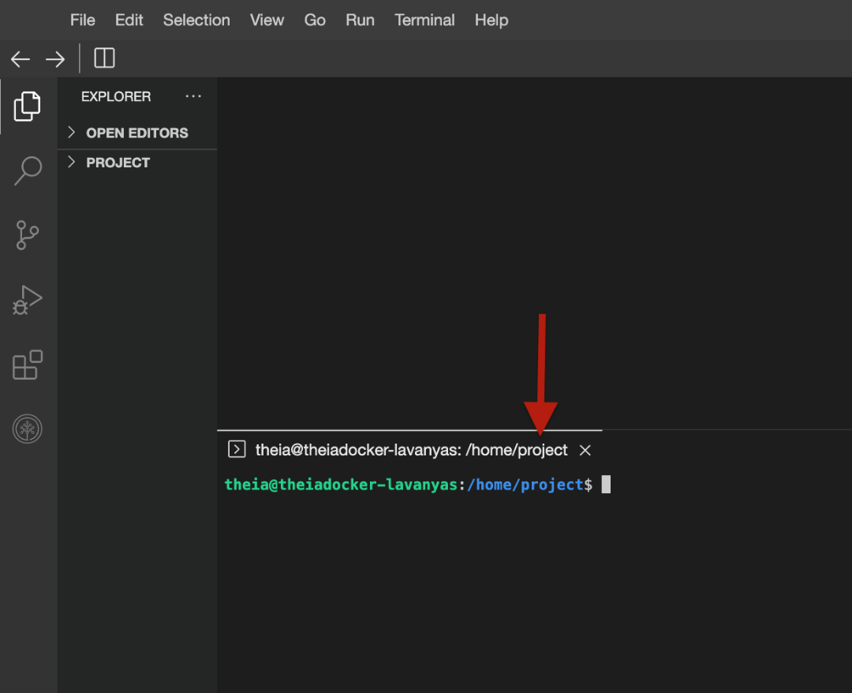

**Run the commands below on the newly opened terminal.**

1. Download Kafka by running the command below:

*wget https://downloads.apache.org/kafka/3.8.0/kafka_2.13-3.8.0.tgz*

1. Extract Kafka from the zip file by running the command below.

*tar -xzf kafka_2.13-3.8.0.tgz*

This creates a new directory kafka_2.13-3.8.0 in the current directory.

#### **Exercise 2: Configure KRaft and start server**

1. Change to the kafka_2.13-3.8.0 directory.

*cd kafka_2.13-3.8.0*

1. Generate a Cluster UUID that will uniquely identify the Kafka cluster.

*KAFKA_CLUSTER_ID="$(bin/kafka-storage.sh random-uuid)"*

***Note****: This cluster ID will be used by the KRaft controller.*

1. KRaft requires the log directories to be configured. Run the following command to configure the log directories passing the cluster ID.

*bin/kafka-storage.sh format -t $KAFKA_CLUSTER_ID -c config/kraft/server.properties*

1. Now that KRaft is configured, you can start the Kafka server by running the following command.

*bin/kafka-server-start.sh config/kraft/server.properties*

***Note****: You can be sure it has started when you see an output contains messages that confirm the Kafka Server started successfully.*

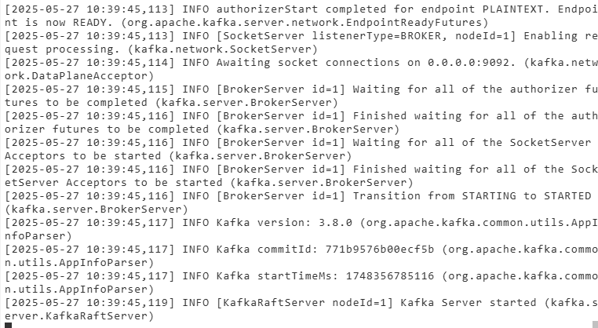

#### **Exercise 3: Create a topic in the admin.py file**

**Install kafka-python**

1. Open a new terminal and navigate to the kafka_2.13-3.8.0 directory.

*cd kafka_2.13-3.8.0*

1. Install the kafka-python package by running the following command.

*pip3 install kafka-python*

1. Create a file named admin.py by running the following command.

*touch admin.py*

1. Open **admin.py** in IDE and paste the following content in the file and save it.

*from kafka.admin import KafkaAdminClient,NewTopic*

*from kafka.errors import TopicAlreadyExistsError*

*admin_client = KafkaAdminClient(bootstrap_servers="localhost:9092", client_id='test')*

*topic_list = []*

*new_topic = NewTopic(name="bankbranch", num_partitions= 2, replication_factor=1)*

*topic_list.append(new_topic)*

*try:*

*# admin_client.delete_topics(topics=["bankbranch"])*

*admin_client.create_topics(new_topics=topic_list)*

*print("Topic created successfully.")*

*except TopicAlreadyExistsError:*

*print("Topic already exists. Skipping creation.")*

***Note****: We are creating a topic "bankbranch" through this code.*

#### **Exercise 4: Create the producer.py file**

You need a producer to send messages to Kafka. You will find the code for the producer in the producer.py file.

1. Create a file named producer.py by running the following command.

*touch producer.py*

1. Open **producer.py** in IDE and paste the following content in the file and save it.

*from kafka import KafkaProducer*

*import json*

*producer = KafkaProducer(value_serializer=lambda v: json.dumps(v).encode('utf-8'))*

*producer.send("bankbranch", {'atmid':1, 'transid':100})*

*producer.send("bankbranch", {'atmid':2, 'transid':101})*

*producer.flush()*

*producer.close()*

In the above code, the producer is sending across two messages through this code. These messages will be received by the consumer.

#### **Exercise 5: Create the consumer.py file**

You need a consumer to read messages from Kafka. The code for consumer will be written in the consumer.py file.

1. Create a file named consumer.py by running the following command.

*touch consumer.py*

 Open **consumer.py** and add:

*from kafka import KafkaConsumer*

*consumer = KafkaConsumer('bankbranch',*

*group_id=None,*

*bootstrap_servers=['localhost:9092'],*

*auto_offset_reset = 'earliest')*

*print("Hello")*

*print(consumer)*

*for msg in consumer:*

*print(msg.value.decode("utf-8"))*

#### **Exercise 6: Execute the three Python files**

1. Execute admin.py and producer.py using the following commands in terminal:

*python3 admin.py*

*python3 producer.py*

1. Open a new terminal and execute the following commands to run consumer.py:

*cd kafka_2.13-3.8.0*

*python3 consumer.py*

1. Your consumer should print the messages sent by the producer as follows:

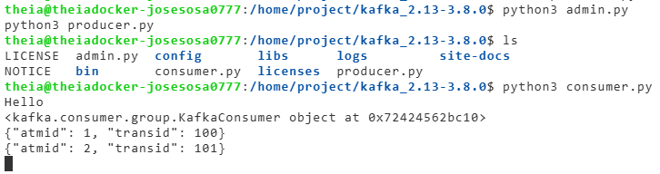

#### **Practice Exercise**

1. Create a new producer from bankbranch in a file named new_producer.py which will take user input as long as the user wants and accept user input for the ATM number they want to transact with (1 or 2) and stream the transaction.
2. Observe the consumer getting the events streamed by the producer in real time.

Solution. In new_producer.py:

from kafka import KafkaProducer

import json

producer = KafkaProducer(value_serializer=lambda v: json.dumps(v).encode('utf-8'))

transid = 102

while True:

        user_input = input("Do you want to add a transaction? (press 'n' to stop): ")

        if user_input.lower() == 'n':

            print("Stopping the transactions")

            break

        else:

            atm_choice = input("Which ATM you want to transact in? 1 or 2 ")

            if (atm_choice == '1' or atm_choice == '2'):

                producer.send("bankbranch", {'atmid':int(atm_choice), 'transid':transid})

                producer.flush()

                transid = transid + 1

            else:

                print('Invalid ATM number')

                continue

producer.close()

Execute:

python3 new_producer.py

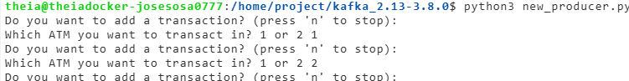

python3 consumer.py

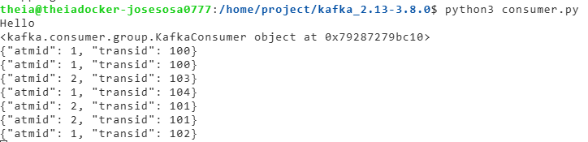

### Summary and Highlights

* An event stream represents entities’ status updates over time
* The main components of an ESP are Event broker, Event storage, Analytic, and Query Engine
* Apache Kafka is a very popular open-source ESP
* Popular Kafka service providers include Confluent Cloud, IBM Event Stream, and Amazon MSK
* The core components of Kafka are brokers, topics, partitions, replications, producers, and consumers
* The Kafka-console-consumer manages consumers
* Kafka Streams API is a simple client library supporting you with data processing in event streaming pipelines
* A stream processor receives, transforms, and forwards the processed stream
* Kafka Streams API uses a computational graph
* There are two special types of processors in the topology: The source processor and the sink processor

### Practice Quiz: Building Streaming Pipelines using Kafka

**Question 1. Event streams represent entity status updates over time. Events have different formats, which of the most common formats can be either a primitive or complex data type? (multiple answers)**

Key-value with a timestamp

Complex format

Primitive format

Key-value format

**Question 2. How does Kafka increase fault-tolerance and throughput?**

Keys

Maps

Indexes

Topic partitions and replications

**Correct**

Correct, the topics are partitioned and replicated amongst brokers so if one goes down there are others available.

**Question 3. The ad hoc processors that perform stream processing can become complicated. The Kafka Streams API helps solve this complication. How does the Streams API help stream processing? (multiple answers)**

Processes and analyzes data

Processes one record at a time

Scripts for CLI

Provides client library

**Question 4. Which of the following describes event streaming?**

Continuous event transportation

Large event volume

Observable state updates over time

External database

**Question 5. What was Apache Kafka originally used for?**

Payments and transactions

Track user activities

Data storage

Auditing

### Graded Quiz: Building Streaming Pipelines using Kafka

**Question 1. The Kafka server side is a cluster with many associated servers. What are the associated servers called?**

Brokers

Associates

Controllers

Sub-servers

**Correct**

Correct, Kafka associated servers are called brokers that act as the event broker.

**Question 2. Which of the following is Kafka Streams API based on?**

Gantt chart

Java

Computational graph

Transformational graph

**Correct**

Correct, the Streams API is based on a computational graph called a stream-processing topology.

**Question 3. Which of the following do stream processors do?**

Processes and forwards

Extracts, transforms, and loads

Receives, transforms, and forwards

Extracts, loads, and transforms

**Question 4. Kafka Streams API is based on a computational graph called a stream processing topology. And in the topology, each node is a stream processor, while edges are the I/O streams. In this topology we find two special types of processors: What are they called?**

Mapping and transformation processor

Aggregation and stream processor

Source and sink processor

Stream and topic processor

**Question 5. Which of the following Kafka main features provides consumption without a deadline?**

Distribution system

Reliability

Permanent persistency

Open source

**Correct**

Correct, Kafka stores events permanently so consumers can access streaming events at any time.

**Question 6. Once events are published and properly stored in topic partitions, you can create _________ to read them.**

Producers

Consumers

Partitions

Brokers

**Question 7. The core component of any ESP is the event broker. Which event broker sub-component performs encryption on data?**

Consumption

Processor

Ingester

Storage

**Question 8. ESPs are a middle layer between multiple event sources and destinations. ESPs may have different architectures and components but also some common components. Which of the following common components receives and consumes events?**

Query engine

Event broker

Analytic engine

Event storage

**Question 9. Which of the following Kafka core components publish events into topics?**

Consumers

Producers

Partitions

Brokers

**Question 10. Which of the Kafka CLI script files manages topics?**

Kafka-console-consumer

Kafka-console

Kafka-console-producer

Kafka-topics

## Module 5 Final Assignment

In this final assignment module, you will apply your newly gained knowledge to explore two very exciting hands-on labs. “Creating ETL Data Pipelines using Apache Airflow” and “Creating Streaming Data Pipelines using Kafka”. You will explore building these ETL pipelines using real-world scenarios. You will extract, transform, and load data into a CSV file. You will also create a topic named “toll” in Apache Kafka, download and customize a streaming data consumer, as well as verifying that streaming data has been collected in the database table.

**Learning Objectives**

* Extract data from CSV, TSV, and fixed width files
* Transform extracted data
* Load transformed data into the staging area.
* Submit, unpause, and monitor a DAG.
* Create a topic in Kafka
* Download and customize a streaming data consumer
* Verify that streaming data has been collected in a database table
* Evaluate your peers’ code and output using the provided rubric and grading scheme.

### Project Overview

**Instructions**

Now that you are equipped with the knowledge and skills to extract, transform and load data you will use these skills to perform ETL, create a pipeline and upload the data into a database. You will use BashOperator with Airflow in the hands-on lab.

**Scenario**

You are a data engineer at a data analytics consulting company. You have been assigned a project to decongest the national highways by analyzing the road traffic data from different toll plazas. Each highway is operated by a different toll operator with a different IT setup that uses different file formats. Your job is to collect data available in different formats and consolidate it into a single file.

In this assignment, you will develop an Apache Airflow DAG that will:

* Extract data from a csv file
* Extract data from a tsv file
* Extract data from a fixed-width file
* Transform the data
* Load the transformed data into the staging area

**Grading Criteria**

There are a total of **25 points for 13 tasks** in this final project spread in one hands-on lab.

Your final assignment will be graded by your peers who are also completing this assignment within the same session. Your grade will be based on the following tasks:

* **Exercise 1: Create imports, DAG argument and definition**
  + Task 1.1: Define DAG arguments (2pts)
  + Task 1.2: Define the DAG (2pts)
* **Exercise 2: Create the tasks using BashOperator**
  + Task 2.1: Create a task to unzip data. (2pts)
  + Task 2.2: Create a task to extract data from csv file (2pts)
  + Task 2.3: Create a task to extract data from tsv file (2pts)
  + Task 2.4: Create a task to extract data from fixed width file (2pts)
  + Task 2.5: Create a task to consolidate data extracted from previous tasks (2pts)
  + Task 2.6: Transform the data (2 pts)
  + Task 2.7: Define the task pipeline (1pt)
* **Exercise 3: Getting the DAG operational**
  + Task 3.1: Submit the DAG (1pt)
  + Task3.2: Unpause and trigger the DAG (3pt)
  + Task 3.3: List the DAG tasks (2 pt)
  + Task 3.4: Monitor the DAG (2pt)

**How to submit**

You will need to submit a screenshot in the JPEG or PNG format or all tasks. The screenshots will be uploaded in the submission step of the final project. You will be prompted to save screenshots throughout the labs and these will be the files you submit during the **Project Submission and Peer Review** section of this course.

### Hands-on Lab: Build ETL Data Pipelines with BashOperator using Apache Airflow

#### **Exercise 1: Set up the lab environment**

1. Start Apache Airflow.

Open Apache Airflow in IDE

1. Open a terminal and create a directory structure for the staging area as follows:  
   **/home/project/airflow/dags/finalassignment/staging**.

*sudo mkdir -p /home/project/airflow/dags/finalassignment/staging*

1. Execute the following commands to give appropriate permission to the directories.

*sudo chmod -R 777 /home/project/airflow/dags/finalassignment*

1. Download the data set from the source to the following destination using the curl command.

*sudo curl https://cf-courses-data.s3.us.cloud-object-storage.appdomain.cloud/IBM-DB0250EN-SkillsNetwork/labs/Final%20Assignment/tolldata.tgz -o /home/project/airflow/dags/finalassignment/tolldata.tgz*

#### **Exercise 2: Create imports, DAG argument, and definition**

**Please use the BashOperator for all tasks in this assignment.**

1. Create a new file named ETL_toll_data.py in /home/project directory and open it in the file editor.
2. Import all the packages you need to build the DAG.
3. Define the DAG arguments as per the following details in the ETL_toll_data.py file:

| **Parameter** | **Value** |
| --- | --- |
| owner | <You may use any dummy name> |
| start_date | today |
| email | <You may use any dummy email> |
| email_on_failure | True |
| email_on_retry | True |
| retries | 1 |
| retry_delay | 5 minutes |

1. ***Take a screenshot*** of the task code. Name the screenshot dag_args.jpg.
2. Define the DAG in the ETL_toll_data.py file using the following details.

| **Parameter** | **Value** |
| --- | --- |
| DAG id | ETL_toll_data |
| Schedule | Daily once |
| default_args | As you have defined in the previous step |
| description | Apache Airflow Final Assignment |

1. ***Take a screenshot*** of the command and output you used. Name the screenshot dag_definition.jpg.

At the end of this exercise, you should have the following screenshots with .jpg or .png extension:  
1. *dag_args.jpg*  
2. *dag_definition.jpg*

# import the libraries

from datetime import timedelta

# The DAG object; we'll need this to instantiate a DAG

from airflow.models import DAG

# Operators; you need this to write tasks!

from airflow.operators.bash_operator import BashOperator

# This makes scheduling easy

from airflow.utils.dates import days_ago

# Defining DAG arguments

# You can override them on a per-task basis during operator initialization

default_args = {

    'owner': 'Jose_Sosa',

    'start_date': days_ago(0),

    'email': ['josesosa0777gmail.com'],

    'email_on_failure': True,

    'email_on_retry': True,

    'retries': 1,

    'retry_delay': timedelta(minutes=5),

}

# Define the DAG

dag = DAG(

    'ETL_toll_data',

    default_args=default_args,

    description='Apache Airflow Final Assignment',

    schedule_interval=timedelta(days=1),

)

#### **Exercise 3: Create the tasks using BashOperator**

1. Create a task named unzip_data to unzip data. Use the data downloaded in the first part of this assignment in Set up the lab environment and uncompress it into the destination directory using tar.

***Take a screenshot*** of the task code. Name the screenshot unzip_data.jpg.

*You can locally untar and read through the file fileformats.txt to understand the column details.*

1. Create a task named extract_data_from_csv to extract the fields Rowid, Timestamp, Anonymized Vehicle number, and Vehicle type from the vehicle-data.csv file and save them into a file named csv_data.csv.

***Take a screenshot*** of the task code. Name the screenshot extract_data_from_csv.jpg.

1. Create a task named extract_data_from_tsv to extract the fields Number of axles, Tollplaza id, and Tollplaza code from the tollplaza-data.tsv file and save it into a file named tsv_data.csv.

***Take a screenshot*** of the task code. Name the screenshot extract_data_from_tsv.jpg.

1. Create a task named extract_data_from_fixed_width to extract the fields Type of Payment code, and Vehicle Code from the fixed width file payment-data.txt and save it into a file named fixed_width_data.csv.

***Take a screenshot*** of the task code. Name the screenshot extract_data_from_fixed_width.jpg.

1. Create a task named consolidate_data to consolidate data extracted from previous tasks. This task should create a single csv file named extracted_data.csv by combining data from the following files:
   * csv_data.csv
   * tsv_data.csv
   * fixed_width_data.csv

The final csv file should use the fields in the order given below:

* + Rowid
  + Timestamp
  + Anonymized Vehicle number
  + Vehicle type
  + Number of axles
  + Tollplaza id
  + Tollplaza code
  + Type of Payment code, and
  + Vehicle Code

***Hint****: Use the bash paste command that merges the columns of the files passed as a command-line parameter and sends the output to a new file specified. You can use the command man paste to explore more.*

**Example**: paste file1 file2 > newfile

***Take a screenshot*** of the task code. Name the screenshot consolidate_data.jpg.

1. Create a task named transform_data to transform the vehicle_type field in extracted_data.csv into capital letters and save it into a file named transformed_data.csv in the staging directory.

***Hint****: You can use the tr command within the BashOperator in Airflow.*

***Take a screenshot*** of the task code. Name the screenshot transform.jpg.

1. Define the task pipeline as per the details given below:

| **Task** | **Functionality** |
| --- | --- |
| First task | unzip_data |
| Second task | extract_data_from_csv |
| Third task | extract_data_from_tsv |
| Fourth task | extract_data_from_fixed_width |
| Fifth task | consolidate_data |
| Sixth task | transform_data |

***Take a screenshot*** of the task pipeline section of the DAG. Name the screenshot task_pipeline.jpg.

At the end of this exercise, you should have the following screenshots with .jpg or .png extension:

1. *unzip_data.jpg*
2. *extract_data_from_csv.jpg*
3. *extract_data_from_tsv.jpg*
4. *extract_data_from_fixed_width.jpg*
5. *consolidate_data.jpg*
6. *transform.jpg*
7. *task_pipeline.jpg*

*# import the libraries*

*from datetime import timedelta*

*# The DAG object; we'll need this to instantiate a DAG*

*from airflow.models import DAG*

*# Operators; you need this to write tasks!*

*from airflow.operators.bash_operator import BashOperator*

*# This makes scheduling easy*

*from airflow.utils.dates import days_ago*

*# Defining DAG arguments*

*# You can override them on a per-task basis during operator initialization*

*default_args = {*

*'owner': 'Jose_Sosa',*

*'start_date': days_ago(0),*

*'email': ['josesosa0777gmail.com'],*

*'email_on_failure': True,*

*'email_on_retry': True,*

*'retries': 1,*

*'retry_delay': timedelta(minutes=5),*

*}*

*# Define the DAG*

*dag = DAG(*

*'ETL_toll_data',*

*default_args=default_args,*

*description='Apache Airflow Final Assignment',*

*schedule_interval=timedelta(days=1),*

*)*

*# Define the tasks*

*# Define the task 'unzip_data'*

*unzip_data = BashOperator(*

*task_id='unzip_data',*

*bash_command='tar -xzf /home/project/airflow/dags/finalassignment/tolldata.tgz',*

*dag=dag,*

*)*

*# Define the task 'extract_data_from_csv'*

*extract_data_from_csv = BashOperator(*

*task_id='extract_data_from_csv',*

*bash_command='cut -f1-4 -d"," /home/project/airflow/dags/finalassignment/vehicle-data.csv > /home/project/airflow/dags/finalassignment/csv_data.csv',*

*dag=dag,*

*)*

*# Define the task 'extract_data_from_tsv'*

*extract_data_from_tsv = BashOperator(*

*task_id='extract_data_from_tsv',*

*bash_command="cut -f5,6,7 /home/project/airflow/dags/finalassignment/tollplaza-data.tsv | tr '\t' ',' > /home/project/airflow/dags/finalassignment/tsv_data.csv",*

*dag=dag,*

*)*

*# Define the task 'extract_data_from_fixed_width'*

*extract_data_from_fixed_width = BashOperator(*

*task_id='extract_data_from_fixed_width',*

*bash_command='awk \'{print $(NF-1) "," $NF}\' /home/project/airflow/dags/finalassignment/payment-data.txt > /home/project/airflow/dags/finalassignment/fixed_width_data.csv',*

*dag=dag,*

*)*

*# Define the task 'consolidate_data'*

*consolidate_data = BashOperator(*

*task_id='consolidate_data',*

*bash_command="""*

*sed -i 's/\r$//' /home/project/airflow/dags/finalassignment/csv_data.csv && *

*sed -i 's/\r$//' /home/project/airflow/dags/finalassignment/tsv_data.csv && *

*sed -i 's/\r$//' /home/project/airflow/dags/finalassignment/fixed_width_data.csv && *

*paste -d "," /home/project/airflow/dags/finalassignment/csv_data.csv *

*/home/project/airflow/dags/finalassignment/tsv_data.csv *

*/home/project/airflow/dags/finalassignment/fixed_width_data.csv *

*> /home/project/airflow/dags/finalassignment/extracted_data.csv*

*""",*

*dag=dag,*

*)*

*# Define the task 'transform_data'*

*transform_data = BashOperator(*

*task_id='transform_data',*

*bash_command="""*

*awk -F',' 'BEGIN {OFS=","} { $4 = toupper($4); print }' *

*/home/project/airflow/dags/finalassignment/extracted_data.csv > *

*/home/project/airflow/dags/staging/transformed_data.csv*

*""",*

*dag=dag,*

*)*

*# define the task 'load'*

*#load = BashOperator(*

*#    task_id='load',*

*#    bash_command='zip log.zip capitalized.txt' ,*

*#    dag=dag,*

*#)*

*# Task pipeline*

*unzip_data >> extract_data_from_csv >> extract_data_from_tsv >> extract_data_from_fixed_width >> transform*

#### **Exercise 4: Getting the DAG operational**

1. Submit the DAG. Use CLI or Web UI to show that the DAG has been properly submitted.  
   ***Take a screenshot*** showing that the DAG you created is in the list of DAGs. Name the screenshot submit_dag.jpg.

*Note: If you don't find your DAG in the list, you can check for errors using the following command in the terminal:*

*airflow dags list-import-errors*

1. Unpause and trigger the DAG through CLI or Web UI.
2. ***Take a screenshot*** of DAG unpaused on CLI or the GUI. Name the screenshot unpause_trigger_dag.jpg.
3. ***Take a screenshot*** of the tasks in the DAG run through CLI or Web UI. Name the screenshot dag_tasks.jpg.
4. ***Take a screenshot*** the DAG runs for the Airflow console through CLI or Web UI. Name the screenshot dag_runs.jpg.

**Screenshot checklist**

You should have the following screenshots with .jpg or .png extension:

1. *submit_dag.jpg*
2. *unpause_trigger_dag.jpg*
3. *dag_tasks.jpg*
4. *dag_runs.jpg*

This action concludes the assignment.

Code:  
*# import the libraries*

*from datetime import timedelta*

*# The DAG object; we'll need this to instantiate a DAG*

*from airflow.models import DAG*

*# Operators; you need this to write tasks!*

*from airflow.operators.bash_operator import BashOperator*

*# This makes scheduling easy*

*from airflow.utils.dates import days_ago*

*# Defining DAG arguments*

*# You can override them on a per-task basis during operator initialization*

*default_args = {*

*'owner': 'Jose_Sosa',*

*'start_date': days_ago(0),*

*'email': ['josesosa0777gmail.com'],*

*'email_on_failure': True,*

*'email_on_retry': True,*

*'retries': 1,*

*'retry_delay': timedelta(minutes=5),*

*}*

*# Define the DAG*

*dag = DAG(*

*'ETL_toll_data',*

*default_args=default_args,*

*description='Apache Airflow Final Assignment',*

*schedule_interval=timedelta(days=1),*

*)*

*# Define the tasks*

*# Define the task 'unzip_data'*

*unzip_data = BashOperator(*

*task_id='unzip_data',*

*bash_command='cd /home/project/airflow/dags/finalassignment && *

*tar -xzf tolldata.tgz --overwrite',*

*dag=dag,*

*)*

*# Define the task 'extract_data_from_csv'*

*extract_data_from_csv = BashOperator(*

*task_id='extract_data_from_csv',*

*bash_command='cut -f1-4 -d"," /home/project/airflow/dags/finalassignment/vehicle-data.csv > /home/project/airflow/dags/finalassignment/csv_data.csv',*

*dag=dag,*

*)*

*# Define the task 'extract_data_from_tsv'*

*extract_data_from_tsv = BashOperator(*

*task_id='extract_data_from_tsv',*

*bash_command="cut -f5,6,7 /home/project/airflow/dags/finalassignment/tollplaza-data.tsv | tr '\t' ',' > /home/project/airflow/dags/finalassignment/tsv_data.csv",*

*dag=dag,*

*)*

*# Define the task 'extract_data_from_fixed_width'*

*extract_data_from_fixed_width = BashOperator(*

*task_id='extract_data_from_fixed_width',*

*bash_command='awk \'{print $(NF-1) "," $NF}\' /home/project/airflow/dags/finalassignment/payment-data.txt > /home/project/airflow/dags/finalassignment/fixed_width_data.csv',*

*dag=dag,*

*)*

*# Define the task 'consolidate_data'*

*consolidate_data = BashOperator(*

*task_id='consolidate_data',*

*bash_command="""*

*sed -i 's/\r$//' /home/project/airflow/dags/finalassignment/csv_data.csv && *

*sed -i 's/\r$//' /home/project/airflow/dags/finalassignment/tsv_data.csv && *

*sed -i 's/\r$//' /home/project/airflow/dags/finalassignment/fixed_width_data.csv && *

*paste -d "," /home/project/airflow/dags/finalassignment/csv_data.csv *

*/home/project/airflow/dags/finalassignment/tsv_data.csv *

*/home/project/airflow/dags/finalassignment/fixed_width_data.csv *

*> /home/project/airflow/dags/finalassignment/extracted_data.csv*

*""",*

*dag=dag,*

*)*

*# Define the task 'transform_data'*

*transform_data = BashOperator(*

*task_id='transform_data',*

*bash_command="""*

*awk -F',' 'BEGIN {OFS=","} { $4 = toupper($4); print }' *

*/home/project/airflow/dags/finalassignment/extracted_data.csv > *

*/home/project/airflow/dags/staging/transformed_data.csv*

*""",*

*dag=dag,*

*)*

*# define the task 'load'*

*#load = BashOperator(*

*#    task_id='load',*

*#    bash_command='zip log.zip capitalized.txt' ,*

*#    dag=dag,*

*#)*

*# Task pipeline*

*unzip_data >> extract_data_from_csv >> extract_data_from_tsv >> extract_data_from_fixed_width >> consolidate_data >> transform_data*

Solution:

*airflow dags list*

airflow dags list|grep "*ETL_toll_data*"

*airflow dags unpause ETL_toll_data*

*airflow tasks list ETL_toll_data*

To manually trigger the DAG:

*airflow dags trigger ETL_toll_data*

To monitor the status of the DAG:

*airflow dags list-runs -d ETL_toll_data*

*# import the libraries*

*from datetime import timedelta*

*# The DAG object; we'll need this to instantiate a DAG*

*from airflow.models import DAG*

*# Operators; you need this to write tasks!*

*from airflow.operators.bash_operator import BashOperator*

*# This makes scheduling easy*

*from airflow.utils.dates import days_ago*

*# Defining DAG arguments*

*# You can override them on a per-task basis during operator initialization*

*default_args = {*

*'owner': 'Jose_Sosa',*

*'start_date': days_ago(0),*

*'email': ['josesosa0777gmail.com'],*

*'email_on_failure': True,*

*'email_on_retry': True,*

*'retries': 1,*

*'retry_delay': timedelta(seconds=5),*

*}*

*# Define the DAG*

*dag = DAG(*

*'ETL_toll_data',*

*default_args=default_args,*

*description='Apache Airflow Final Assignment',*

*schedule_interval=timedelta(days=1),*

*)*

*# Define the tasks*

*# Define the task 'unzip_data'*

*unzip_data = BashOperator(*

*task_id='unzip_data',*

*bash_command='cd /home/project/airflow/dags/finalassignment && *

*tar -xzf tolldata.tgz --overwrite',*

*dag=dag,*

*)*

*# Define the task 'extract_data_from_csv'*

*extract_data_from_csv = BashOperator(*

*task_id='extract_data_from_csv',*

*bash_command='cut -f1-4 -d"," /home/project/airflow/dags/finalassignment/vehicle-data.csv > /home/project/airflow/dags/finalassignment/csv_data.csv',*

*dag=dag,*

*)*

*# Define the task 'extract_data_from_tsv'*

*extract_data_from_tsv = BashOperator(*

*task_id='extract_data_from_tsv',*

*#bash_command="cut -f5,6,7 /home/project/airflow/dags/finalassignment/tollplaza-data.tsv | tr '\t' ',' > /home/project/airflow/dags/finalassignment/tsv_data.csv",*

*bash_command="""*

*awk -F '\\t' '{printf "%s,%s\\n", $(NF-1), $NF}' /home/project/airflow/dags/finalassignment/tollplaza-data.tsv *

*| tr -d '\r' > /home/project/airflow/dags/finalassignment/tsv_data.csv*

*""",*

*dag=dag,*

*)*

*# Define the task 'extract_data_from_fixed_width'*

*extract_data_from_fixed_width = BashOperator(*

*task_id='extract_data_from_fixed_width',*

*bash_command='awk \'{print $(NF-1) "," $NF}\' /home/project/airflow/dags/finalassignment/payment-data.txt > /home/project/airflow/dags/finalassignment/fixed_width_data.csv',*

*dag=dag,*

*)*

*# Define the task 'consolidate_data'*

*consolidate_data = BashOperator(*

*task_id='consolidate_data',*

*bash_command="""*

*sed -i 's/\r$//' /home/project/airflow/dags/finalassignment/csv_data.csv && *

*sed -i 's/\r$//' /home/project/airflow/dags/finalassignment/tsv_data.csv && *

*sed -i 's/\r$//' /home/project/airflow/dags/finalassignment/fixed_width_data.csv && *

*paste -d "," /home/project/airflow/dags/finalassignment/csv_data.csv *

*/home/project/airflow/dags/finalassignment/tsv_data.csv *

*/home/project/airflow/dags/finalassignment/fixed_width_data.csv *

*> /home/project/airflow/dags/finalassignment/extracted_data.csv*

*""",*

*dag=dag,*

*)*

*# Define the task 'transform_data'*

*transform_data = BashOperator(*

*task_id='transform_data',*

*bash_command="""*

*awk -F',' 'BEGIN {OFS=","} { $4 = toupper($4); print }' *

*/home/project/airflow/dags/finalassignment/extracted_data.csv > *

*/home/project/airflow/dags/staging/transformed_data.csv*

*""",*

*dag=dag,*

*)*

*# define the task 'load'*

*#load = BashOperator(*

*#    task_id='load',*

*#    bash_command='zip log.zip capitalized.txt' ,*

*#    dag=dag,*

*#)*

*# Task pipeline*

*unzip_data >> extract_data_from_csv >> extract_data_from_tsv >> extract_data_from_fixed_width >> consolidate_data >> transform_data*

*# import the libraries*

*from datetime import timedelta*

*# The DAG object; we'll need this to instantiate a DAG*

*from airflow.models import DAG*

*# Operators; you need this to write tasks!*

*from airflow.operators.bash_operator import BashOperator*

*# This makes scheduling easy*

*from airflow.utils.dates import days_ago*

*# Defining DAG arguments*

*# You can override them on a per-task basis during operator initialization*

*default_args = {*

*'owner': 'Jose_Sosa',*

*'start_date': days_ago(0),*

*'email': ['josesosa0777gmail.com'],*

*'email_on_failure': True,*

*'email_on_retry': True,*

*'retries': 1,*

*'retry_delay': timedelta(minutes=5),*

*}*

*# Define the DAG*

*dag = DAG(*

*'ETL_toll_data',*

*default_args=default_args,*

*description='Apache Airflow Final Assignment',*

*schedule_interval=timedelta(days=1),*

*)*

*# Define the tasks*

*# Define the task 'unzip_data'*

*unzip_data = BashOperator(*

*task_id='unzip_data',*

*bash_command='cd /home/project/airflow/dags/finalassignment && *

*tar -xzf tolldata.tgz --overwrite',*

*dag=dag,*

*)*

*# Define the task 'extract_data_from_csv'*

*extract_data_from_csv = BashOperator(*

*task_id='extract_data_from_csv',*

*bash_command='cut -f1-4 -d"," /home/project/airflow/dags/finalassignment/vehicle-data.csv > /home/project/airflow/dags/finalassignment/staging/csv_data.csv',*

*dag=dag,*

*)*

*# Define the task 'extract_data_from_tsv'*

*extract_data_from_tsv = BashOperator(*

*task_id='extract_data_from_tsv',*

*bash_command="cut -f5,6,7 /home/project/airflow/dags/finalassignment/tollplaza-data.tsv | tr '\t' ',' > /home/project/airflow/dags/finalassignment/staging/tsv_data.csv",*

*dag=dag,*

*)*

*# Define the task 'extract_data_from_fixed_width'*

*extract_data_from_fixed_width = BashOperator(*

*task_id='extract_data_from_fixed_width',*

*bash_command='awk \'{print $(NF-1) "," $NF}\' /home/project/airflow/dags/finalassignment/payment-data.txt > /home/project/airflow/dags/finalassignment/staging/fixed_width_data.csv',*

*dag=dag,*

*)*

*# Define the task 'consolidate_data'*

*consolidate_data = BashOperator(*

*task_id='consolidate_data',*

*bash_command="""*

*sed -i 's/\r$//' /home/project/airflow/dags/finalassignment/staging/csv_data.csv && *

*sed -i 's/\r$//' /home/project/airflow/dags/finalassignment/staging/tsv_data.csv && *

*sed -i 's/\r$//' /home/project/airflow/dags/finalassignment/staging/fixed_width_data.csv && *

*paste -d "," /home/project/airflow/dags/finalassignment/staging/csv_data.csv *

*/home/project/airflow/dags/finalassignment/staging/tsv_data.csv *

*/home/project/airflow/dags/finalassignment/staging/fixed_width_data.csv *

*> /home/project/airflow/dags/finalassignment/staging/extracted_data.csv*

*""",*

*dag=dag,*

*)*

*# Define the task 'transform_data'*

*transform_data = BashOperator(*

*task_id='transform_data',*

*bash_command="""*

*awk -F',' 'BEGIN {OFS=","} { $4 = toupper($4); print }' *

*/home/project/airflow/dags/finalassignment/staging/extracted_data.csv > *

*/home/project/airflow/dags/staging/transformed_data.csv*

*""",*

*dag=dag,*

*)*

*# Task pipeline*

*unzip_data >> extract_data_from_csv >> extract_data_from_tsv >> extract_data_from_fixed_width >> consolidate_data >>  transform_data*

### [Optional] Hands-on Lab: Build an ETL Pipeline using PythonOperator with Apache Airflow

You are a data engineer at a data analytics consulting company. You have been assigned a project to de-congest the national highways by analyzing the road traffic data from different toll plazas. Each highway is operated by a different toll operator with a different IT setup that uses different file formats. Your job is to collect data available in different formats and consolidate it into a single file.

**Objectives**

In this assignment, you will develop an Apache Airflow DAG that will:

* Extract data from a csv file
* Extract data from a tsv file
* Extract data from a fixed-width file
* Transform the data
* Load the transformed data into the staging area

#### **Exercise 1: Prepare the lab environment**

1. Start Apache Airflow.

Open Apache Airflow in IDE

*Please wait until Airflow starts up fully and is active before you proceed further. If there is an error starting Airflow, please restart it.*

1. Open a terminal and create a directory structure for staging area as follows:  
   **/home/project/airflow/dags/python_etl/staging**.

*sudo mkdir -p /home/project/airflow/dags/python_etl/staging*

1. Execute the following commands to avoid any permission issues in writing to the directories.

*sudo chmod -R 777 /home/project/airflow/dags/python_etl*

#### **Exercise 2: Add imports, define DAG arguments, and define DAG**

1. Create a file named ETL_toll_data.py in /home/project directory and add the necessary imports and DAG arguments to it.

| **Parameter** | **Value** |
| --- | --- |
| owner | <You may use any dummy name> |
| start_date | today |
| email | <You may use any dummy email> |
| retries | 1 |
| retry_delay | 5 minutes |

1. Create a DAG as per the following details.

| **Parameter** | **Value** |
| --- | --- |
| DAG id | ETL_toll_data |
| Schedule | Daily once |
| default_args | as you have defined in the previous step |
| description | Apache Airflow Final Assignment |

#### **Exercise 3: Create Python functions**

1. Create a Python function named download_dataset to download the data set from the source to the destination. You will call this function from the task.

**Source:** <https://cf-courses-data.s3.us.cloud-object-storage.appdomain.cloud/IBM-DB0250EN-SkillsNetwork/labs/Final%20Assignment/tolldata.tgz>

**Destination:** /home/project/airflow/dags/python_etl/staging

1. Create a Python function named untar_dataset to untar the downloaded data set.
2. Create a function named extract_data_from_csv to extract the fields Rowid, Timestamp, Anonymized Vehicle number, and Vehicle type from the vehicle-data.csv file and save them into a file named csv_data.csv.
3. Create a function named extract_data_from_tsv to extract the fields Number of axles, Tollplaza id, and Tollplaza code from the tollplaza-data.tsv file and save it into a file named tsv_data.csv.
4. Create a function named extract_data_from_fixed_widthto extract the fields Type of Payment code and Vehicle Code from the fixed width file payment-data.txt and save it into a file named fixed_width_data.csv.
5. Create a function named consolidate_data to create a single csv file named extracted_data.csv by combining data from the following files:
   * csv_data.csv
   * tsv_data.csv
   * fixed_width_data.csv

The final csv file should use the fields in the order given below:

Rowid, Timestamp, Anonymized Vehicle number, Vehicle type, Number of axles, Tollplaza id, Tollplaza code, Type of Payment code, and Vehicle Code

1. Create a function named transform_data to transform the vehicle_type field in extracted_data.csv into capital letters and save it into a file named transformed_data.csv in the staging directory.

#### **Exercise 4: Create a tasks using PythonOperators and define pipeline**

1. Create 7 tasks using Python operators that does the following using the Python functions created in Task 2.
   1. download_dataset
   2. untar_dataset
   3. extract_data_from_csv
   4. extract_data_from_tsv
   5. extract_data_from_fixed_width
   6. consolidate_data
   7. transform_data
2. Define the task pipeline based on the details given below:

| **Task** | **Functionality** |
| --- | --- |
| First task | download_data |
| Second task | unzip_data |
| Third task | extract_data_from_csv |
| Fourth task | extract_data_from_tsv |
| Fifth task | extract_data_from_fixed_width |
| Sixth task | consolidate_data |
| Seventh task | transform_data |

#### **Exercise 5: Save, submit, and run DAG**

1. Save the DAG you defined.
2. Submit the DAG by copying it into **$AIRFLOW_HOME/dags** directory.
3. Use CLI or Web UI to unpause the task.
4. Observe the outcome of the tasks in DAG on the Airflow console.

Solution

*from datetime import timedelta*

*from airflow.models import DAG*

*from airflow.operators.python import PythonOperator*

*from airflow.utils.dates import days_ago*

*import requests*

*import tarfile*

*import csv*

*import shutil*

*# Define the path for the input and output files*

*source_url = 'https://cf-courses-data.s3.us.cloud-object-storage.appdomain.cloud/IBM-DB0250EN-SkillsNetwork/labs/Final%20Assignment/tolldata.tgz'*

*destination_path = '/home/project/airflow/dags/python_etl/staging'*

*# Function to download the dataset*

*def download_dataset():*

*response = requests.get(source_url, stream=True)*

*if response.status_code == 200:*

*with open(f"{destination_path}/tolldata.tgz", 'wb') as f:*

*f.write(response.raw.read())*

*else:*

*print("Failed to download the file")*

*# Function to untar the dataset*

*def untar_dataset():*

*with tarfile.open(f"{destination_path}/tolldata.tgz", "r:gz") as tar:*

*tar.extractall(path=destination_path)*

*# Function to extract data from CSV*

*def extract_data_from_csv():*

*input_file = f"{destination_path}/vehicle-data.csv"*

*output_file = f"{destination_path}/csv_data.csv"*

*with open(input_file, 'r') as infile, open(output_file, 'w') as outfile:*

*writer = csv.writer(outfile)*

*writer.writerow(['Rowid', 'Timestamp', 'Anonymized Vehicle number', 'Vehicle type'])*

*for line in infile:*

*row = line.split(',')*

*writer.writerow([row[0], row[1], row[2], row[3]])*

*# Function to extract data from TSV*

*def extract_data_from_tsv():*

*input_file = f"{destination_path}/tollplaza-data.tsv"*

*output_file = f"{destination_path}/tsv_data.csv"*

*with open(input_file, 'r') as infile, open(output_file, 'w') as outfile:*

*writer = csv.writer(outfile)*

*writer.writerow(['Number of axles', 'Tollplaza id', 'Tollplaza code'])*

*for line in infile:*

*row = line.strip().split('\t')*

*writer.writerow([row[4], row[5], row[6]])*

*# Function to extract data from fixed width file*

*def extract_data_from_fixed_width():*

*input_file = f"{destination_path}/payment-data.txt"*

*output_file = f"{destination_path}/fixed_width_data.csv"*

*with open(input_file, 'r') as infile, open(output_file, 'w') as outfile:*

*writer = csv.writer(outfile)*

*writer.writerow(['Type of Payment code', 'Vehicle Code'])*

*for line in infile:*

*parts = line.strip().split()*

*if len(parts) >= 2:*

*# Get the last two columns*

*payment_code = parts[-2]*

*vehicle_code = parts[-1]*

*writer.writerow([payment_code, vehicle_code])*

*# Function to consolidate data*

*def consolidate_data():*

*csv_file = f"{destination_path}/csv_data.csv"*

*tsv_file = f"{destination_path}/tsv_data.csv"*

*fixed_width_file = f"{destination_path}/fixed_width_data.csv"*

*output_file = f"{destination_path}/extracted_data.csv"*

*with open(csv_file, 'r') as csv_in, open(tsv_file, 'r') as tsv_in, open(fixed_width_file, 'r') as fixed_in, open(output_file, 'w') as out_file:*

*csv_reader = csv.reader(csv_in)*

*tsv_reader = csv.reader(tsv_in)*

*fixed_reader = csv.reader(fixed_in)*

*writer = csv.writer(out_file)*

*writer.writerow(['Rowid', 'Timestamp', 'Anonymized Vehicle number', 'Vehicle type', 'Number of axles', 'Tollplaza id', 'Tollplaza code', 'Type of Payment code', 'Vehicle Code'])*

*next(csv_reader)*

*next(tsv_reader)*

*next(fixed_reader)*

*for csv_row, tsv_row, fixed_row in zip(csv_reader, tsv_reader, fixed_reader):*

*writer.writerow(csv_row + tsv_row + fixed_row)*

*# Function to transform data*

*def transform_data():*

*input_file = f"{destination_path}/extracted_data.csv"*

*output_file = f"{destination_path}/transformed_data.csv"*

*with open(input_file, 'r') as infile, open(output_file, 'w') as outfile:*

*reader = csv.DictReader(infile)*

*writer = csv.DictWriter(outfile, fieldnames=reader.fieldnames)*

*writer.writeheader()*

*for row in reader:*

*row['Vehicle type'] = row['Vehicle type'].upper()*

*writer.writerow(row)*

*# Default arguments for the DAG*

*default_args = {*

*'owner': 'Your name',*

*'start_date': days_ago(0),*

*'email': ['your email'],*

*'retries': 1,*

*'retry_delay': timedelta(minutes=5),*

*}*

*# Define the DAG*

*dag = DAG(*

*'ETL_toll_data',*

*default_args=default_args,*

*description='Apache Airflow Final Assignment',*

*schedule_interval=timedelta(days=1),*

*)*

*# Define the tasks*

*download_task = PythonOperator(*

*task_id='download_dataset',*

*python_callable=download_dataset,*

*dag=dag,*

*)*

*untar_task = PythonOperator(*

*task_id='untar_dataset',*

*python_callable=untar_dataset,*

*dag=dag,*

*)*

*extract_csv_task = PythonOperator(*

*task_id='extract_data_from_csv',*

*python_callable=extract_data_from_csv,*

*dag=dag,*

*)*

*extract_tsv_task = PythonOperator(*

*task_id='extract_data_from_tsv',*

*python_callable=extract_data_from_tsv,*

*dag=dag,*

*)*

*extract_fixed_width_task = PythonOperator(*

*task_id='extract_data_from_fixed_width',*

*python_callable=extract_data_from_fixed_width,*

*dag=dag,*

*)*

*consolidate_task = PythonOperator(*

*task_id='consolidate_data',*

*python_callable=consolidate_data,*

*dag=dag,*

*)*

*transform_task = PythonOperator(*

*task_id='transform_data',*

*python_callable=transform_data,*

*dag=dag,*

*)*

*# Set the task dependencies*

*download_task >> untar_task >> [extract_csv_task, extract_tsv_task, extract_fixed_width_task] >> consolidate_task >> transform_task*

### [Optional] Hands-on Lab: Build a Streaming ETL Pipeline using Kafka

You are a data engineer at a data analytics consulting company. You have been assigned to a project that aims to de-congest the national highways by analyzing the road traffic data from different toll plazas. As a vehicle passes a toll plaza, the vehicle's data like *vehicle_id*, *vehicle_type*, *toll_plaza_id*, and *timestamp* are streamed to Kafka. Your job is to create a data pipeline that collects the streaming data and loads it into a database.